**Local Residential Exemptions**

A report of the Lexington Ad Hoc Policy Study Committee

March 2019

DRAFT

Version 0.22

March 11, 2019

NOT FOR REDISTRIBUTION WITHOUT PERMISSION FROM COMMITTEE CHAIR

POTENTIAL OPEN MEETING LAW VIOLATION TO DISTRIBUTE

Contacts: Mark Andersen or Vicki Blier

**Executive Summary** **5**

**Introduction** **7**

**Criteria for Examining Residential Exemptions** **9**

Direct, Intended Consequences 9

Economic and Psychological Impact on the Household 9

Impact on Household Migration 9

Indirect and Second-Order Effects 9

Housing Impact 10

Lexington Budgetary Impact 10

Equitable Taxation 10

Evaluative framework 10

**Housing-Cost Stress and Out-Migration in Lexington** **12**

An Analysis of the Public Services and Housing Costs Survey 12

Housing stress 13

1. Renters report high housing stress more often than owners. 13

2. High housing stress is reported at all ages, lengths of residence, incomes, and home values. 14

3. Income is a better predictor of housing stress than is home value. 15

4. Means tested targeting offers higher precision than the State’s Residential Exemption (SRE), but low recall. 15

Migration potential 16

5. Renters are more likely to migrate than owners. 16

6. Housing stress significantly drives migration for homeowners. 17

7. Home value and income are not significant predictors of migration for homeowners. 18

8. Middle aged populations have the highest forecast of migration. 19

Open Response Comments 20

Statistical Study 21

Summary 21

**Property Tax Relief Measures Currently Available to Lexington Residents** **23**

Town Programs 23

The committee examined programs in place in Lexington today to assist homeowners with property taxes. 23

Property Tax Exemptions 23

Property Tax Deferrals 24

Senior Service Program 25

State Program 25

The Massachusetts Senior Circuit Breaker Property Tax Credit 25

Utilization of Lexington’s Property Tax Programs in Lexington 26

**Residential Properties in Lexington** **27**

Classification of Residential Properties 27

Residential Property Types 28

Single Family Homes in Lexington 29

Two-Family Homes in Lexington 30

Condominiums in Lexington 31

Large Apartment Complexes in Lexington 33

Undeveloped Land 34

For-Profit Child Care Facilities 34

Group Living Facilities 35

Brookhaven 36

Affordable and Subsidized Housing 36

Conclusion 37

**The State’s Residential Exemption** **38**

State Residential Exemption Process 38

Setting an Exemption Percentage, and thereby an Exemption Amount 38

Eligibility and Verification 39

Exemption Amount and Tax Rate Calculation 39

Misunderstanding #1. A residential exemption reduces Lexington taxes 45

Misunderstanding #2. A residential exemption simply shifts tax burden onto apartments 45

Misunderstanding #3. A residential exemption is progressive by shifting tax burden from low price homes onto high price homes 45

Direct Consequences of SRE on Homes and Property Classes 45

Owner-occupied Single Family Homes and Condominiums 45

Tax Burdens Relative to Peer Communities 47

Indirect Consequences of the State Residential Exemption 54

Perspectives from the Lexington Real Estate Community 55

Perspectives from Economists and Housing Policy Experts 56

Aggregate Residential and Commercial Property Value in Lexington 58

Condominium Conversions 59

Income Profile of Winners and Losers in SRE 60

Residential Exemptions in Massachusetts Communities 63

Summary 64

**Massachusetts Model Means-Tested Residential Exemption Laws** **65**

Massachusetts Model Means-Tested Exemption Laws 66

Adoption 66

Limits on Exemption Efficacy 67

Funding 67

An Assessor’s Perspective on Means-Tested Residential Exemptions 67

Implementation Issues Experienced by Concord 68

Perspectives from Economists and Housing Policy Experts 68

Summary 69

**Lexington Means-Tested Exemption Proposals** **70**

Lexington Proposals 70

Rationales for Eligibility 70

Rationales for Benefits 72

Proposal #1: Circuit Breaker Style Means-Tested Exemption 73

Proposal #2: Octogenarian Means-Tested Tax Exemption 76

Property Tax Freeze Models in other States 79

Evaluation 79

**Conclusions and Recommendations** **82**

Recommendations 82

Appendix: Property Tax Benchmark Charts **84**

**Services, Housing Stress and Emigration Survey** **101**

Survey Executive Summary 101

1. Overview 102

2. Survey Process 103

Survey Structure 105

3. Survey Respondents 108

4. Comparative Charts and Correlation Analysis on Housing Stress and Migration 113

4a. Housing Stress in the Survey 113

4b. Migration in the Survey 133

5. Correlation Charts 147

6. Open Responses to Survey 151

7. Statistical Analysis of Housing Stress and Predicted Migration Decisions 159

8. Survey Response Summary 165

# 

# Executive Summary

This report summarizes the year long research undertaken by the Lexington Ad Hoc Residential Exemption Committee in its study of residential exemptions as a tool to helping residents remain in their homes (committee charge). During the course of the year, the committee surveyed residents, interviewed subject matter experts, reviewed legislation, and evaluated fitness for Lexington.

In 2019, Lexington’s residential tax rates are higher than many peer communities, and significant capital projects are planned. The committee’s survey shows that monthly housing stress (broader than property taxes) impacts a wide swath of Lexington residents, and especially renters. The committee has concluded that a statutory residential exemption would not specifically target those with need, and would impact some property owners quite negatively.

A statutory residential exemption has the effect of lowering property taxes for residents who occupy and own (with appropriate title) homes assessed below about $1,100,000. This exemption is funded by charging increased taxes to all residential properties which are not owner occupied (primarily apartments, senior housing, open land, and rented homes) and all properties valued at over about $1,100,000. This tax shift not only transfers responsibility for local tax burden, but shapes future demographics by increasing the value of certain properties and depressing the value of other properties.

With full economic capitalization of this shift, the exemption is believed to have a single generational impact, as those with lower valued properties (such as condominiums) will be rewarded with a lower tax bill and see their home value appreciate in the market such that upon sale a future buyer is anticipated to pay a surcharge offsetting any tax break. Thus, a residential exemption improves affordability for current asset holders but accomplishes nothing for longer term affordability.

Moreover, an exemption may create an incentive for an owner of an apartment building or multi-family home to convert to condominiums, thereby shifting tax benefits back to that property, and at the same time undermining Lexington’s objective to support diverse demographics. While empirical studies of these hypothesized shifts and effects are virtually non-existent, the committee has serious concerns about how a large residential exemption would impact demographics.

Alternatives such as means tested exemptions were examined, and the committee strongly favored such proposals in the abstract. Two conceptual exemptions are proposed: one which rebates property taxes for those with limited means to pay, and another which effectively freezes property taxes at fixed levels for those reaching a certain age (such as 80). These proposals would require further community conversation and specific legislation for Lexington approved at the state level. The committee feels that one or both of these proposals could genuinely balance financial stability and predictability for the community with the desire to protect those people who wish to remain in their homes as they age. These exemptions target individuals rather than properties, and are not transferable at sale, and therefore could support Lexington’s residents without material distortion of residential housing.

These observations are all made in a context of materiality, as a 10% reduction in taxes might be required to provide material relief, and subject matter experts and survey data suggest that even such a reduction would not impact migration decisions. Material tax reductions cannot occur for a large number of residents without significant changes to Lexington finances. The committee tends to recommend material reductions for a small minority rather than immaterial reductions for a majority. And as administration of any exemption requiring review of ownership title is burdensome, future policy makers should recognize that there will be a cost offset to administering any program depending on the extent of verification and number of applicants.

Existing programs are reviewed by the committee. A key exemption program (the state circuit breaker) does not have thresholds sufficient for the Lexington population, and the committee recommends that Lexington advocate for adjustments to eligibility criteria. Moreover, state programs such as the circuit breaker may penalize widows, and the committee feels this population requires further protection from ineligibility for numerous programs.

A common objection to exemptions is that they benefit a property owner’s heirs at the expense of other town residents. The existing tax deferral program is endorsed by the committee, since it allows the property owner full control of their financial choices. However, sufficient obstacles exist for tax deferral that state action would be required to ensure that homeowners with mortgages could be guaranteed access to tax deferrals. At the local level, Lexington might further expand access to tax deferrals by increasing income ceilings, while setting the interest rate to Lexington’s long term borrowing rate to ensure cost neutrality.

The committee recommends that policy makers review the detailed survey, which provides insight on housing stress and migration attitudes in relation to demographics, as well as concerns about taxes. This survey along with tax benchmarking with other towns could be used as a data context for many town projects and policies. This research suggests a system between taxes, demographics, and migration which policy makers should further examine to protect Lexington’s position in attracting and retaining residents.

Key recommendations:

* Evaluate expansion of tax deferrals.
* Do not adopt the Massachusetts residential exemption.
* Initiate a community conversation about adopting a means-tested exemption or age-based property tax freeze.
* Advocate for adjustments to state circuit breaker (income for widowers, maximum property assessment).
* Further study the financial health and needs of the octogenarian (80+) population, and determine what programs or services would promote the option for aging in one’s own home.
* Examine out-migration from Lexington in comparison with peer communities, and investigate increased forecasts of out-migration among the middle aged population.

# Introduction

In Lexington, a growing school population and an ongoing stream of large capital projects have driven tax rates higher than peer communities and have increased pressure on taxpayers. While the Massachusetts Residential Exemption has been available to the Selectmen for decades, it remained unclear whether this law would be an appropriate tool for taxpayer relief. Therefore, in early 2018 the Lexington Board of Selectmen formed an Ad Hoc Residential Exemption Policy Study Committee (in this report, “the Committee”) to examine whether instituting a residential property tax exemption would serve the interests of the Lexington community.

A committee was appointed and presented with this charge:

*Preserving affordability for residents is the Board's top financial goal. This ad-hoc committee will... study the Residential Exemption and analyze if adopting the exemption could help reduce the property tax burden and make it easier for residents to remain in their homes. The ad-hoc committee will focus on identifying policy questions and will make recommendations to the Selectmen regarding the residential exemption.[1]*

The Massachusetts Residential Exemption is a local option available to all municipalities. When applied, it provides a locally computed, uniform flat exemption to all owner-occupied residential properties. A provision of the law maintains municipal revenue at the same level by increasing the residential tax rate by a compensatory amount. The exemption then has the effect of reducing taxes on residential properties with low assessed value, increasing taxes on residential properties with high assessed value, and substantially increasing taxes residential properties which are not owner occupied. This exemption is used by only 16 of the 351 municipalities in Massachusetts, and communities adopting it are characterized by significant numbers of properties which are not owner occupied.

After several months of study and a first public hearing, the Committee determined that it should also study state-approved local ordinances which provide means-tested exemptions. The Selectmen consented and extended the committee’s charge and timeline through the end of 2018. The Committee then expanded its scope to include means-tested exemptions which are presently adopted in Sudbury, Concord, Hopkinton, Reading and Wayland.

Means-Tested Residential Exemptions vary across communities, but share the characteristic that eligibility for the exemption is limited to those who qualify, primarily on the basis of income and age. These exemptions typically also have requirements for residency-length, home value, and assets besides one’s primary residence. The Committee’s study and this report also encompass an evaluation of these exemptions, which could be adopted in Lexington through a home rule petition to the Massachusetts legislature.

After reviewing a prior working group’s output and the few reports produced by other communities, the Committee set an ambitious course of seeking more data and expertise to inform this analysis. This report describes the results of two public hearings, a roundtable with real estate brokers, a second roundtable with housing policy experts, and a data analysis of a Services and Housing Stress survey which reached 7% of Lexington's adult population. Furthermore, the Committee consulted with assessment staff in Lexington and other communities to learn about implementation experiences with residential exemptions. This new empirical research was combined with data on Lexington demographics and ownership to provide an overview of how residential exemptions would impact Lexington.

Modifying a community’s taxation policy not only impacts the present generation’s tax bill, but can impact demographics, housing structures and affordability, budgets, and tax policy for decades. We wish for our community to absorb and debate the present tax policy and proposed changes, and how adoption decisions could shape Lexington’s future.

# Criteria for Examining Residential Exemptions

As the Committee considered the pros and cons of various residential exemptions, many considerations occurred to the committee. Who gains and who loses? Can apartment owners pass through taxes as increased rents? What would happen to housing prices? Should Lexington’s tax policy impact a snow-birder who spends part time in Lexington?

With so many intended and unintended consequences (or “second order effects”), it is challenging to provide a clear and consistent framework. Moreover, effects which seem more “fair” or desirable to one party, may seem patently unfair to another.

## Direct, Intended Consequences

The Committee Charge includes the phrase “if adopting the exemption could help reduce the property tax burden and make it easier for residents to remain in their homes.” Interpreting this charge, the committee identified two interpretations for the phrase “easier for residents to remain in their homes”.

### *Ec*onomic and Psychological Impact on the Household

A common complaint is that Lexington property taxes make it difficult for residents to remain in their homes because large tax costs displace necessary expenses ranging from food, energy, and medical expenses to entertainment. Moreover, even if the economic impact is not a hardship, the stress that some residents may feel in realizing that property taxes are among their largest annual expenses can create a sense of stress and alienation from the town. The Committee’s first interpretation of the phrase “easier for residents to remain” is an attempt to measure for each type of residential exemption whether it materially impacts economic and psychological stress in the household.

### Impact on Household Migration

Practical interpretation of the phrase “easier for residents to remain in their homes” suggests that the objective is met if residents in fact would more often remain in their homes. In other words, would adopting a residential exemption impact migration decisions of residents. Some feel that high property taxes have the impact of “forcing” some residents to leave Lexington. A typical political argument is that if the tax burden is decreased, fewer residents will in fact leave Lexington. A literal interpretation of the charge was then to use data and expert consultations to evaluate whether residential exemptions would impact decisions made by Lexington households.

## Indirect and Second-Order Effects

Beyond the specific economic and migration impacts of a residential exemption, the Committee found a wide range of impacts which could ripple through the community. We felt these impacts could not be neglected, though they fall outside the wording of the charge. Key categories of these indirect effects also were evaluated for each type of exemption.

### Housing Impact

Residential exemptions may impact housing in several respects: housing turnover may impact housing availability, tax conditions may impact the balance between owner-occupied and non owner-occupied housing, rents and prices may be affected. For each exemption type, the committee identified the anticipated housing effects.

### Lexington Budgetary Impact

If a residential exemption succeeds in making it easier for residents to remain in their homes, one should expect a demographic shift to occur, and in particular some change in out-migration patterns. Because demographic shifts impact utilization of local services, and in particular public school enrollment (by far the most expensive service in Lexington), a residential exemption might be expected to impact operating and capital costs for the town. For each exemption, the committee evaluated possible budgetary impact.

### Equitable Taxation

Real estate property taxation is grounded in a concept that owners of more property have greater ability to pay than those with less property, and therefore tax policy should be related to that property. This concept of tax policy is enshrined in the Massachusetts Constitution which provides for equal taxation rates on each class of property. The Committee examined how each exemption type impacts concepts of tax fairness. Each exemption policy departs from residential proportionality under some conditions. We identify these conditions and describe how they can relate to tax fairness.

## Evaluative framework

Any potential policy tool created to address the criteria we have described above should be evaluated for how well it will help target residents, and how well it avoids assisting those outside the target. Providing tax relief to those struggling seems a significant goal; providing tax relief to those who are not struggling is an unlikely goal. It may not be possible to meaningfully assist all of the former at the exclusion of the latter. Potential public policies can be compared by how effectively tax relief reaches the target population. In the interpretive portions of this report, we will use the terms precision and recall (borrowed from data science) as a framework for evaluation:

A public policy X is created to target population Y but has the effect of instead helping population Z.

**Precision** = The percentage of people within the beneficiary group who are actually members

of the target group. (What % of Z are members of class Y.)

**Recall** = The percentage of people in the target group who are in the beneficiary group. (What % of members of class Y are in class Z.)

By employing precision and recall as evaluation metrics, the committee is able to leverage data to quantify how effective exemption public policies are likely to be in their direct consequences. Separately, this report also describes indirect consequences of public policies, which must also be a consideration for policy makers.

# 

# Housing-Cost Stress and Out-Migration in Lexington

## An Analysis of the Public Services and Housing Costs Survey

The Committee undertook a detailed survey of Lexington residents with a goal of increased insight to financial housing stress and migration, and how these might relate to proposed residential exemptions. We wanted to assess: what portion of the community experiences high stress related to property taxes, how property taxes and high stress relate to migration decisions, and whether proposed tax exemptions would benefit members of the community with greatest need or least use of services. This section of the report only considers survey data as a source of evidence, and by itself, does not constitute a comprehensive assessment of residential exemptions.

The committee created a survey in summer-fall 2018 and administered it in the October-November 2018 time frame. The survey yielded 1,475 responses from Lexington residents, or approximately 7% of the adult population.

The survey allows assessment of whether relationships exist between demographic and tax levels along with two behavioral variables: housing stress and likelihood of leaving Lexington within ten years (migration). While behavioral variables describe subjective experiences, the committee believes the broad outlines of the results provide insight into residential exemption policy. Per the committee’s charge[2], two goals of a residential exemption would be to assist those with high housing stress (especially when property taxes contribute) or to impact decisions to leave Lexington. To discuss measurement of possible policies, we use the conceptual framework of precision and recall.[3] **Precision** is the percentage of those helped by a policy who are in the class of intended beneficiaries. **Recall** is the percentage of all intended beneficiaries assisted by a given policy.

A complete description of this survey, including participation, evaluation of response demographics, illustrative charts, statistical analyses, and responses to open-ended questions is provided in the appendix to this report. Moreover, all data without personally identifying information (PII) will be published. This chapter will summarize key conclusions of the survey, and the appendix can be referenced for complete analysis.

Each conclusion will be identified along with relevance to to the Massachusetts State Residential Exemption (SRE) or a Means-Tested Residential Exemption (MTRE). These exemptions are described in more detail in later chapters.

## Housing stress

A first set of insights relates to housing stress, which is the frequency with which owners or renters report that they experience stress related to housing payments. Housing payments may include mortgage, equity loans, home improvement, utilities, or property taxes. The committee sought to determine whether property tax remedies would materially assist residents experiencing housing stress.

### 1. Renters report high housing stress more often than owners.

The survey provided unequivocal evidence that renters are more often stressed by housing costs than owners. 58% of renters report high housing stress, as compared with only 18% of owners.

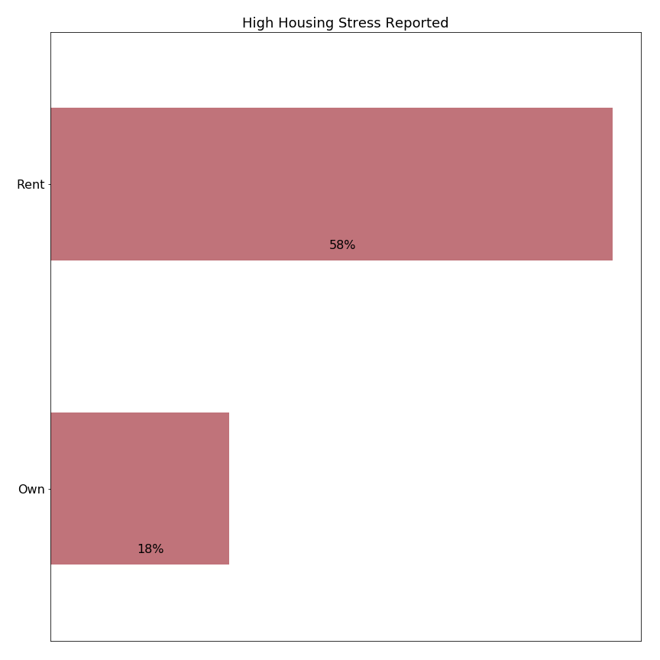

This finding argues against adoption of the State’s Residential Exemption (SRE), because the SRE would increase taxes on owners of rental properties which may be passed through to renters. Additional indirect effects of increased tax rate on rental property may include apartment conversion to condominiums (to avoid the higher tax rate and let individual condominium owners take advantage of the exemption) and increased apartment rental rates (due to lower supply of apartments).

### 2. High housing stress is reported at all ages, lengths of residence, incomes, and home values.

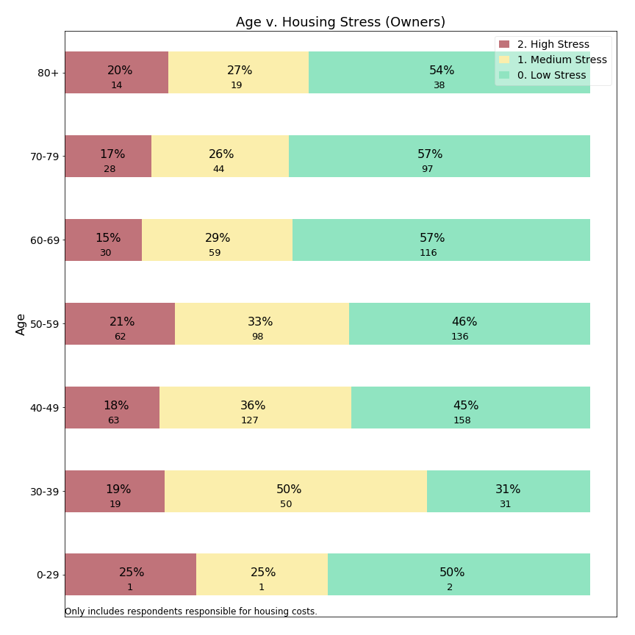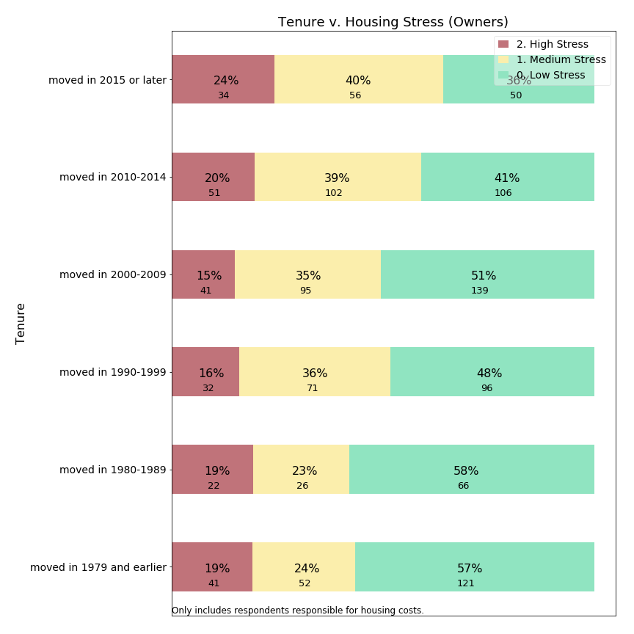

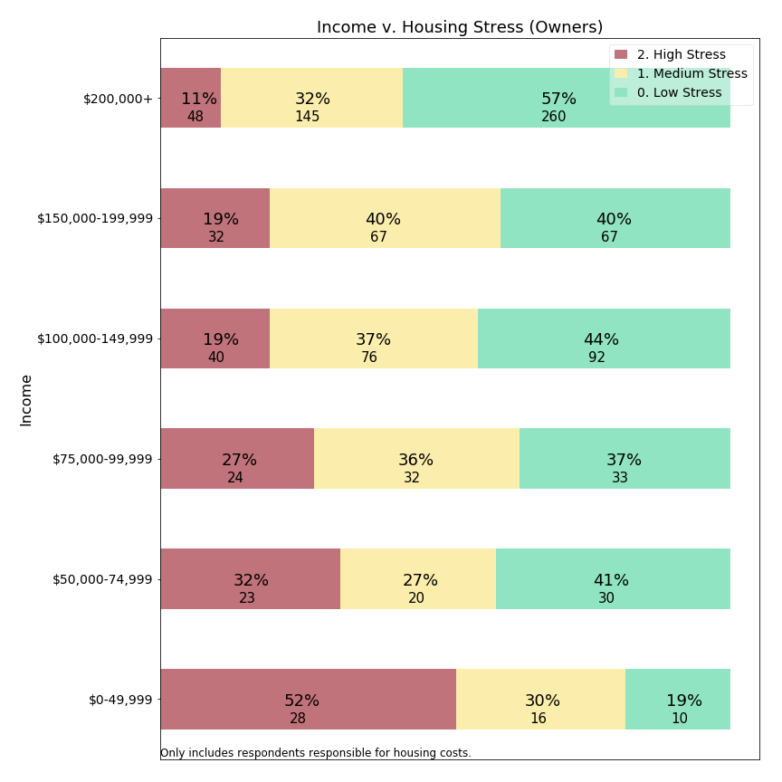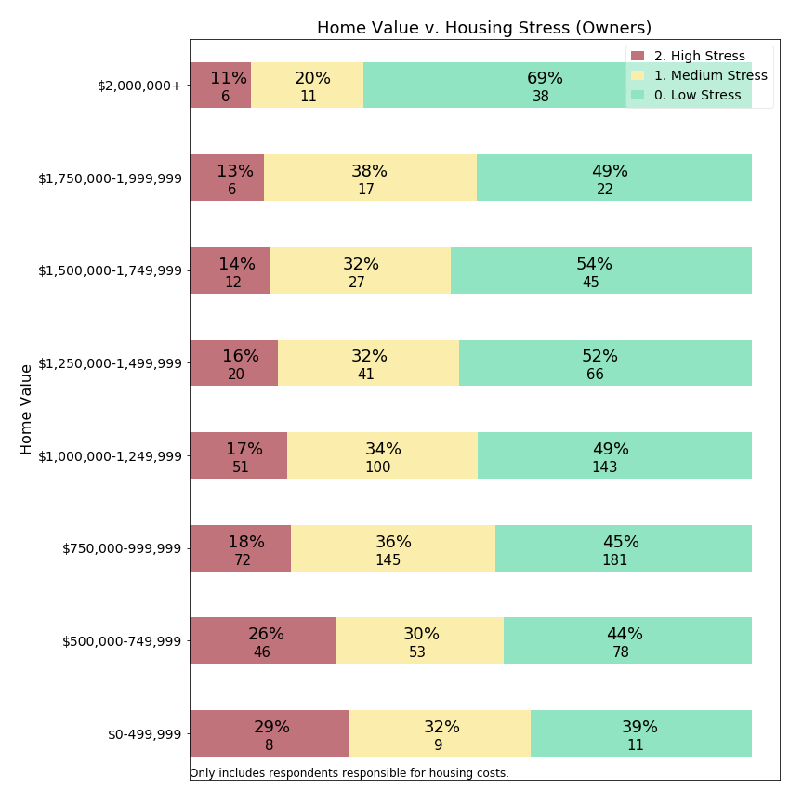

This finding argues against adoption of the SRE, because the SRE would provide relatively low precision: many of its beneficiaries report medium or low levels of housing stress. At the same time, a SRE would increase property taxes for those owning homes above the breakeven point; some of these owners already report high levels of housing stress.

### 3. Income is a better predictor of housing stress than is home value.

This finding (bottom left figure in the prior section) illustrates that a means-tested residential exemption based on income would provide for the higher precision than a SRE based on home value. *Note the higher rates of housing stress at lower income levels (bottom left) in comparison to rates of housing stress at lower home values (bottom right).*

### 4. Means tested targeting offers higher precision than the State’s Residential Exemption (SRE), but low recall.

This chart uses survey variables to construct an approximation for eligibility to a generic means tested exemption, and shows stress levels for those with value 1 (eligible) v. 0 (ineligible):

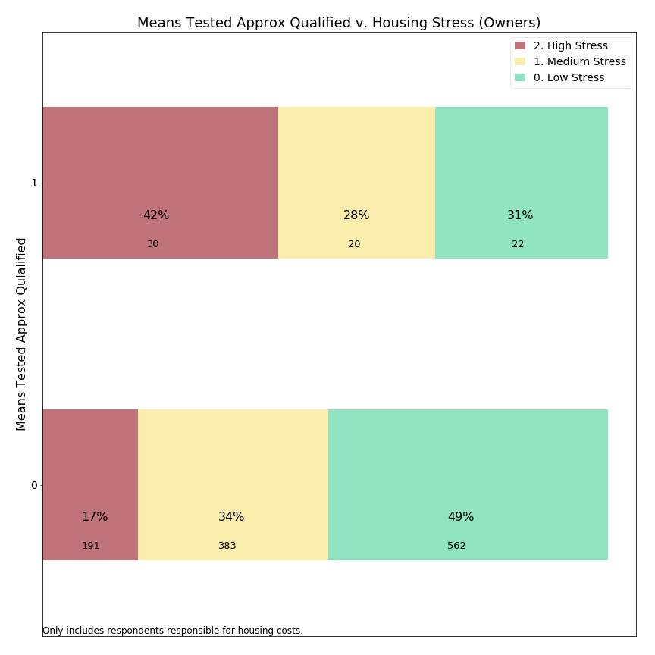

Only a small portion of households that responded to our survey would benefit from a MTRE (low recall), but a means-tested exemption would have higher precision. High precision means that most beneficiaries have the target criteria (high housing stress). However, a MTRE would have low recall, because only about 10-15% of homeowners experiencing high housing stress would be eligible. We conclude that neither the SRE nor a MTRE offers both high precision and high recall: helping many who need assistance while ensuring help lands mostly with those who need it.

## Migration potential

A second set of key insights relates to a question about future migration. Residents were asked whether they anticipated migrating from Lexington in the next ten years. The survey allowed us to examine the relationship between high likelihood of departing Lexington and demographic variables.

### 5. Renters are more likely to migrate than owners.

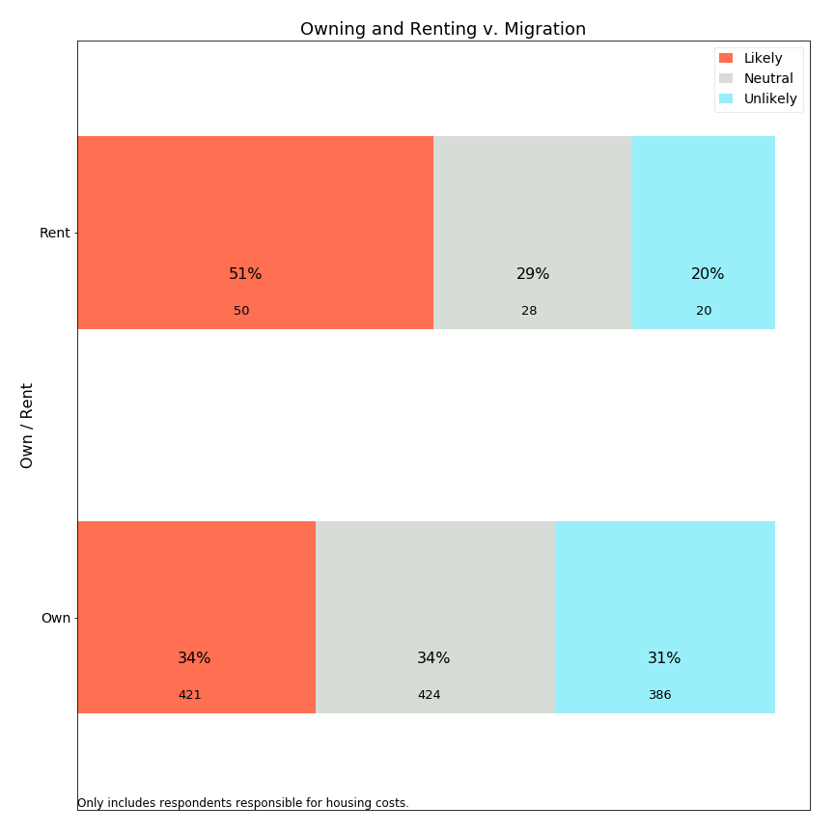

51% of renters forecast leaving in the next 10 years compared to 34% of owners. We expect renters to be more transient populations, and find it noteworthy that 34% of owners also anticipate leaving Lexington. The Committee has no benchmark to evaluate this percentage, but notes that it seems a high rate for anticipated migration, as actual migration would also include unexpected life changes and events beyond what survey residents can forecast.

### 6. Housing stress significantly drives migration for homeowners.

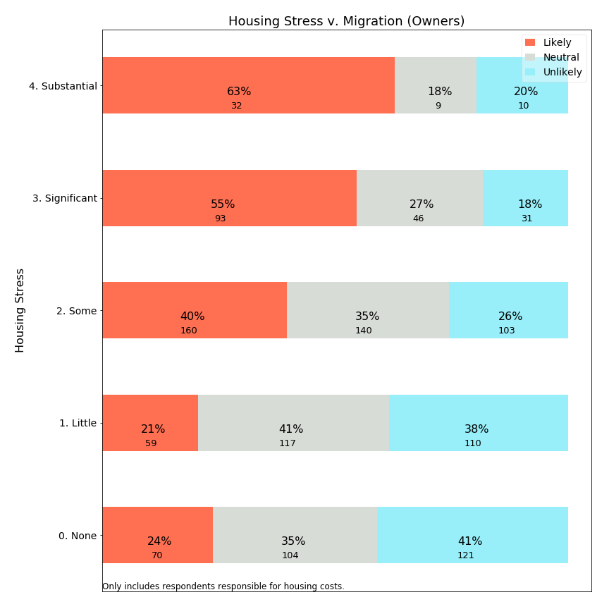

We see a strong relationship between housing stress and forecasted out-migration. This survey does not prove that a causal relationship exists, only a correlation is demonstrated between housing stress and anticipated migration.

### 7. Home value and income are not significant predictors of migration for homeowners.

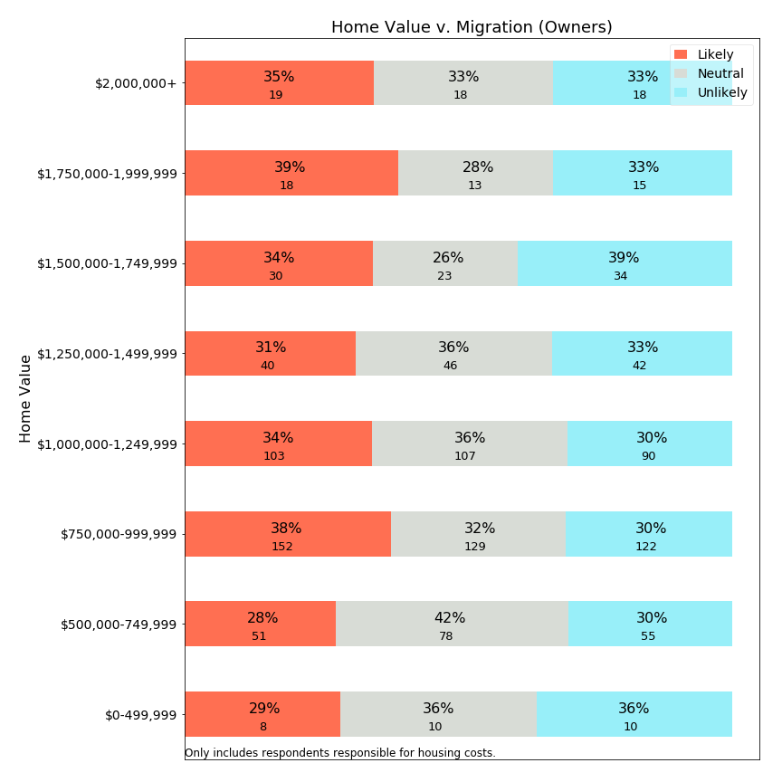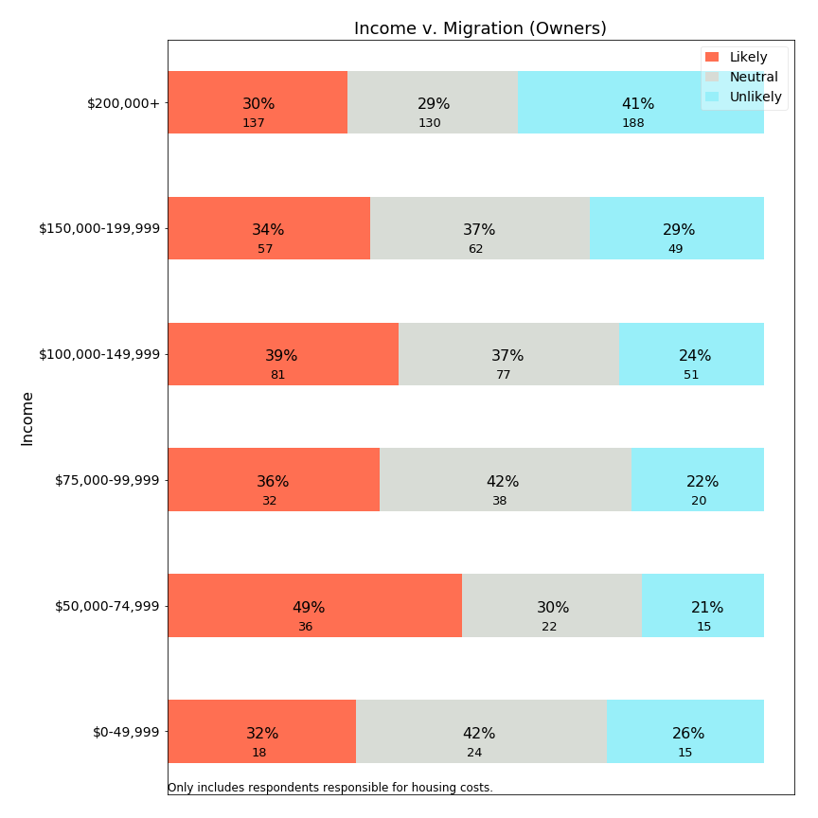

The finding that home value and income do not predict migration demonstrates that an effective public policy to address migration concerns would have to *address housing stress without simply relying on home value or income as proxies for stress*. Surprisingly, those with the lowest income levels or home values have *depressed* levels of migration relative to those with median incomes and home values. A conclusion is that a direct application of SRE or MTRE should not be expected to reduce migration effectively.[4]

### 8. Middle aged populations have the highest forecast of migration.

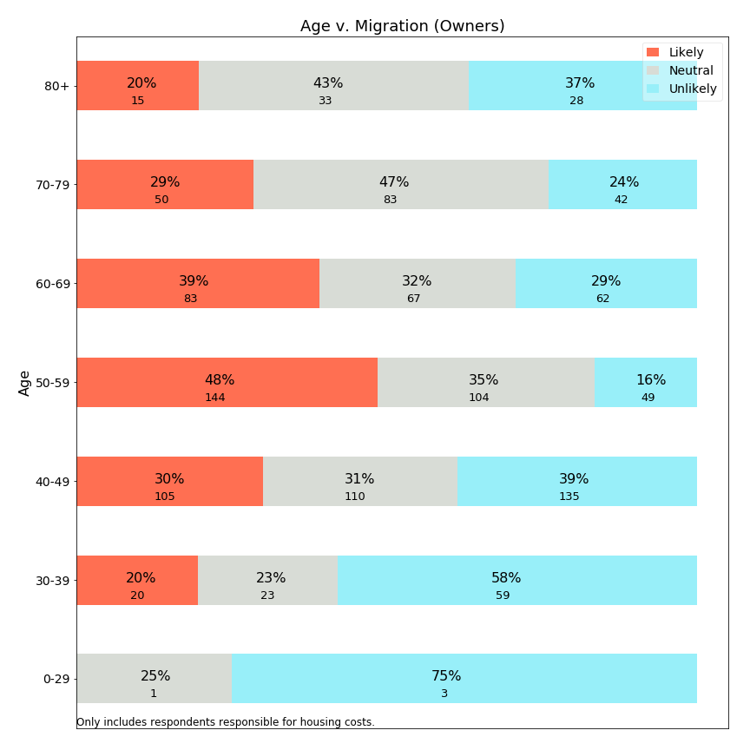

The survey data shows that expectation to leave Lexington is highest among 50-59 year olds, with about half of residents in this age category expecting to leave Lexington within 10 years. A residential exemption which requires age 65, such as most existing models for MTRE, would not benefit this population. Instead, an age 65+-targeted exemption would help a group forecasting lower levels of migration. It may be that age-based residential exemption programs target populations which already have lower levels of forecast migration or mobility.

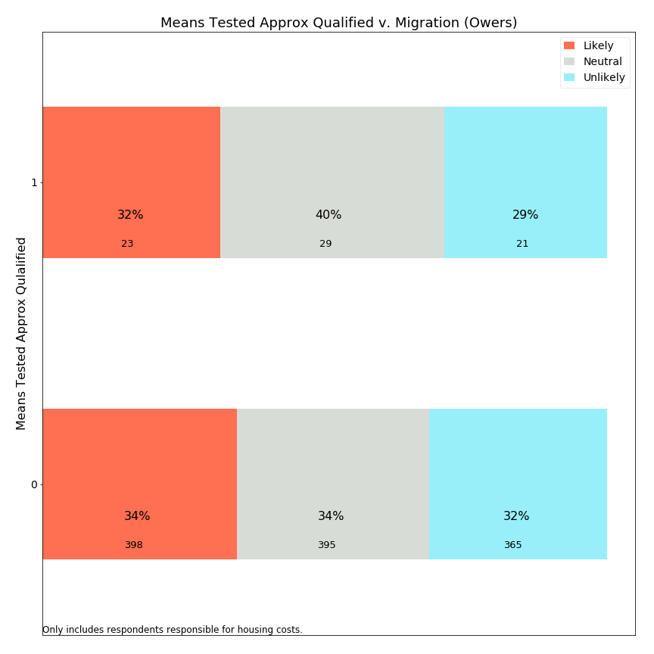

This chart evaluating forecast migration for those approximately qualified for a means tested exemption shows that very little difference in migration forecast exists between the means tested population and the broader population. Therefore, a means-tested exemption might reach those with housing stress, but the data does not provide evidence it would reduce migration.

We conclude that both SRE and MTRE approaches may assist in reducing housing stress for some portions of our community, but it is unclear that these programs would change how long people stay in their homes.

## Open Response Comments

The survey was constructed to focus initially on town services, and yet residents used the first open response question to raise concerns about property taxes *even before the first explicit mention of taxes* in the survey. Many respondents expressed gratitude at the opportunity to share their feelings about taxes and about housing stress, and appreciate that the Town is listening. The appendix provides an enumeration of the most frequent words used in open response comments and sample quotes.

Key repeated points from open response comments:

* High property taxes are on the minds of many Lexington residents.
* Fixed income residents or those approaching retirement are concerned about how to manage large and increasing property tax burdens.
* Residents do not understand why taxes continue to escalate at a high rate, and some feel Lexington government spends beyond what is necessary.
* Residents would like to stay in Lexington, but some find the cost impossible.
* Some residents feel the town services are great, while others feel they are too few for the high property taxes.
* Medium and long term residents report that their taxes have tripled or more since moving to Lexington.
* Residents in unimproved, small homes do not understand why their property taxes are substantial.
* Property taxes increase much faster than inflation.

## Statistical Study

Our multivariable study suggests that property taxes may impact propensity to move via housing stress, but the effect is minimal and really only exists for those for whom property taxes constitute the preponderance of monthly housing costs.

## Summary

In summary, Lexington residents are concerned about housing costs and property taxes across a wide demographic spectrum. Fixed exemption programs which shift taxes from low assessed value homes to those with high assessed values would have low precision as many beneficiaries do not have high housing stress, and such a program would shift higher taxes on to other residents--including numerous residents who experience high housing stress. Those receiving a higher tax burden may include those at a life stage and with financial resources to respond to a tax shift by migrating from Lexington. A residential exemption could exacerbate migration patterns. Thus, the survey does not provide support for a state residential exemption.

A Means Tested Residential Exemption could be structured to provide higher precision, with many beneficiaries who experience high housing stress. The limitation of such a program is low recall: fewer than 15% of residents reporting high housing stress would benefit from such an exemption. As a targeted program it may seem more attractive than the SRE, but it will have very limited scope and yet carry higher implementation costs (see later chapter).

Residents have voiced concern about the overall level of property taxes in Lexington, and neither exemption provides the across-the-board tax relief to all residents. To address these needs, the town would have to look to actions outside the scope of this committee.

The stress of owning a home in Lexington may not be evenly shared; a high stress burden occurs across a wide spectrum of Lexington’s homeowners. Any public policy which addresses the needs of some homeowners will necessarily shift this burden onto other homeowners or on to renters, who may also feel burdened. Policy makers need to take resentment and burden shifting onto already-burdened populations into account when making such a shift.

# 

# Property Tax Relief Measures Currently Available to Lexington Residents

## Town Programs

### The committee examined programs in place in Lexington today to assist homeowners with property taxes.

### Property Tax Exemptions

The town of Lexington has adopted most local-option tax exemption programs enabled by State legislation and has expanded all program benefits to the maximum allowable by statute. Most programs are designed to aid income-qualified seniors, veterans, blind people, or surviving spouses of firemen and policemen killed in the line of duty. An exemption from the Town’s Community Preservation Act surcharge is the only local property tax program that applies to income-qualified property tax payers of any age.

Tax Exemptions are a cost to the Town, partially reimbursed by the State. The cost of FY2018 property tax exemptions is estimated to be approximately $201,000. The State reimbursement is estimated to be approximately $89,000.

|  |  |  |  |
| --- | --- | --- | --- |
| **FY2019 Statutory Property Tax Exemption Programs as Adopted by Lexington** | | | |
| **Clause and Name** | **Abbreviated Description**  More qualifications and details  will apply | **FY2019 Exemption Amount** | **Exemptions Granted**  **In FY2018**  (latest available data) |
| 17D Surviving Spouses, minors or persons 70 years or over | Total assets other than house of less than $40,000. No income limit | $350. | 2 |
| 18 Hardship. | Hardship due to age, infirmity and poverty. At discretion of Board of Assessors | 100% | 0 |
| 18A Temporary Deferral- limited duration | Financial hardship due to change to active military status | 100% | 0 |
| 22(a-f) Veterans | Purple Heart recipients, or service-related 10% disabled or more, Gold Star Parents, and others | $800. | 65 |
| 22A Veterans & surviving spouses | Service-related loss of one foot, hand, or sight in one eye, or certain military service decoration award winners | $1,500. | 0 |
| 22B Veterans & surviving spouses. | Service-related loss of use of both feet, hands, sight in both eyes | $2,500. | 0 |
| 22C Veterans & surviving spouses | Service-related 100% disability and living in specially adapted housing | $3,000. | 0 |
| 22D Surviving spouse | Un-remarried spouse of serviceman presumed dead, or who died due to service-related injury | 100% | 2 |
| 22E Veterans & surviving spouses | Service-related 100% disability | $2,000. | 8 |
| 22F PARA Paraplegics & surviving spouses of paraplegics | Paraplegic from service-related injury | 100% | 4 |
| 37A Blind | Persons certified blind | $1,000. | 14 |
| 41C Certain elderly persons 65 years of age or over | Low income and low assets | $2,000. | 25 |
| 42 Surviving spouses of police officers/firefighters killed in the line of duty |  | 100% | 1 |
| CPA SURCHARGE EXEMPTION | Moderate income seniors and non-seniors. Income limits scaled to household size. | 100%  of CPA surcharge  $317 avg.exemption | 176 |
| **TOTAL** |  |  | **295** |

01-17-2019

### 

### Property Tax Deferrals

Property Tax Deferrals enable seniors to postpone paying any or all of their property tax until the property is conveyed or they or a surviving spouse dies. Lexington’s Property Tax Deferral Program provides the opportunity for the greatest amount of property tax relief of all programs available to seniors. In 2006, Lexington successfully petitioned the State legislature to allow the Town to provide lower interest rates and more generous income qualifications than the State property tax deferral law allowed at that time. In the ensuing years, Lexington has incrementally increased qualifying income limits and has matched deferral interest rates to the Monthly One Year Constant Maturity Treasury Rate as published by the Federal Reserve Bank for the first week in March preceding the Town’s new Fiscal Year. This rate generally runs below the Prime Rate and roughly matches the interest that the deferred amounts would have earned if the funds had been held in Lexington’s free cash accounts.[5] Seniors who defer their property tax may also defer water and sewer charges.

With a total of 877 deferrals among all Massachusetts municipalities in FY2018, utilization rates for Property Tax Deferrals are very low state-wide. Despite recent gains in participation, Lexington, with 42 deferrals in FY2018, is no exception. Anecdotal evidence suggests that seniors feel that a deferral would indicate a “desperation” that is out of proportion to their situation, or they want to leave their home unencumbered to their heirs. A small number of seniors who would like to defer have existing equity loans or mortgages and are kept from deferring by their lender, largely because bank liens are, by law, secondary to municipal tax liens.

Unlike tax exemptions, tax deferrals are not subsidized by other taxpayers beyond any differential between the interest rate charged and the actual cost to the Town.

### Senior Service Program

Administered by Lexington’s Human Services Department, Lexington’s FY2019 Senior Service Program provides a property tax credit of up to $1,540 per household for seniors with household incomes of up to $70,000 in exchange for work performed for the Town or the School Department. This program is paid for from a line-item in the Town budget. XX seniors benefitted from this program in FY at a cost to the Town of XX

## State Program

### The Massachusetts Senior Circuit Breaker Property Tax Credit

Administered by the State through the income tax return process, this program provides a tax credit or a direct payment from the State of one dollar for every dollar that the owner’s property tax exceeds 10% of his or her income, up to $1100. Renters also qualify for the Circuit Breaker when 25% of their rent exceeds 10% of their income.

Income limits, house value limits and the maximum credit change annually by a cost of living adjustment.

This program has no cost to the Town of Lexington. In Tax Year 2016, 447 Lexington seniors received this State benefit at an average of $1,032 each. 735 Lexington taxpayers received the benefit in 2009, and usage has declined steadily since then.

**Circuit Breaker Parameters, Tax Year 2018**

|  |  |
| --- | --- |
| Income Limit | Single: $58,000.  Head of Household: $73,000.  Married, filing jointly: $88,000. |
| House Value Limit | $778,000. |
| Maximum Credit Given | $1,100. |

### Utilization of Lexington’s Property Tax Programs in Lexington

Utilization of Lexington’s property tax exemptions for veterans has steadily declined from 123 beneficiaires in 2006 to almost half that number in 2018. These exemptions are generally related to service-related disability with no consideration of income. The decline in recipients is likely due to the declining number of living veterans of World War II and the smaller number of veterans who fought in subsequent military operations.

Utilization of Lexington’s 41C property tax exemption, which benefits low income seniors, declined steeply between 2011 and 2013 and has leveled off since then.

Property Tax Deferrals, after many years of consistently low utilization, experienced a 65% increase in accepted applications, maintaining the higher utilization rate over the past three years.

### 

# Residential Properties in Lexington

The tax policies discussed in this report apply to properties classified as residential property per Massachusetts law and assessment guidelines. However, the typical taxpayer or town meeting member is likely not familiar with all the instances of residential property. This chapter provides an overview of all residential property classes, with details specific to Lexington. The information in this chapter serves as a reference for further chapters evaluating how changes in tax policy impact residential property holders.

As a matter of policy, a residential tax exemption pertains to a **resident**. The committee understands that a citizen is deemed a resident of Lexington if they file a Massachusetts resident state tax return (Form 1), and declare Lexington as their residence. In general, state laws govern location of residency, and this would be unambiguous for most citizens. However, the committee is also aware that some citizens may live in a gray area where they could either willfully adjust their town or state of residence, legally or illegally. One example, might be so-called “snow birds” which spend part of a year in Florida and part of a year in Massachusetts, and may give consideration to a variety of financial incentives in declaring residency.

Later chapters discuss both the existing state residential tax exemption and possible means-tested tax exemptions. Because these models largely benefit *owner occupied* residential properties, this chapter also provides information on which types of residential properties are likely to be owner occupied.

This section’s data reflects Lexington residential property in Fiscal Year 2019, and what we know of significant near term projects. While these concrete examples help examine near-term impact, policy makers should consider the evolving needs of the community as well.

## Classification of Residential Properties

The State’s Residential Exemption (SRE) statute creates exemptions for particular “Class One, residential” properties. These code 1 residential properties are distinct from industrial, commercial, and personal property and are defined as follows:

“CODE 1 M.G.L. Chapter 59 §2A: All real property used or held for human habitation containing one or more dwelling units including rooming houses with facilities assigned and used for living, sleeping, cooking and eating on a non-transient basis, and including a bed and breakfast home with no more than three rooms for rent. Such property includes accessory land, buildings or improvements incidental to such habitation and used exclusively by the residents of the property or their guests. Such property shall include: (i) land that is situated in a residential zone and has been subdivided into residential lots, and (ii) land used for the purpose of a manufactured housing community, as defined in Chapter 140, §32F. Such property shall not include a hotel or motel.

Incidental accessory land, buildings or improvements would include garages, sheds, inground swimming pools, tennis courts, etc. Non-incidental accessory land, classified and coded differently, would include mixed use properties, such as a variety store, machine shop, etc. on a residential parcel.”

## Residential Property Types

The Lexington assessment database includes the following types of residential property:

|  |  |  |  |  |  |  |
| --- | --- | --- | --- | --- | --- | --- |
| Residential Class** | Parcel Count* | Total Assessed Value | % of Assessed Total | Mean Assessed Value | Median Assessed Value | Likely Owner Occupied? |
| **Single Family** | 9,030 | $9,486,786,000 | 89.7% | $1,050,588 | $939,000 | Yes |
| **Condominium** | 1,057 | $623,512,900 | 5.9% | $589,889 | $530,000 | Yes |
| **Two Family** | 159 | $135,414,000 | 1.3% | $851,660 | $783,000 | Yes |
| **Three Family** | 11 | $9,451,000 | 0.1% | $859,182 | $810,000 | Yes |
| **Multiple Houses** | 31 | $40,179,000 | 0.4% | $1,296,097 | $1,256,000 | Yes |
| **Four Unit Apts** | 1 | $899,000 | 0.0% | $899,000 | $899,000 | Yes |
| **8+ Unit Apts** | 8 | $196,268,000 | 1.9% | $24,533,500 | $14,416,000 | No |
| **Group Living** | 4 | $7,020,000 | 0.1% | $1,755,000 | $1,329,500 | No |
| **Child care facility** | 5 | $7,027,000 | 0.1% | $1,405,400 | $1,076,000 | No |
| **Mixed Use** | 17 | $11,022,920 | 0.1% | $648,407 | $1,082,000 | Yes |
| **Miscellaneous (106)** | 35 | $6,100,000 | 0.1% | $174,286 | $78,000 | Yes |
| **Developable Land** | 53 | $30,142,000 | 0.3% | $568,717 | $519,000 | No |
| **Potentially Developable Land** | 63 | $6,864,000 | 0.1% | $108,952 | $109,000 | No |
| **Undevelopable Land** | 398 | $8,768,000 | 0.1% | $22,030 | $23,000 | No |
| **Land (adjustment)** |  | $1,185,000 | 0.0% |  |  | No |
|  | 10,872 | $10,570,638,820 |  | $972,281 |  |  |

*Parcel count is the number of assessed parcels. A single apartment parcel may provide housing for hundreds of families, and therefore the parcel count only provides a partial view of the number of impacted individuals and families.

**Classifications are described in <https://www.lexingtonma.gov/sites/lexingtonma/files/uploads/lexington_resid_dcm_fy_2018.pdf> and <http://www.mass.gov/dor/docs/dls/bla/classificationcodebook.pdf>.

From this table, a few key points should be highlighted about Lexington’s residential tax base:

* Homes which could be owner occupied (single family, two family, three family, condominium, and multiple houses on one parcel) account for 97% of residential assessed value in Lexington.
* Condominiums account for about 10% of all residential parcels, but are also distinctive in having lower median and mean assessed values than other owner occupied properties.
* Eight commercial apartment buildings have a combined $196 million in assessed value. A fixed residential exemption offers no real benefit to these operations, and is impossible with commercial ownership. However, as will be discussed in a later section on indirect effects, the apartments penalized by residential tax exemptions might be convertible to condominiums, which are rewarded by residential tax exemptions.
* Group living facilities and child care facilities are typically operated with commercial ownership and not owner occupied.
* Until developed, land cannot be owner occupied. Only 53 lots in Lexington are deemed “developable”, and tax policies could impact motivation to develop these properties.

The following sections are intended to provide additional flavor to the types of properties of each class which exist in Lexington.

### Single Family Homes in Lexington

In FY2019, the mean single family home assessment in Lexington is $1,050,588, while the median home assessment is $939,000. The mean is higher than the median due to the long tail of high-end residential properties, some even above the $3,000,000 truncation for the following chart:

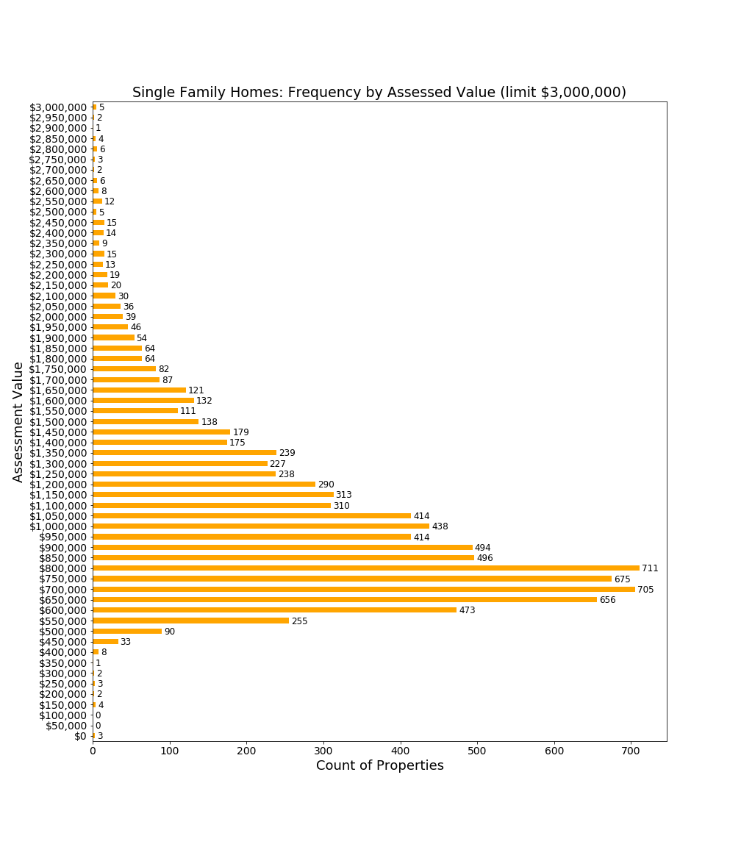

The chart above shows the count of properties assessed by $50,000 increments. For example, 90 properties are assessed for amounts from $500,000 to $549,999.

This chart shows that large numbers of properties are assessed in the $600,000-$900,000 range, well below the median property assessment. This means that a large cluster of single family home owners would receive some financial benefit from a residential exemption.

### Two-Family Homes in Lexington

Two-family homes are typically assessed at lower values than single family homes, and no Lexington two-family homes are currently assessed above $2,000,000.

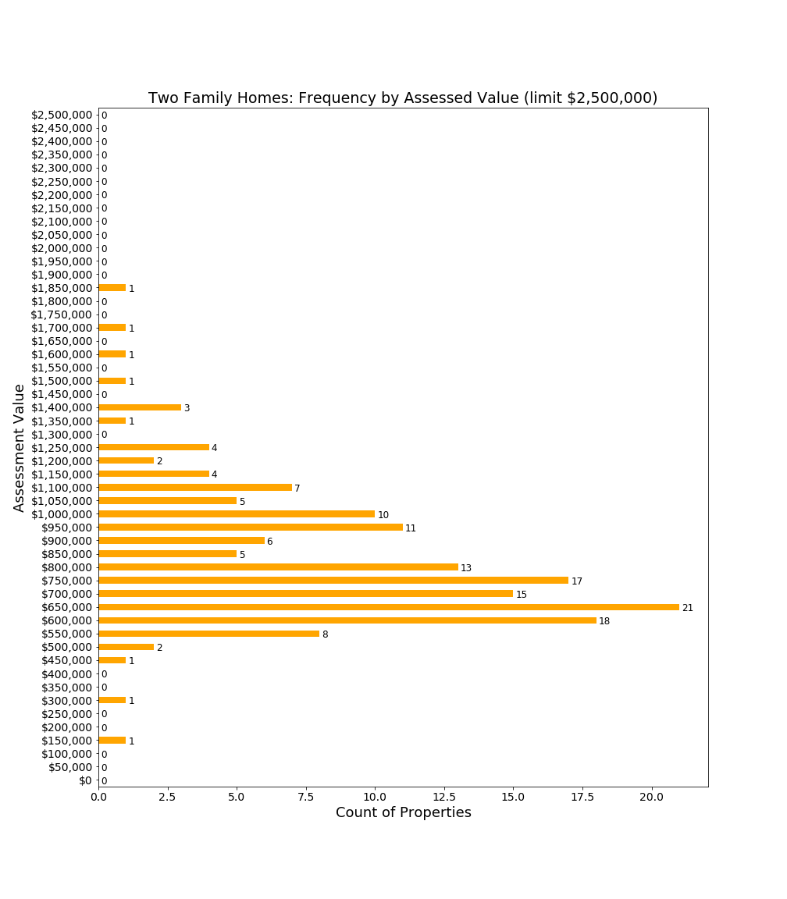

A two-family home can have only one owner occupant, and therefore the physical structure can earn only a single owner-occupied exemption. However, with sufficient tax incentives, the owner of a two-family home might convert the structure to two condominiums. The effect of the conversion would impact taxes (both condominiums could potentially receive owner-occupied exemptions thereby lowering tax incidence) and demographic (condominium owners could be expected to be a wealthier and more stable population than renters).

### Condominiums in Lexington

With a median assessed value of $530,000, condominiums in Lexington have lower values than two-family homes. Due to their lower assessed values, nearly all Lexington condominium owners would benefit from a fixed exemption per property which shifts taxes to higher valued properties.

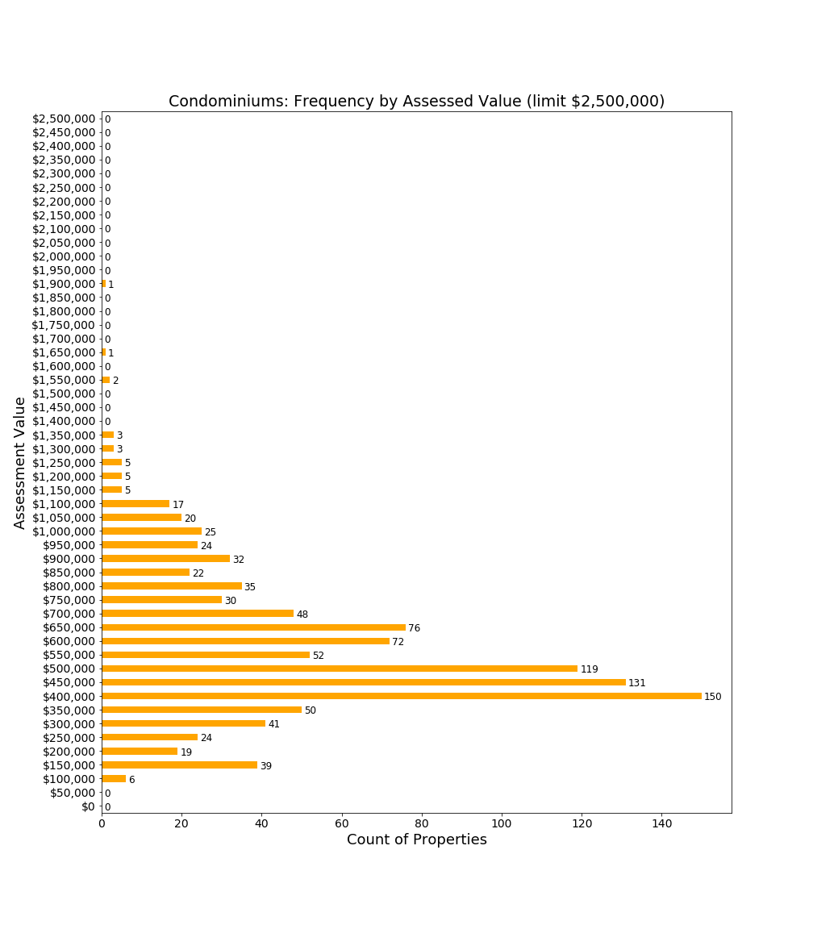

## 

### Large Apartment Complexes in Lexington

Eight large apartment complexes contribute about $200,000,000 to Lexington’s property tax base, or approximately $2,800,000 in property taxes. These properties are comprised of 984 units with an average property tax contribution of approximately $2,845 per unit.

|  |  |  |  |
| --- | --- | --- | --- |
| **Complex** | **Address** | **Assessed Value** | **Units** |
| Avalon Lexington Hills | 1000 Main Campus Drive | $82,852,000 | 387 |
| Avalon Lexington Ridge | 987 Waltham Street | $37,960,000 | 198 |
| Battle Green | 32 Worthen Road | $8,135,000 | 48 |
| Captain Parker Arms (Avalon) | 125 Worthen Road | $19,199,000 | 94 |
| Countryside Manor | 425 Woburn Road | $9,633,000 | 51 |
| Franklin School | Stedman Road | $5,491,000 | 38 |
| Katahdin Woods | 307 Wood Street | $25,382,000 | 128 |
| 1 April Lane | 1 April Lane | $7,616,000 | 40 |
|  |  | **$196,268,000** | **984** |

While the impact of residential exemptions on apartments will be covered in later sections, three noteworthy points are appropriate when one considers this class of property in general.

First, apartment buildings are commercial enterprises. Yet, state tax law taxes commercial apartment buildings at the residential tax rate rather than the commercial tax rate. Lexington is among a number of communities which have a “split” tax rate, where commercial enterprises pay a higher tax rate than residences: for FY2019 the Lexington commercial tax rate is 27.69 mils compared with 14.30 mils for the residential tax rate. Therefore, while one could regret an increase in taxes for apartment buildings beyond 14.30 which could be partially discharged to renters, another perspective is that these businesses are operating in Lexington at a deep tax discount relative to other commercial enterprises.

Second, and unlike other commercial businesses, apartments have a clear and negative impact on Lexington’s financial structure. The 2014 Enrollment Working Group Report indicated that in 2015, 43.6% of apartment units had school children with an average 1.46 students per apartment with children. Therefore, the apartments, collectively, house about 626 public school students. In FY2016, Lexington spent $18,003 per pupil[6]. So, at FY2016 spending levels, the impact of 626 public school students would be $11,269,878. Because the total contribution of apartments to Lexington for all taxes ($2,800,000) is less than 25% of the *educational operating* (i.e. excluding capital) costs, these apartment buildings demand substantially more from the Lexington fiscal base than is covered their tax contributions.

Finally, while apartment buildings may support a broader demographic than single family homes, they also serve another purpose for Lexington, which is to contribute materially to the town’s goal of 10% affordable housing. Of Lexington’s 1328 Subsidized Housing Inventory Units,[7] 802 are provided by five apartment buildings. If Lexington’s SHI were to fall below 10% affordable housing, then Chapter 40B rules would allow developers to subvert local zoning regulations. Therefore, these apartments serve a useful function for a town seeking to regulate residential development.

### Undeveloped Land

Land in residential districts is categorized and assessed depending on the ease with which it can be transformed into occupied residential property.

Developable land has a higher assessment (median $519,000) than undevelopable land because it can be developed into residential housing. A tax policy which penalizes developable land for remaining idle (e.g. missing out on an owner-occupied residential exemption) could spur development of these assets into owner-occupied housing.

Potentially developable land and undevelopable land refer to properties which might not be easily developed. These properties also cannot be owner occupied, so owners of these properties cannot benefit from exemptions for owner occupied properties.

It seems reasonable to expect that many of the privately owned, undevelopable lands are small tracts abutting a parcel owner’s primary residence. One can conduct a thought experiment about the impact of conjoining or separating parcels of land from a primary residence based on opportunities to capture potential tax exemptions, and conclude that the residential exemption system is neutral to these transfers and therefore sensible.

### For-Profit Child Care Facilities

Although commercial enterprises, for-profit child care facilities are classified and taxed as residential properties. Lexington currently has five such properties:

|  |  |  |
| --- | --- | --- |
| **Facility Name** | **Location** | **FY19 Assessment** |
| Bright Horizons | 903 Waltham Street | $1,718,000 |
| First Circle Learning Center | 80 Maple Street | $879,000 |
| Goddard School | 332 Concord Avenue | $1,076,000 |
| LEAP School | 210 Marrett Road | $2,445,000 |
| Lexington Knowledge Beginnings | 429 Marrett Road | $909,000 |
|  |  | **$7,027,000** |

For-profit child care facilities are not owner occupied, and therefore would not benefit from a residential exemption. Again, as these are commercial enterprises in practice, one could reasonably debate whether the desired policy for taxes should be the current residential tax rate or the much higher commercial tax rate.

### Group Living Facilities

Group living facilities are classified as residential rather than commercial. Lexington currently has four group living facilities:

|  |  |  |
| --- | --- | --- |
| **Facility Name** | **Location** | **FY19 Assessment** |
| Artis Senior Living | 430 Concord Road | $3,181,000 |
| Supportive Living | 7 Oakland Street | $1,378,000 |
|  | 50 Percy Road | $1,281,000 |
|  | 52 Percy Road | $1,180,000 |
|  |  | **$7,020,000** |

Lexington’s fall 2018 Town Meeting approved development of two additional facilities: an assisted living facility (Waterstone) and a memory care facility (Bridges). These are for-profit enterprises which should be classified for a residential group facility tax once built. The fall 2018 presentation envisioned these properties would contribute $600,000 in property taxes per year to Lexington, suggesting a residential assessment of about $42,000,000. The combined Waterstone and Bridges projects illustrate how quickly the residential property profile in Lexington may change, and why it is important to consider broader possibilities when enacting residential tax policies.

Again, as commercial enterprises, for-profit group living facilities receive favorable tax treatment in Lexington when compared with commercial enterprises. However, because Lexington’s residential and commercial tax rates may already differ significantly from peer communities, economic competitiveness also deserves consideration, not just fairness relative to other commerical businesses.

### Brookhaven

Brookhaven is a lifecare community for seniors that provides services ranging from assisted living through nursing home care. It is considered to be a not-for-profit community. Currently, Symmes Lifecare Inc. (d/b/a Brookhaven) makes a negotiated Payment In Lieu Of Taxes (PILOT) to Lexington rather than being taxed directly as a residential property. It is unresolved whether Lexington could tax Brookhaven directly rather than accepting this payment in lieu of taxes.

In 2017, Brookhaven entered into a memorandum of understanding with Lexington that will increase its PILOT payments. This was part of a larger agreement with Brookhaven concerning a planned Brookhaven expansion. These increased PILOT payments will begin in fiscal year 2022, and will put the Brookhaven facility on a trajectory to increase its estimated payment to $573,001 in FY2020.

Because Brookhaven pays a PILOT, no change in residential exemption policy will directly impact tax payments from Brookhaven. However, a residential exemption could increase the gap between PILOT payments and what Brookhaven would pay if taxed directly. The residential exemption could motivate renegotiation of the Brookhaen agreement, or contribute to a revised PILOT level when future negotiation occurs.[8]

### Affordable and Subsidized Housing

Lexington has more than 800 subsidized and affordable apartment units and houses that are owned, managed, funded or overseen by a complex variety of local, state and federal entities. Subsidized housing, which comprises about 40% of the total, serves tenants with very low incomes, including families, elderly, and disabled persons.

All of the subsidized housing and some of the affordable housing is owned either by the Town of Lexington or the Commonwealth of Massachusetts. Properties owned by the government are not subject to property tax, so these units would not be affected by the adoption of the SRE.

Much of Lexington’s affordable housing consists of designated apartments located within privately owned apartment buildings. While the apartment buildings themselves would see an increase in property tax if the Town were to adopt the SRE, rental rates for the affordable units are dictated by the State and would remain unaffected.

Lexington also has almost 90 units of deed-restricted affordable ownership apartments. These units are privately owned by income-qualified owners and in perpetuity may be sold only to other income-qualified owners at a controlled price. These units are required to be the primary residence of the owner and may not be rented out. As privately owned owner-occupied residential properties these units, which have very low assessments, would receive a decrease in their property tax if the Town were to adopt the SRE.

## Conclusion

This chapter describes the many types of properties which contribute to Lexington’s residential property tax base. While some properties--such as single-family homes, two-family homes and condominiums--may be owner-occupied, others such as large apartment buildings and group housing facilities are generally not owner-occupied.

It is noteworthy that some properties are taxed at residential rates despite being commercial in nature. One could argue that these properties are under-taxed relative to their purely commercial peers, and in fact some might not provide sufficient taxes to cover their economic impact to the town. But Lexington does not exist in a vacuum, so these arguments should be tempered by Lexington’s competitive position in the residential housing market.

As Lexington considers changing how taxes are derived from the residential tax base, policy makers should recognize that new projects as well as zoning changes could impact how residential properties are utilized. Policy makers should think not only about short term impacts, but also what types of long term impacts are sought as well as whether Lexington will have flexibility in responding to changes in housing needs in our society, and whether tax changes would impact competitiveness for all classes of residential owners with surrounding communities.

# The State’s Residential Exemption

The Residential Exemption Policy Study Committee’s (REPSC) original charge was to study the Massachusetts Residential Exemption. After weighing pros and cons of this exemption, the Committee requested scope expansion to include means-tested residential exemptions as found in other communities which have enabling legislation. This chapter will cover the Massachusetts RE while the next chapter examines means-tested residential exemptions. To avoid confusion, throughout this document, the term SRE is used to refer to a “State Residential Exemption” which has been passed by the Massachusetts legislature and is available to all municipalities in Massachusetts, while the term MTRE will refer to a variety of means-tested residential exemptions which may exist or could be created.

The State’s Residential Exemption (SRE) is a local tax option available to the Selectmen:

*With respect to each parcel of real property classified as Class One, residential, in each city or town...at the option of the board of selectmen... there shall be an exemption equal to not more than 35 percent of the average assessed value of all Class One, residential, parcels within such city or town; provided, however, that such an exemption shall be applied only to the principal residence of a taxpayer as used by the taxpayer for income tax purposes.[9]*

Only 16 of 351 municipalities in Massachusetts presently utilize the SRE, and these communities are typically cities or vacation communities, with none closely resembling Lexington in housing stock or demographics.

## State Residential Exemption Process

### Setting an Exemption Percentage, and thereby an Exemption Amount

Each year, as part of the State regulated tax-rate setting process, the Selectmen are required to set a percentage for a Residential Exemption. Lexington Selectmen have historically chosen a 0% factor, in effect, declining to adopt the SRE. Supporting documentation for options is found in the tax classification packet[10], which includes projections for adoption at percentages such as 10%, 20%, and 35% (typical %’s used by other municipalities).

If the Lexington Selectmen select a percentage above 0%, the following processes would be set in motion:

* Lexington residents would be notified of a new residential exemption.
* The Board of Assessors and the Lexington Assessor would have to determine a process to certify and then certify which properties are eligible for a residential exemption.
* The residential tax rate would be increased to offset the projected revenue shortfall due to the exemption.

### Eligibility and Verification

Per the state law, parcels that are “*the principal residence of a taxpayer as used by the taxpayer for income tax purposes”* would receive a residential exemption. In other municipalities, identification of these parcels occurs via voluntary affidavit by the taxpayer, with required evidence such as federal tax return, state tax return, drivers license, vehicle registration, utility bills or bank statements. Practices differ on the handling of real estate transfers and whether annual recertification is required.

Once affidavits are submitted for an estimated 9000+ parcels, Lexington would apply its own process for residency verification. Significant verification may be required given financial incentives to cheat. Penalties for lying on the affidavit have not been investigated by the committee. Verification within Lexington might be time consuming for the more than 1,400 properties in Lexington owned by trusts, where review of trust structure and beneficial interest would be required.[11]

### Exemption Amount and Tax Rate Calculation

The Lexington assessor provides the Selectmen with the assessed value of the average *residential parcel*. As shown earlier, this average parcel value is broader than single family homes, and includes parcels such as non-developable land and apartment buildings. Therefore, the average parcel value is simply the assessed value of all residential parcels in Lexington divided by the number of parcels.[12] According to the FY2019 tax classification packet, the average residential parcel assessment in Lexington is **$973,804**.

The percentage set by the Selectmen is multiplied by the average residential parcel to determine an exemption amount. The result would be a *fixed exemption amount which would be applied to every residential parcel in Lexington to which eligibility is confirmed*. The exemption amount is subtracted from the parcel value before application of the tax rate. This table identifies exemption amounts which would occur for various exemption percentages if hypothetically adopted in FY2019:

|  |  |
| --- | --- |
| Exemption Percent | Exemption Amount Per Occupied Parcel |
| 2.5% | $24,345 |
| 5.0% | $48,690 |
| 7.5% | $73,035 |
| 10.0% | $97,380 |
| 12.5% | $121,726 |
| 15.0% | $146,071 |
| 17.5% | $170,416 |
| 20.0% | $194,761 |
| 22.5% | $219,106 |
| 25.0% | $243,451 |
| 27.5% | $267,796 |
| 30.0% | $292,141 |
| 32.5% | $316,486 |
| 35.0% | $340,831 |

As the above table shows, the range of exemption percentage options range from nominal to profound impacts on taxable assessed values.

The Committee is aware that for many taxpayers, understanding of a tax exemption stops at this point. Residents are often enthusiastic supporters of reduced taxes through a residential exemption. Several residents have informed the committee that they support a residential exemption based on a belief that this exemption would lower taxes for all Lexington residents.

However, perhaps the most important point is that the **total Lexington tax levy remains unchanged**. Revenue neutrality is accomplished by *increasing the tax rate on residential class property* to offset the loss in revenue for residential exemptions.

Based on 2019 figures and the Assessor’s estimate of 9,265 exempt parcels[13], the following table illustrates how the lower aggregate residential assessed value combined with fixed residential tax revenue results in an *increased residential tax rate*:

|  |  |  |  |  |
| --- | --- | --- | --- | --- |
| Exemption Amount | Taxable Value of Lexington Residential Assessed Value after Exemption  (Total) | Residential Tax Revenue | Resulting Residential Tax Rate | % Increase in Tax Rate |
| 0% | $10,570,638,820 | $149,308,233 | 14.12 | 0% |
| 5% | $10,119,524,117 | $149,308,233 | 14.75 | 4.5% |
| 10% | $9,668,409,414 | $149,308,233 | 15.44 | 9.3% |
| 15% | $9,217,294,711 | $149,308,233 | 16.20 | 14.7% |
| 20% | $8,766,180,008 | $149,308,233 | 17.03 | 20.6% |
| 25% | $8,315,065,305 | $149,308,233 | 17.96 | 27.2% |
| 30% | $7,863,950,602 | $149,308,233 | 18.99 | 34.5% |
| 35% | $7,412,835,899 | $149,308,233 | 20.14 | 42.6% |

As this table shows, the greater residential exemption rates result in a reduction of residential assessed value subject to taxation, and therefore in higher tax rates on residential properties.

While the tables above illustrate the range of options available to the Selectmen, a more tangible perspective for residents may be to show the impact on homes. Such an impact illustration requires the selection of a particular SRE percentage, and this report does so using 20% merely to illustrate key relationships between property values and taxes.

The following table illustrates a 20% SRE assuming FY2019 tax rates, as above. The FY2019 preliminary tax rate is 14.12 mills. At a 20% SRE, the tax rate is estimated to increase to 17.03 mills. The following table shows the tax paid by the parcel owner at status quo (no SRE) (column B), and with the SRE when owner occupied (column C), with the SRE when not owner occupied (column D). Columns E and F show the changes in taxation.

|  |  |  |  |  |  |  |
| --- | --- | --- | --- | --- | --- | --- |
| **FY2019 Tax Illustration:**  **20% SRE** |  | **Tax With Real Estate Exemption** | |  | **Change in Tax Due to Exemption** | |
| **(A)** | **(B)** | **(C)**  **Owner Occupied** | **(D)**  **Non Owner Occupied** |  | **(E)**  **Owner Occupied** | **(F) Non Owner Occupied** |
| **Assessed Residential Property Value** | **FY2019 Property Tax** | **Tax With Exemption** | **Tax With Exemption** |  | **Change in Tax** | **Change in Tax** |
| $400,000 | $5,648 | $3,496 | $6,813 |  | -$2,152 | $1,165 |
| $500,000 | $7,060 | $5,199 | $8,516 |  | -$1,861 | $1,456 |
| $600,000 | $8,472 | $6,902 | $10,219 |  | -$1,570 | $1,747 |
| $700,000 | $9,884 | $8,605 | $11,923 |  | -$1,279 | $2,039 |
| $800,000 | $11,296 | $10,309 | $13,626 |  | -$987 | $2,330 |
| $900,000 | $12,708 | $12,012 | $15,329 |  | -$696 | $2,621 |
| $1,000,000 | $14,120 | $13,715 | $17,032 |  | -$405 | $2,912 |
| $1,100,000 | $15,532 | $15,418 | $18,736 |  | -$114 | $3,204 |
| $1,200,000 | $16,944 | $17,122 | $20,439 |  | $178 | $3,495 |
| $1,300,000 | $18,356 | $18,825 | $22,142 |  | $469 | $3,786 |
| $1,400,000 | $19,768 | $20,528 | $23,845 |  | $760 | $4,077 |
| $1,500,000 | $21,180 | $22,231 | $25,548 |  | $1,051 | $4,368 |
| $1,600,000 | $22,592 | $23,934 | $27,252 |  | $1,342 | $4,660 |
| $1,700,000 | $24,004 | $25,638 | $28,955 |  | $1,634 | $4,951 |
| $1,800,000 | $25,416 | $27,341 | $30,658 |  | $1,925 | $5,242 |
| $1,900,000 | $26,828 | $29,044 | $32,361 |  | $2,216 | $5,533 |
| $2,000,000 | $28,240 | $30,747 | $34,065 |  | $2,507 | $5,825 |

Key observations:

* SRE increases property taxes on all non-owner occupied properties (it has no relation to the type of non-owner occupied property). These properties always experience an increase and the most dramatic negative impact of the SRE.
* For owner occupied properties assessed below $1,000,000, a material decrease in taxes occurs, a larger decrease the smaller the assessed property.
* For owner occupied properties assessed near the breakeven point, in the $1,000,000-$1,200,000 range, an immaterial change to taxes occurs
* For property owners with values well above the breakeven point, the taxes increase a material amount, increasing steadily as the property has higher values.

Finally, it is important to observe that the majority of residential parcels will have a reduced tax burden, offset by increases on a minority of parcels.

Using this 20% illustration, the following table shows the impact on the median property of sub-classes of residential property likely to be owner occupied:

|  |  |  |  |  |
| --- | --- | --- | --- | --- |
| Residential Class | Median Assessed Value | Status quo: Median Tax at 14.12 | Owner occupied: Median tax at 17.02 | Not owner occupied: Median tax at 17.02 |
| Single Family | $939,000 | $13,259 | $12,667 | $15,982 |
| Condominium | $530,000 | $7,484 | $5,706 | $9,021 |
| Two Family | $783,000 | $11,056 | $10,012 | $13,327 |
| Three Family | $810,000 | $11,437 | $10,471 | $13,786 |
| Multiple Houses | $1,256,000 | $17,735 | $18,062 | $21,377 |
| Four Unit Apts | $899,000 | $12,694 | $11,986 | $15,301 |

This table illustrates that for most of these classes of properties, the owner of the median assessed property would receive a tax reduction provided the home is verified as owner occupied. However, one subclass, multiple houses have high enough median value that the median property would experience a tax increase even if owner occupied. Conversely, the median condominium would experience the largest decrease in property taxes.

The chart below further illustrates how tax level relates to property value. The chart is intended to illustrate two points:

* The term “breakeven” in the residential exemption discussions refers simply to the point at which an owner occupied parcel experiences no difference in taxes due between the SRE and the status quo. (Red and blue lines intersect at the “breakeven” point.)
* A non owner-occupied parcel owner always pays more taxes with a SRE, and is therefore worse off in all cases under a SRE. These disadvantaged properties are not only apartment buildings, but also single family homes owned remotely.

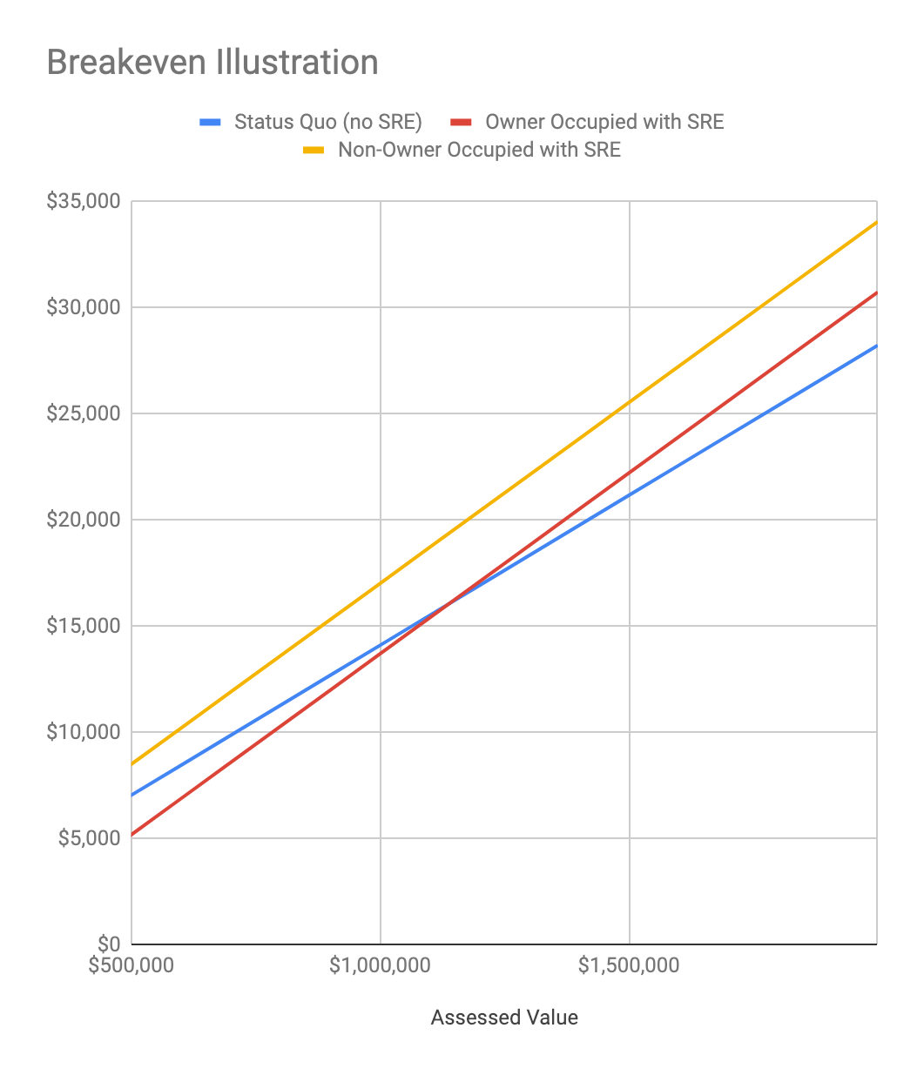

This chart is provided because the term “breakeven” often occurs in residential exemption discussions. While broader policy consideration should not focus on the breakeven point, it comes up in dialogue with taxpayers concerned about personal impacts. As indicated earlier, residential, owner-occupied parcels near the breakeven point (e.g. +/- $100,000 from $1,100,000) will experience nominal changes in taxes from the status quo, which could vary between years but should in no case be materially large, provided eligibility is verified each year. For all taxpayers, failure to verify owner occupancy could result in a substantial increase in taxes.[14]

The revenue-neutral tax burden shift is often confusing to residents. Clarification about some common misunderstandings regarding SRE may assist resident understanding:

### Misunderstanding #1. A residential exemption reduces Lexington taxes

No. The aggregate tax exemption impact is estimated and then the tax rate is increased to offset that loss exactly. The total residential class impact will essentially be unchanged. The sum of all tax relief experienced by residential parcel holders will be offset by an equal new tax burden experienced by other residential parcel holders.

### Misunderstanding #2. A residential exemption simply shifts tax burden onto apartments

It is not that simple. Two types of residential parcel holders would see an increase. First, those owning residential properties above the breakeven point would see an increase. Secondly, any parcel which is not verified as owner occupied would see an increase, whether that is the smallest piece of undeveloped land or the largest apartment building. There are a variety of parcels detailed in an earlier chapter which would experience a tax increase.

### Misunderstanding #3. A residential exemption is progressive by shifting tax burden from low price homes onto high price homes

A definition of a progressive tax from Investopedia reads:

A progressive tax is a tax that imposes a lower [tax rate](https://www.investopedia.com/terms/t/taxrate.asp) on low-income earners compared to those with a higher income, making it based on the [taxpayer's](https://www.investopedia.com/terms/t/taxpayer.asp) ability to pay.[15]

The SRE would reward those who occupy their own homes, and these asset holders are typically wealthier members of the community than those who rent. Landlords would see a significant increase in taxes, and attempt to pass those through to tenants. Moreover, Lexington condominiums may be owned by those with significant income or assets, who would see a substantial lowering of tax burden. Therefore, while the SRE may appear to be progressive when only considering homeowners, but broadly speaking is not progressive.

## Direct Consequences of SRE on Homes and Property Classes

### Owner-occupied Single Family Homes and Condominiums

The chart below is introduced as a format for evaluation of Lexington taxes as well as for comparison against benchmark communities. Based on FY2018 tax values (available in all communities), this provides a guide to understanding the impact of a SRE in Lexington, as well as in other communities. It is introduced here for Lexington to prepare the reader for comparison charts later in this section.

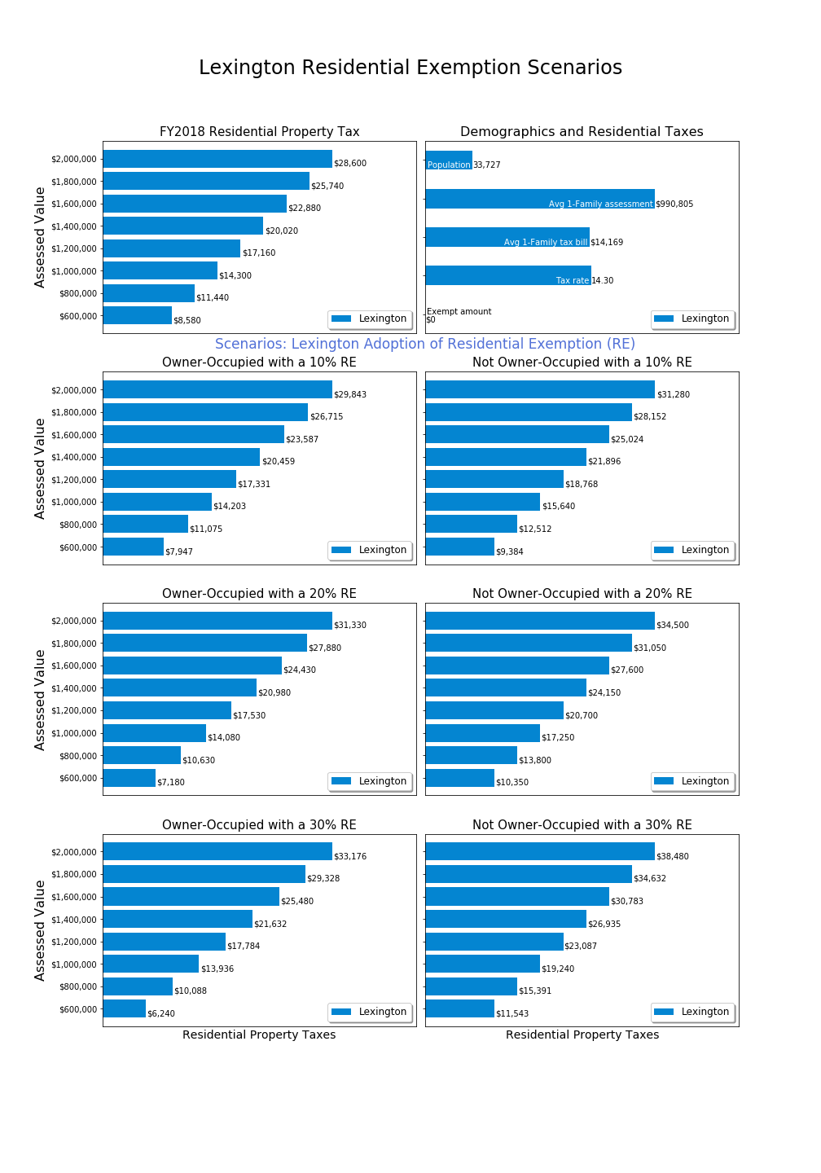

This chart series is intended to provide the status quo for FY2018 (top line) and the impact of possible residential exemption amounts on owner occupied and non owner occupied properties (chart rows 2-4).

The top left chart shows the FY2018 residential tax rate applied to properties ranging from $600,000 to $2,000,000. Each bar shows the tax amount in relative proportion with a label for the tax at each assessed value.

The top right chart shows demographic data and tax rate data useful for comparing communities. Due to lack of space, the vertical legend occurs as text within the chart. The community population is from recent census estimates. The average single family assessment is from state data and the average single family tax bill. These figures are included because different communities may have more or less expensive single family homes, so the comparison of tax rate does not provide a complete picture for understanding relative assessments. The tax rate line shows the FY2018 residential tax rate, and for those communities with a FY2018 residential exemption, the last bar “exempt amount” will show that amount. For Lexington, there is a 14.30 tax rate and $0 exemption amount for FY2018.

Rows two through four show the impact of various SRE scenarios, ranging from 10% to 30%. The illustrated percentages are intended to represent options and are not committee suggestions. For these rows, the left column shows resulting tax for owner occupied properties, and the right column shows resulting tax for non owner occupied properties.

Example: If someone owns a $1,000,000 home, we can determine from the upper left chart that their FY2018 tax would be $14,300 without a SRE. If a SRE were created at the 20% level, their property tax would be $14,080 if owner occupied (lower left) and $17,250 if not owner occupied (lower right).

### Tax Burdens Relative to Peer Communities

Adoption of a residential exemption impacts Lexington’s economic competitiveness relative to peer communities. Benchmark charts are included for 17 communities selected either for geographic proximity, similar socioeconomic status, or likely out migration within Massachusetts. Three charts are included in this chapter as examples for discussion, and the remaining charts are included in an appendix.

**Peer Community: Newton**

Newton is often cited as a socioeconomic peer with similar distance to Boston:

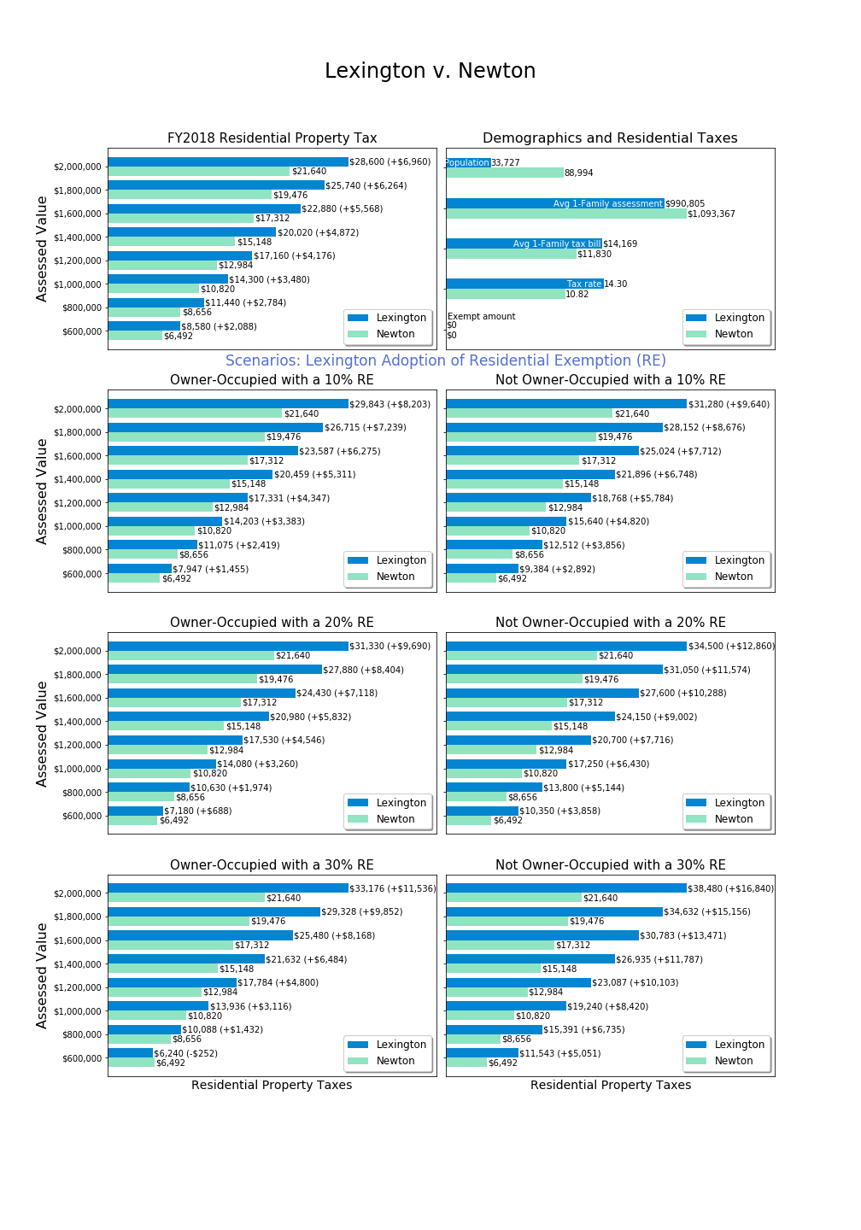

The principal difference between this chart series and the Lexington-only chart series is that two values are shown for each bar, one for Lexington (blue) and one for the comparison community (green). The difference in tax impact is shown in parentheses to assist the reader in comparing impact. Again, these charts are all for FY2018 because tax information is readily available in all communities for the completed fiscal year.

The upper right chart shows that Newton has an average single home assessment $100,000 greater than Lexington but a lower tax rate (10.82 v. 14.30), and therefore a lower average single family home tax ($11,830 v. $14,169). The result of this tax rate differential can be seen in the upper left chart which shows that a $1,000,000 property in Newton is taxed at $10,820, which is $3,480 less than a $1,000,000 property in Lexington.

Readers with an investment mindset might appreciate the $3,480 tax difference, which is a drag on the value of a $1,000,000 investment in a community. Other readers might focus on the fact that a $1,000,000 Lexington home might be nicer than a $1,000,000 Newton home, and therefore the comparison is not apples-to-apples. Because communities and housing stock are not identical, we encourage considering the differences in average single family home values and average single family tax bills when evaluating tax differentials across communities.

Next, one would consider how a residential exemption in Lexington would impact competitiveness against Newton, which currently does not have a residential exemption. Examining the hypothetical 20% SRE row, one can see that a $1,000,000 home would hardly be impacted in Lexington if owner occupied, but if not owner occupied the tax gap between Lexington and Newton would grow to $6,430. Thus, a residential exemption would have an obvious impact on retarding investment ownership and rental of Lexington homes relative to Newton homes.

Looking at the $600,000 level (condominium end of market), a 20% residential exemption would substantially reduce the tax burden relative to Newton ($688 v. $2,088 at status quo), provided the home is owner occupied. In examining newer homes at the $2,000,000 level, a 20% residential exemption would increase the tax burden relative to Newton from $6,960 today to $9,690 if owner occupied and to $12,860 if not owner occupied.

**Adjacent Community: Burlington**

Burlington is an example of a geographically proximate community where some Lexington residents have downsized to and reduced their property tax burden. Retaining residents requires Lexington policy makers to ensure that taxes and services are competitive with communities such as Burlington, Waltham, Arlington, Woburn and Bedford.

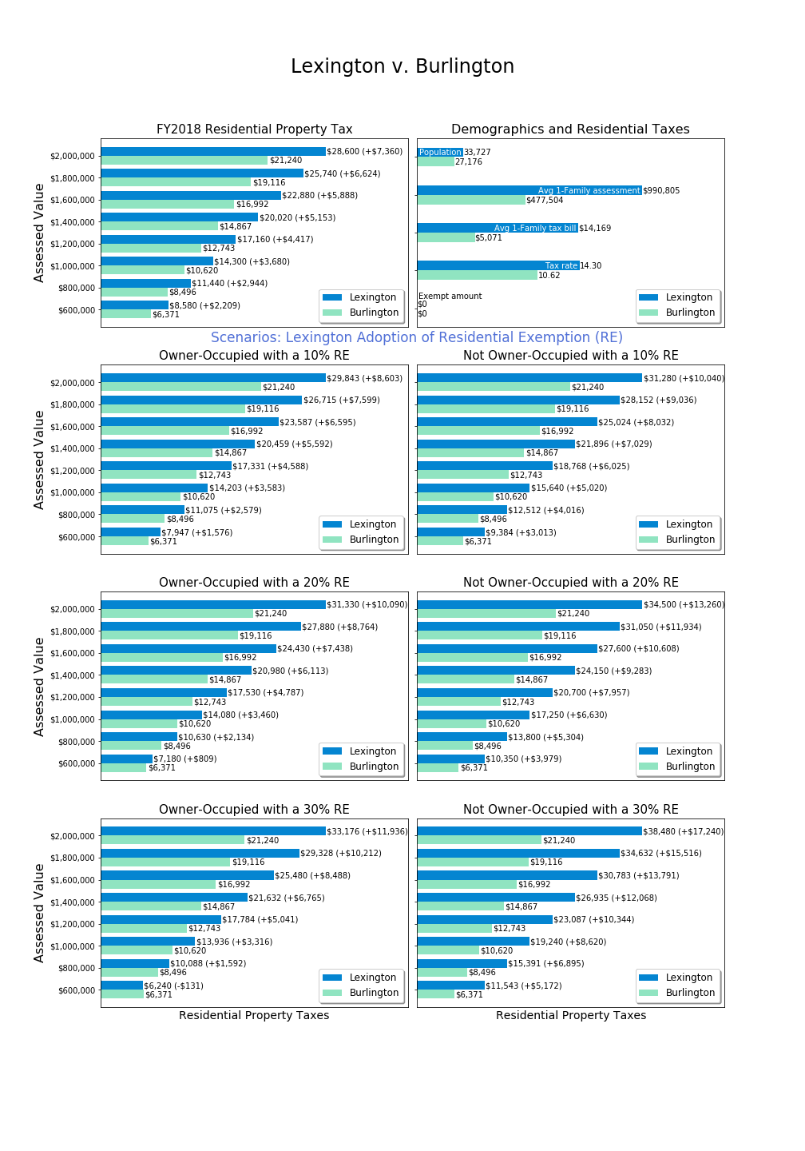

The upper right chart shows that Burlington not only has a lower tax rate than Lexington (10.62 v. 14.30 mils), but a substantially lower average single family value (at $477,504 less than half the Lexington average). The result of these two factors is that the average single family tax bill in Burlington is $5,071 compared with $14,169 in Lexington.

Starting with such disparate property values and tax bills, it becomes more difficult to evaluate the impact of a residential exemption. A wide gap exists today. A residential tax exemption could lower the tax gap for a $600,000 property, although one would continue to expect to pay less taxes in Burlington because of lower property values. Conversely, the owner of a $2,000,000 home would be further penalized relative to Burlington, and could find greater reward in shifting ownership to Burlington with lower home values and taxes.

**Migration Target: Boston**

Anecdotally, some former Lexington residents choose to downsize to condominiums or townhouses in Boston. What is the impact of a residential exemption for Lexington upon competitiveness with the Boston market?

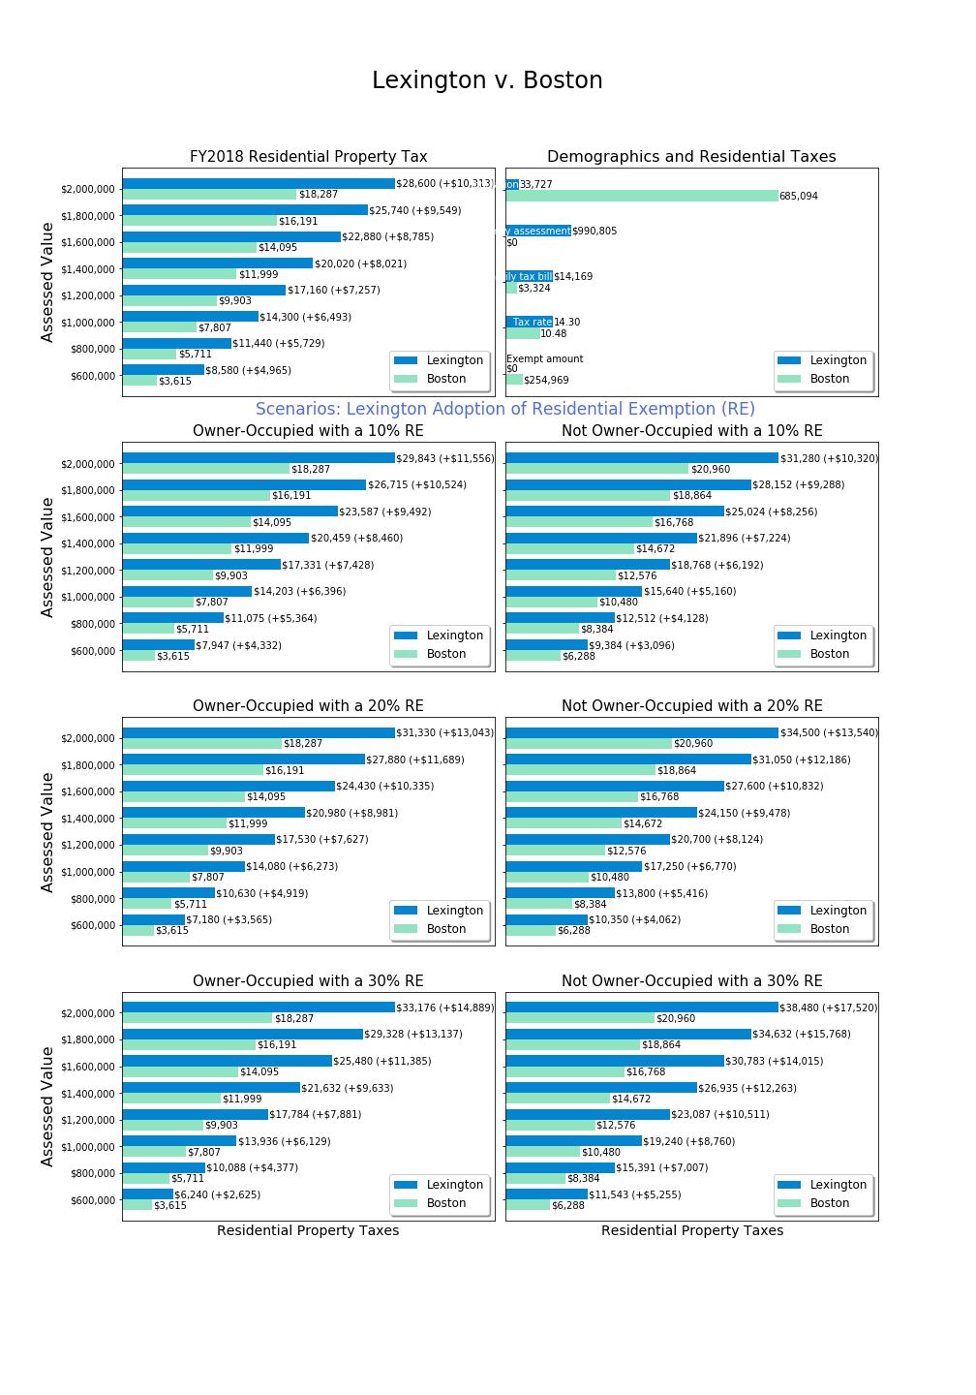

Unfortunately, the state does not provide data on the average single family assessment and tax bill for municipalities such as Boston which have a residential tax exemption.[16] The upper right chart shows that Boston’s tax rate is 10.48 (relative to 14.30 mills in Lexington), and that rate applies after an exemption of $254,969. Thus, the effective tax rate in Boston is far lower than Lexington, because as demonstrated earlier the 10.48 tax rate is the scaled up tax rate corresponding to that exemption amount. If Lexington provided an exemption of $254,969, then it’s tax rate would be about 18 mills, thus it appears that Lexington’s tax rate is effectively about 70% higher than the Boston residential tax rate.

The status quo chart (upper left) shows that for a $1,000,000 property in Lexington the taxes are $6,493 per year greater than Boston. For a $600,000 property the gap is $4,965, which is 137% greater than the Boston tax bill because the latter has a residential exemption, and therefore tax ratios do not scale linearly. For a $2,000,000 property, a Lexington taxpayer pays $10,313 more, which is only 56% more than a Boston taxpayer owning such a property.

With a 20% residential exemption, the $1,000,000 owner occupied property owner in Lexington pays $6,273 more, about the same as the status quo. If the Lexington property were not owner occupied, the gap grows to $9,443, 121% more than their Boston peer. Because a 20% SRE benefits lower value properties, the $600,000 property owner would see their relative tax burden shrink to $3,565 more, in this scenario “only” 99% more than a Boston taxpayer. But the $2,000,000 property owner would then pay $13,043 more, an increase to 71% above Boston taxpayers.

Because Boston has a residential exemption, the Boston property tax values shown in the left column assume an owner occupied home and in the right column assume a non owner occupied home. The Boston tax for a non-owner occupied $1,000,000 property is $10,480. A Lexington non-owner occupied home is today taxed at $14,300, just under $4,000 more than the Boston home. This gap is smaller than other gaps because Boston’s full tax rate applies to the non-owner occupied residence. If Lexington adopts a residential exemption, the property tax gap to Boston’s tax on non-owner occupied properties will increase as exemption levels rise.

**Non-Owner Occupied Impact**

As described earlier, residential property might not be owner occupied because it is land (low value) or operates commercially (medium to high assessed value). With SRE, non-owner occupied properties will have an experience higher tax rates which are required to absorb the impact of exemptions.

The chart below illustrates a previous table, showing the percent increase in residential property taxes which would apply to a non-owner occupied parcel, based on the residential exemption percent set by the Selectmen (zero to 35%).

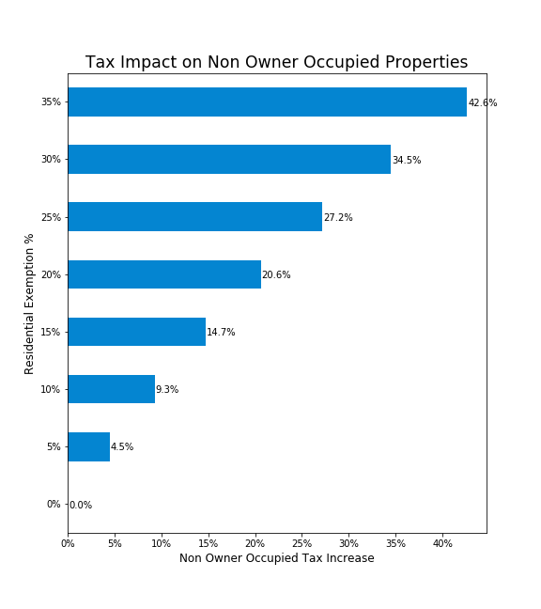

## Indirect Consequences of the State Residential Exemption

While the logistics for verification and calculation of taxes can be easily described, the committee focused on learning about the indirect and long term consequences of adopting a SRE. Little academic research appears to have been published on this topic, and therefore the committee interviewed various experts and undertook its own survey and data analysis. In this section, we will first introduce the opinions of experts which framed the committee’s analysis, and the concerns raised and ultimately conclusions reached in this area.

### Perspectives from the Lexington Real Estate Community

The Committee invited Real Estate Brokers with experience in Lexington residential real estate. Participants were Diamond Hayes (William Raveis Real Estate), Robert Cohen (Coldwell Banker), and Beth Sager (Keller Williams Realty). These subject matter experts were asked questions about property tax stress and how people make decisions to buy and sell Lexington residential property.

**Do High Lexington Property Taxes Drive Migration?**

The brokers agreed that downsizing has been the primary reason for migration from Lexington in recent history, however downsizing square footages doesn’t necessarily mean downsizing financial investment in real estate.

Brokers had a mixed view of the role of property taxes as a motivation to sell. One broker indicated that buyers who are trading up within Lexington don’t care about taxes, but for sellers who have lived in their homes for 40 years, taxes are a primary issue. Other brokers saw property taxes as secondary to the personal challenges of stairs and upkeep. Property taxes were discussed as part the overall financial picture for some senior homeowners, factoring into whether they can afford to maintain their houses. After paying their property tax, fixed income home owners may not have enough funds to maintain the home and things start to fall apart. Houses in need of much repair are more likely to become tear-downs, which present an easy exit plan.

The brokers discussed whether tax breaks, even as much as $3,000 would change the selling decisions of homeowners who are considering leaving Lexington. The brokers felt that this was not likely, and that overall, most residents here support the higher taxes. The brokers felt that the existing tax deferral program, which could improve a senior homeowner’s cash flow by the entire amount of their tax bill, is not taken advantage of by most who would qualify. They indicated that most residents do not know about the Town’s tax deferral program.

**Lexington’s House Rental market**

Brokers indicated that the Lexington house rental market is very strong, with even some high-end houses being purchased for purpose of renting them out. Some house purchases are made as an investment vehicle for foreign funds, where Lexington residential property may be seen as a stronger investment than the stock market.

Not all renters are families with children. The desirability of living in Lexington, aside from the value of the public schools, drives motivation to live here. Monthly rents of $3,5000 are typical of single family home rentals, although some rents are much higher.

All brokers agreed that any property tax increase would be passed on to renters.

**Property Tax as a Disincentive to Buy in Lexington**

The brokers had varying responses about the level of concern expressed by home purchasers regarding property taxes. All agreed that Lexington schools are the top motivating factor and that many buyers will “do whatever it takes” to make it work. One broker pointed out that for every lower priced home on the market, there are 10 to 12 potential buyers.

Home buyers looking to move from Boston or Cambridge for better schools often question the tax rate because Boston and Cambridge property taxes are significantly lower. However other towns close to Boston and Cambridge with highly regarded schools, such as Winchester, Concord, Newton, Brookline and Belmont, also have high property taxes. Property tax concerns for school-motivated buyers are mitigated by the high cost of paying private school tuition which exceeds what could be saved by moving to a town with lower property taxes and less desirable schools.

**Other Effects of the State’s Residential Exemption in Lexington**

The brokers agreed that increased taxes on higher cost houses would not change the business model for developers. Developers pay property tax on the knocked down house’s assessed value, not the value of the newly built house. The buyer is the one who pays the new, higher tax rate.

The brokers also agreed that the SRE property tax reductions at the lower end of house values would not be material enough to slow out-migration, and the increases at the higher end house values would not be material enough to discourage buying.

### Perspectives from Economists and Housing Policy Experts

The Committee invited four experts on housing policy and economics to a round table conversation which took place on October 5, 2018. The participants were Peter Enrich (Northwestern University law professor), Jonathan Haughton (Suffolk University economics professor), Chris Herbert (Managing Director Harvard University’s Joint Center for Housing Studies), and Chris Kluchman (Housing Choice Program Director, Massachusetts Housing Partnership/Department of Housing and Community Development).

The panel agreed that the intended primary effect of a Residential Exemption is a tax burden shift among homeowners, from lower valued homes onto higher valued homes and onto non-owner-occupied residential properties They noted that an underlying assumption behind this shift is that people with lower value homes also have lower incomes and experience more financial stress—exacerbated by continually increasing property taxes. However, the panel also noted that that income and property value are not perfectly correlated.

Another effect of a Residential Exemption that was discussed would be an indirect shift of some of the property tax burden onto renters, who may be a financially vulnerable, asset poor population in Lexington. Increases in the property tax on apartments and multi-family homes may create an incentive to convert rental units into condominiums, capturing more tax benefit from the residential exemption. This could reduce the size of the rental market in Lexington, depending on the size of the exemption (incentive) and the market response.

Owners of rented-out single family homes may prefer to sell the home because market conditions may not allow them to pass along the increase. Because the Lexington rental market is already very small, shrinking the rental market could increase monthly rental rates. If the goal of this Committee’s exploration is retention of financially strained current residents, panel discussion indicated that shifting more of the property tax burden onto renters could increase migration.

It was pointed out, however, that property taxes can also be viewed as a services fee—which would reasonably be passed on to renters. Lexington provides excellent services, which is part of why it remains a desirable place to live.

Panelists observed that implementation of the Residential Exemption would have implications for all facets of the housing market. An important hypothesis is that property tax changes would be capitalized into home value, increasing the property value for lower valued homes and decreasing the value of higher value homes. Capitalization can occur both because a buyer is shrewd in analyzing the impact of taxes on an asset purchase, or because a buyer has a budget and the sum of mortgage and property taxes determine the maximum amount which can be invested in a home purchase.

A first ramification of capitalization is that *future homeowners would not receive any benefit or penalty from a residential exemption*, and the effect of SRE is twice impactful to existing homeowners. For example, a typical Lexington condominium owner would be *twice blessed*: first with a property tax reduction and second with an increase in property value due to the fact that potential buyers could bid higher when a lower tax bill applies. Conversely, the owner of an expensive home would be *twice cursed*: they would face a higher tax bill and their property would be less attractive in the housing market, lowering sale price. The future home buyer confronts these higher and lower prices, respectively, and therefore would experience an investment/mortgage cost which offsets the impact of the tax policy change. *The tax policy change is a one-generation effect with no specific benefit to future homeowners*.

This first ramification is reasonably well understood, and anecdotally can be observed in Cambridge and Boston where entry level units have risen in price, reflecting their low tax rates.[17]

A second ramification was introduced by Dr. Haughton, which is that the initial capitalization would change the home price and that in turn would erode the property tax impact promised by static analysis.

Example: A condominium owner is told that their $600,000 assessed value condominium will have a decrease in property taxes from $8,580 to $7,180 (minus $1,400) with a 20% SRE. However, within a few years and full assessment valuation cycle, their $600,000 condominium has increased in value to $640,000 while more expensive properties have not increased as much or may have declined. This same homeowner sees their $7,180 tax bill increase to $7,582 due to the fact their property is now more attractive. (Ironically, they are dissatisfied about their updated property tax bill which reflects the fact that the tax policy has upgraded their home value with no effort of their own.)

Dr. Haughton developed a multi-step model and estimated that about 28% of the residential tax exemption effect would be lost due to change in property values in the opposite direction from the tax effect.[18] *For policy makers and committee members concerned about supporting Lexington residents remaining in their homes over a longer term, it is especially disconcerting to realize that a residential exemption is a double handout to existing homeowners with no documented long term benefit for future residents.*

There was a clear consensus among panel members that the State Residential Exemption is a blunt instrument, affecting the entire residential housing market in both potentially desirable and potentially undesirable ways.

None of these experts advocated adopting the State Residential Exemption to address the challenge of assisting lower income seniors with remaining in Lexington, though two panelists said they could support it being implemented at a lower level (i.e. a 10% exemption) as either a progressive tax or a symbolic consideration for passing a contemporaneous override. To address the core challenge, the guests preferred the Means Tested approach and urged increased promotion of Lexington’s Tax Deferral Program.

### Aggregate Residential and Commercial Property Value in Lexington

Under Proposition 2 ½, the total tax revenue in Lexington can not grow faster than a calculated rate[19], and the town has opted to tax at the maximum levy limit permitted by law for the last 20 years.[20] In practice, the town calculates the maximum tax levy and then proportionally assigns it to classes of property (residential, commercial, industrial, and personal) that exist within the town. Each class absorbs a proportion of the increase, but this proportion is driven by the change in assessed value for each class. Because residential properties have been appreciating in Lexington more rapidly than commercial properties, a “tax shift” occurs where residential properties in effect absorb most of the town tax increase, and therefore homeowners experience tax rate increases beyond the aggregate levy limit increase.

Adopting a residential exemption will impact home values in Lexington, but the committee has not determined whether the aggregate impact of the dynamic system would be to increase residential aggregate value or decrease residential aggregate value. Any change in aggregate value would further impact the taxes paid by each class of property. A change in aggregate value is a secondary effect and should therefore be small, but to homeowners stressed by a 5% increase, a change to 4% or 6% might be seen as psychologically material.

### Condominium Conversions

The committee and roundtable experts have not examined the factors which drive condominium conversion in detail. It could be that market forces beyond property tax policy largely drive this phenomenon. However, in observing the extent to which condominiums have replaced apartments in formerly large rental markets, one should be concerned how tax policies impact conversion.

Under a residential exemption, a two family home would have a single homeowner and at most one residential exemption. At a 20% SRE, an exemption exempts $195,000 against a revised tax rate of 17.03, saving about $3,321/year in property taxes. At a discount rate of 5%, each exemption is worth $66,417.

For a two family homeowner, conversion to a condominium should allow the capture of this $66,417 value. By itself, this might not be sufficient motivation for conversion, but when combined with other benefits it could serve as a tipping point. Inevitably some two family home owners would convert to condominiums in response, decreasing rental availability and changing Lexington demographics.

For an owner of a larger apartment building, the incentives would be materially larger. Katahdin Woods has 128 units, and if these were condominiums each one would receive a $3,321/year reduction in property taxes under a 20% exemption. Multiplied by all 128 units, this amounts to a $425,088/year reduction in taxes which discounted at 5% is a $8,500,000 benefit, which is equal to about one third of the value of Katahdin Woods itself.[21]

Significant condominium conversions may increase rental rates, change the demographics of Lexington, and further erode the benefit of a residential exemption as all residential properties have their tax rates increased to absorb these conversions.[22] The committee is concerned that direct implementation of the SRE could negatively impact Lexington’s diversity and housing goals, and even fail to provide the forecast financial benefit once second order effects occur.

### Income Profile of Winners and Losers in SRE

Those who lose most with a SRE are owners of parcels which are not owner occupied. For single family homes, we do not have detailed information profiling those owners. However, using the survey of residnets, insights can be offered about who benefits with adoption of SRE.

Using self-reported income, this chart shows the frequency distribution for homeowners:

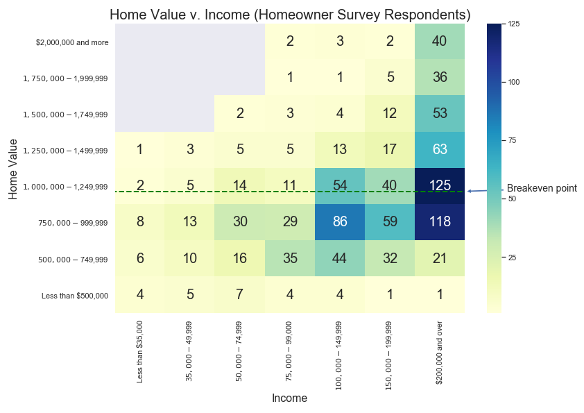

In each cell, the number represents the count of respondents who had the income and home value at the intersection shown. The coloring of the cell is simply a heatmap (bar on the far right) with darker blue colors showing more frequent occurrences.

A few observations are noteworthy:

* Below the breakeven point (about $1,000,000 for this chart), all income levels are represented and most households report incomes over $100,000.
* For those living in homes assessed below $750,000, only a minority have household incomes above $200,000, while this income level is more prevalent among higher valued homes.
* Some households live on very limited incomes (under $75,000) in homes as high as $1,749,999. Households above the breakeven point with limited income may struggle to pay increased taxes under SRE.

One might also review the ability to pay property taxes directly for homeowners versus the indirect payment of property taxes by renters. Among survey respondents, owners reported household income as follows:

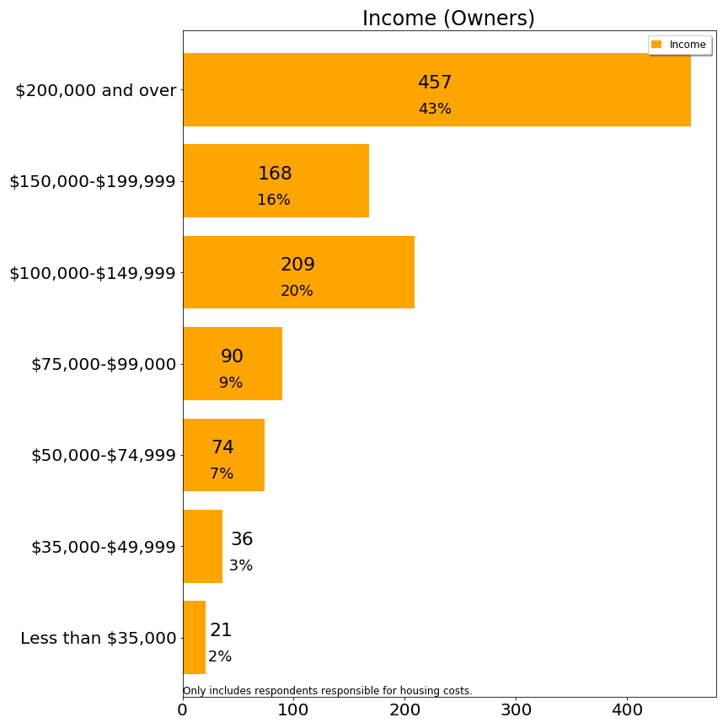

The majority of owners have household incomes above $100,000 per year.

Whereas renters reported household income as follows:

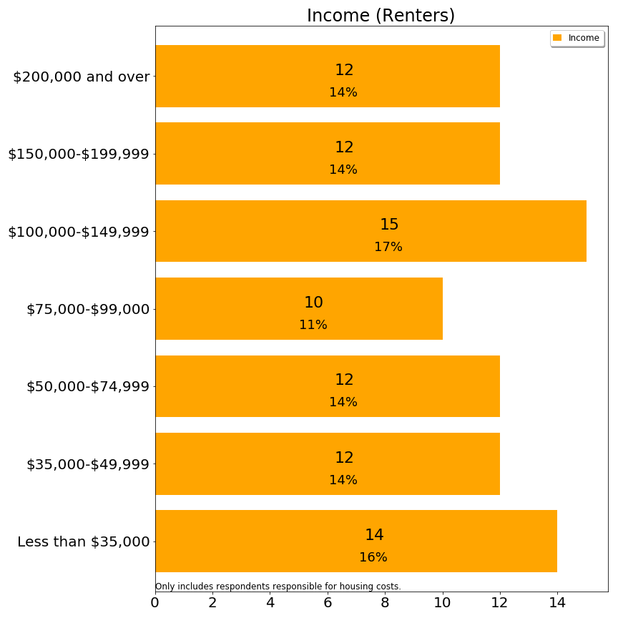

Slightly less than half of renters have household incomes above $100,000 per year. As shared earlier, renters pay far less property taxes than owners, even on a pass through basis. However, these statistics demonstrate both somewhat lower ability to pay property taxes among renters, and also that renters range the spectrum from very low to high income. The committee’s hypothesis is that some portion of increased property taxes could be passed through to renters, except for renters living in rent-controlled housing set at regional rates. However, if owners react by converting to condominiums, such change could be especially difficult for those with incomes below $75,000 (and a presumably low asset levels), a group which is 44% of renters (as compared with 12% of owners).

## 

## Residential Exemptions in Massachusetts Communities

The committee examined towns which have adopted SRE to understand their procedures and whether they are solving issues similar to Lexington. This table shows the municipalities in Massachusetts which have adopted the SRE:

|  |  |
| --- | --- |
| **City** | **Residential Exemption:**  **% of Class One** |
| Boston | 35% |
| Brookline | 20% |
| Cambridge | 30% |
| Chelsea | 27.5% |
| Everett | 25% |
| Malden | 30% |
| Somerville | 35% |
| Waltham | 25% |
| Watertown | 23% |
|  |  |
| **Town** |  |
| Barnstable | 20% |
| Nantucket | 20% |
| Provincetown | 20% |
| Somerset | 10% |
| Tisbury | 18% |
| Truro | 20% |

The first set of communities are cities, which have large rental populations. For these communities, the SRE serves the purpose of shifting tax burden from homes to apartments. Unfortunately, it may also have the effect of contributing to condo conversions, and therefore the attempt to increase taxation on apartments could backfire by reducing housing in these communities for people with few financial resources.

With the exception of Somerset, the set of towns are vacation communities on the Cape or islands, with significant numbers of absentee owners of second homes. The effect of these exemptions is to shift financial burden from the year-round owners to the seasonal owners. This shift could also have the indirect effect of giving preference to year round owners who may impose greater costs on these towns.

The committee has not found any published studies from these communities justifying a residential exemption.[23] Two municipalities have discontinue the SRE: Marlboro and Weymouth. Only anecdotal information has been gathered on the reason for these discontinuations.

## Summary

This chapter describes the process of the state residential exemption and anticipated verification. It provides a static analysis of which property owners would pay more and which would pay less, and provides three series of charts benchmarking Lexington to other communities with and without a residential exemption (further examples in the appendix).

Beyond static analysis, many issues are raised about indirect and long term effects of adopting a SRE:

* A tax shift is expected to be capitalized into home values, providing a “double impact” on existing homeowners and eliminating any economic benefit for future Lexington homeowners.
* A dynamic analysis of the property tax effect suggests that 28% of the static change would be eroded by a shift in property values. The actual impact on homeowners will be less than stated in the static analysis because properties at the lower end would inflate some amount while high end properties would suffer some deflation.
* There is speculation on whether these tax changes would be passed through to renters. In the short term, most committee members feel that landlords charge the maximum amount possible, and Lexington rates are not materially higher than neighboring communities at present. It is possible that rental rates would increase, but inconsistently.
* Over the long term the rental market might be reasonably expected to shrink with a residential exemption. Absentee landlords would be less likely to invest in Lexington real estate for investment purposes (due to differential to peer towns) and two family homes and apartment buildings would have material incentive to convert units to condominiums. Conversion to condominiums would shrink rental inventory and likely drive rental rates upwards, changing Lexington’s demographics.[24]

# Massachusetts Model Means-Tested Residential Exemption Laws

Five towns in Massachusetts have adopted a model of Residential Exemption known as a Means-Tested Residential Exemption (MTRE). Unlike the State’s Residential Exemption (SRE), which applies an exemption to a broad swath of owner-occupied residential properties without regard to the income, assets or age of the owners, MTRE’s grant property tax exemptions to seniors only, based on their income and assets. MTRE’s are subject to specified caps on house value and overall cost to the town’s budget. Most MTRE’s are revenue-neutral to the town, with the cost of the benefit redistributed among all residential taxpayers by a commensurate increase in the tax rate.[25]

The appeal of means-tested exemptions is their higher precision in targeting residents in need of assistance. Such targeting reduces the broader housing market impacts of the residential exemption, and creates more modest tax shifts.

Sudbury created the first model means-tested exemption, which has its main elements copied by Concord, Reading, and Hopkinton (see table, below, with distinguishing details among these models). Under the “Sudbury model”, a taxpayer who is 65 or more years old, possessing home and asset values below a modest level, and at least ten years residency could receive a property tax reduction calculated to bring their tax level down to 10% of their income.

Wayland has adopted a second type of means-tested Residential Exemption. Under Wayland’s MTRE version, homeowners who meet the Circuit Breaker’s eligibility criteria (see second table below) receive a match of up to a 100% of the state circuit breaker limit (presently $1100), provided the amount does not reduce their property tax bill to below ten percent of their income. Reading’s version of this model provides a benefit that is between 50% and 200% of the Circuit Breaker Benefit.

## Massachusetts Model Means-Tested Exemption Laws

|  |  |  |  |  |  |
| --- | --- | --- | --- | --- | --- |
|  | **Sudbury** | **Concord** | **Reading** | **Hopkinton** | **Wayland**  **“Circuit Breaker Matching”** |
| Income Limit | Per Circuit Breaker | Per Circuit Breaker | Per Circuit Breaker | Per Circuit Breaker | Per Circuit Breaker |
| Asset Limit | “Excessive” | “Excessive” | “Excessive” | “Excessive” | No test |
| Age | Per Circuit Breaker | Per Circuit Breaker | Per Circuit Breaker | Single 65+, joint 60+ allowed | Per Circuit Breaker |
| House Value | Average Single Family Home (SFH) +10% | < Median SFH | Per Circuit Breaker | Per Circuit Breaker | Per Circuit Breaker |
| Residency | 10 year consecutive | 10 year consecutive | 10 year consecutive | 10 year consecutive | 10 year consecutive |
| Benefit | Exemption of the amount that property tax exceeds 10% of income, less the amount that the homeowner qualified for under the Circuit Breaker income limits. | Exemption of the amount that property tax exceeds 10% of income, less the amount that the homeowner qualified for under the Circuit Breaker income limits. | 50% to 200% of the amount that the homeowner qualified for under the Circuit Breaker | Set annually by Selectmen- benefit is 50% to 200% of State Circuit Breaker | Up to 100% match of the Circuit Breaker |
| Min Property Tax | 50% | 50% |  | 50% | none |
| Benefit Cost Cap | Maximum total of benefits is .5 to 1 % of levy, pre rate-setting per Selectmen | Maximum total of benefits is .5 to 1 % of levy, pre rate-setting per Selectmen |  |  | none |
| If cap exceeded | Income percentage criteria is increased until the designated amount is matched | Income percentage criteria is increased until the designated amount is matched |  |  |  |
| Who funds? | Residential reallocation | Residential reallocation | Residential reallocation | Residential reallocation | Overlay Account |

**Massachusetts Circuit Breaker Parameters, 2018 Tax Year**

|  |  |
| --- | --- |
| Income Limit | Single: $58,000.  Head of Household: $73,000.  Married, filing jointly: $88,000. |
| House Value Limit | $778,000. |
| Maximum Credit Given | $1,100. |

## 

## Adoption

Creating a MTRE requires a town to write a home rule petition asking for state approval. Because the Committee was inclined towards action, our initial intent was to select an optimal match for Lexington from among the existing models. However, as we delved deeper, we discovered that assessors were dissatisfied with the ambiguity of adopted legislation, and it was not clear that these other models would function exactly as desired for Lexington. The next section provides additional details about existing implementations, while the following section proposes possible models for Lexington.

## Limits on Exemption Efficacy

As the Committee learned more about MTREs as implemented elsewhere, we encountered evidence that both the SRE and MTREs could cost a municipality money which would then be offset by reduced state aid to local residents. For example, an individual in Lexington may receive a $1100 income tax rebate each year due to the Circuit Breaker, because their property taxes exceed 10% of their income and their income level qualified. However, if Lexington adopted a tax exemption which reduced their property taxes by $1500, pushing the individual’s tax-to-income ratio below 10%, their state income tax rebate from the Circuit Breaker would be reduced to zero. Thus, the taxpayer would only net gain $400 of the $1500 provided by Lexington. In discussing the MTRE with the implementation expert in the Wayland Assessor’s Office, it was confirmed that several taxpayers receive a Wayland Circuit Breaker match on an every-other-year basis, as the local funds not only displace the State funds, but in fact make the taxpayer ineligible for local reduction on an alternating year basis. Thus, legislation could reduce predictable cash flows for residents and cost the town money which serves no net benefit for residents.

## Funding

A MTRE can be funded by reallocation to the residential property tax class (as the SRE does), to all property tax classes, or funded via an overlay account within the tax levy. Because MTREs typically require less than 1% of a town’s revenue, either approach might prove practical. As the MTRE comparison chart above demonstrates, communities following the Sudbury model have funded their exemptions by increasing the residential tax rate, while Wayland funds from an overlay account.

## An Assessor’s Perspective on Means-Tested Residential Exemptions

Lane Partridge, the Concord Assessor and the Chair of the Massachusetts Assessor’s Association, met with the Committee on November 16, 2018 to share Concord’s experience with the implementation of Special Legislation that granted Concord their own version of a Means-Tested Residential Exemption.

The Concord law is based on Sudbury’s means-tested exemption with the exception of capping Concord’s eligible house value at the town’s median single family occupancy (SFO) value rather than the *average* SFO plus 10% limit utilized in Sudbury. Otherwise, both Concord and Sudbury’s eligibility parameters match those of the State Senior Circuit Breaker Property Tax Credit.

The first year of Concord’s implementation was FY 2018, which is based on income and property data from Calendar Year 2017.

### Implementation Issues Experienced by Concord

Some Committee members felt means-tested exemptions would depend on adjusted gross income (AGI) reported on one’s state tax return, and would therefore fairly easily calculated. Instead, the Circuit Breaker application and Massachusetts models use the Circuit Breaker income worksheet--which adds Social Security and other distributions not taxed on the State tax return. The Concord assessor hired a CPA to assist their office in understanding the Circuit Breaker process. In their experience, taxpayers routinely make errors in filling out these complex worksheets, and the assessor’s office has a duty to review each application for accuracy, which is a time consuming process.

As with other means-tested exemptions, asset limits are not specified by Concord’s law. Instead, the law gives the Concord Board of Assessors the authority to set the policy on other assets. The Concord assessors exclude applicants with more than $250,000 in additional assets. The assessor shared with the committee that external asset testing was made difficult by the lack of accurate reporting by applicants. The Concord assessor specifically highlighted that the population a means-tested exemption is designed to target may have lower levels of financial literacy and an inability to self-assess eligibility or provide accurate information to an assessor without further support.

In the end, a large effort on the part of Concord assessment staff was required in year one to provide a small number of property tax exemptions. While 250 Concord residents were approved for the state Circuit Breaker in 2017, only 59 applied for the Concord MTRE. The assessor indicated that multiple announcements and mailings had been distributed, so their office believed most eligible residents had been notified, and they hypothesized that the $250,000 asset limit had discouraged many applications. Of the 59 applicants, only 49 were approved in FY2018. Thus, the Concord effort reaches only 20% of circuit breaker applicants, and provides a benchmark should Lexington adopt similar provisions.

## Perspectives from Economists and Housing Policy Experts

As referenced in the SRE section of this report, the Committee invited a panel of four experts on housing policy and economics to a round table conversation on October 5, 2018. The panel noted that MTREs differ from the SRE in that the benefit is based on the taxpayer’s need rather than on the value of the taxpayer’s property. It benefits a smaller, but more targeted group of beneficiaries and, unlike the SRE, it doesn’t have as significant unintended effect of impacting home values. The MTRE approach can assist lower income seniors at thresholds determined by Lexington itself.

The panel described a few drawbacks of existing MTREs as well. One is that the ten year residency requirement in place in some communities may violate federal standards on mobility. (A second issue with this residency requirement was voiced at the Lexington public hearing, which is that a long residency requirement might have the unintended side-effect of promoting Lexington’s existing racial and ethnic demographic over groups outside Lexington.) On the other hand, a residency requirement can satisfy taxpayers that an exemption intended to help residents struggling to remain in their homes would not be consumed by newcomers who might deliberately purchase properties calculated to take advantage of these programs.

Panel members also discussed the Lexington Tax Deferral program as an important property tax relief tool that seems to be an under-utilized program. The panel felt that effort spent on educating residents about and promoting this program might be the most effective approach for assisting lower income senior residents.

## Summary

In short, the committee examined existing means-tested residential exemptions (MTRE). The direct consequences of these programs were not always efficient, with local tax reductions offsetting the state circuit breaker. These discussions made the committee aware that *even the SRE would result in fewer state circuit breaker deductions*, another example of how local exemption dollars could fail to land in the hands of local taxpayers and relieve tax burden.

The committee felt that none of the existing programs was ready for direct duplication, nor was an easy best-of-breed legislation approach possible. Assessors and staff interviewed shared that they had wished their committees had studied legal provisions in detail before adopting legislation. Therefore, the committee undertook to provide broad outlines to legislation which could be crated for Lexington, a subject to which we next turn.

# Lexington Means-Tested Exemption Proposals

A straw poll found the committee had mixed reactions to the SRE but were generally enthusiastic about Lexington adopting a variant of a means-tested residential exemption. The committee also recognized that existing means-tested legislation have acknowledged gaps or flaws, and with the opportunity to draft a specific Lexington home rule petition set about attempting to do so. A first obstacle was that the committee does not have a specific charge for which segment of the population should be assisted, and opinions varied about who should be helped. Should a Lexington proposal help lower income or house poor? Should it help the homeowner or the renter? Should it treat the long term resident the same as the newcomer?

After initial research, the committee proposed two “types” of exemption proposals, and recognized that it does not make sense to draft detailed legislation without clear community support for a particular purpose. The committee provided the Selectmen an interim update in January 2019, and based on their input have decided to outline these two types of exemptions but not draft legislation. Therefore, this chapter is not intended to be a comprehensive blueprint or legislative draft, and it will require community participation to determine a course of action and then additional work from a future body to evaluate and propose the details of the final legislation.

This chapter will first review the eligibility criteria found in typical means-tested proposals, and share what the committee has learned or recommends in each area. Then the chapter will describe two types of proposals: one proposal focused principally on residents with limited means and a second focused primarily on residents who have reached a certain age.

Finally, it should be noted that an expedient path is for the Lexington Selectmen to lobby for changes in state legislation. The existing Massachusetts circuit breaker could be changed to expand eligibility to Lexington residents who need financial assistance but live in homes above the circuit breaker cutoff. The maximum amount of the circuit breaker could be increased to be more in line with typical property tax payments. Finally the state legislature should ensure legal support for residents to take advantage of tax deferrals.

## Lexington Proposals

Many considerations impacted the design of possible proposals. Here we outline rationales which informed the committee in construction of proposals. Following the rationales, two proposals are introduced and evaluated against criteria.

## Rationales for Eligibility

**Age:** With an aging population that is staying health longer and retiring later, using age 65 as an age cutoff has the unfortunate effect of making so many residents eligible that levels of financial assistance become diminished. It makes sense to start financial assistance at age 70 or later to balance the desire to provide assistance with the number of individuals who may feel that their age justifies assistance. As an individual ages further beyond 70, access to new sources of income may diminish due to declines in physical mobility and intellectual agility.

**Home Value:** Capping eligibility based on the *median* Lexington home value may make political sense, so taxpayers are not subsidizing those who choose to remain in better than median homes.

**Asset Level:** Households with material asset bases may be reasonably expected to tap into those asset bases before receiving a town subsidy. We may reasonably expect younger retirees to require more assets than older retirees because it is assumed that their assets will have to last them for a longer period of time. However it is not clear that this would require applying higher thresholds for younger retirees. Maintaining a consistent asset level across ages would have the effect of providing more relief for senior retirees and less to younger retirees who should have a larger asset base.

**Income Level:** Combined with assets, lower income is commonly thought to represent need. However, with the advent of Roth IRAs which do not have required minimum distributions (RMDs) of IRAs, households may be able to better control the years in which they receive income and through financial planning create evidence of a need for financial subsidy. Therefore, income cannot be the only means-testing criterion. We have also learned that the Circuit Breaker income formula includes non-taxable sources of income, and therefore it also seems important to follow that pattern rather than using adjusted gross income (AGI) from a tax return.

**Ownership:** The guiding principle is property tax relief, so the notion advanced is that someone paying property taxes is (by definition) an owner and would be the one receiving relief. Therefore these criteria collectively focus on access to income and assets for a beneficial owner(s). This also avoids a “rent-a-senior” situation where a senior citizen participates in the household specifically to provide relief for an otherwise unqualified owner. The committee also discussed whether Lexington should follow the state Circuit Breaker pattern in providing tax relief to renters as well. From the Wayland assessor’s office we learned that providing financial assistance to renters involves assisting a resident which has no direct property tax to rebate or refund, and at best imputing taxes which are not paid by the individual. Therefore the committee does not recommend directly undertaking *property tax relief* for renters (despite survey evidence indicating significant housing stress).

**Residency Length in Lexington:** An argument for longer residency requirements is to benefit those individuals who have already “paid into” the local tax system and are not simply moving into town for a tax break, while an argument to waive residency requirements was a concern raised by Peter Enrich that such requirements might violate mobility guidelines in federal law. Towns with existing means tested exemptions have residency requirements. The Committee feels that a 5 year residency requirement is a compromise between paying into the system and yet maintaining openness and support for newcomers. Proposed legislation should specifically address whether the length of residency is additionally restricted as contiguous or recent.

## Rationales for Benefits

**Materiality:** Benefits should be material enough to have an appreciable effect on the beneficiary’s financial decisions. A program with immaterial benefits and significant administrative costs makes no sense.

**Supplemental:** The benefits received should be assumed to accompany other remedies and breaks available to a household, such as the State circuit breaker and Lexington’s tax deferral program. Lexington’s proposal should avoid displacing other financial assistance available to the homeowner, and instead be crafted to add to existing financial supports.

**Justifiability to other residents:** The survey indicates that a large part of the population has difficulty with housing costs, so any benefits should be justifiable even to another resident struggling with housing and not receiving a benefit.

**Targeted:** Benefits should be targeted to individuals with demonstrated need.

**Housing Price Impact:** Benefits should be designed so that they attach to the individual rather than the property, and thereby avoid adding material distortion to housing prices.

**Financial cliffs:** Critics of existing state and local policies point to financial cliffs, causing a household slightly above a criteria to lose all financial assistance. Legislation should provide smoothing as possible, yet avoid excessive complexity.

**Predictability:** Total benefits offered to a household should be relatively consistent from year to year, avoiding every-other year effects or other oscillations due to interactions with other systems.

**Widow-Protection:** The benefit system should avoid penalizing those who become widowed. (Existing systems tend to lower income and asset thresholds upon death of a partner, and fail to reflect that many household costs continue beyond that event.)

**Understandability:** Taxpayers and beneficiaries should be able to comprehend the benefit system being proposed.

**Flexibility for Government:** In asking the state for a home rule petition, the guidelines should be constrained enough that a future generation cannot easily expand the scope or benefit of the program beyond its original intent. However, as benefits are indexed to other legislation (such as the state Circuit Breaker), enough flexibility should exist that town government can respond when material changes occur to demographics or to related legislation (such as the Circuit Breaker being rescinded).

**Flexibility for Individuals:** Avoid restrictions that impose undue burdens for beneficiaries who seek to relocate within Lexington or remodel their home, especially for home modifications which allow homeowners to age in place.

**Impacts on Town Budget:** The beneficiary pool should be small enough that material support to targeted individuals could be absorbed with a relatively small impact among non-beneficiary taxpayers or within the town’s annual budget.

## Proposal #1: Circuit Breaker Style Means-Tested Exemption

This proposal was developed with the intent of reflecting the goals of other MTREs while adjusting for limitations such as addressing needs of widows and avoiding local tax rebates which result in reduced state circuit breaker and therefore are wasteful uses of local funds.

**Goal:** Provide material assistance to seniors with demonstrated financial need as a supplement to existing vehicles (circuit breaker, deferral, etc.). The objective is to lower a household’s property tax contribution closer to 15% of income for those households experiencing high levels of property tax stress.

**Eligibility:**

*Age:* 70+ years

*Owner: Oldest owner of household, with 50%+ beneficial ownership*

*Residency:* 5 years, with 2 continuous

*Home Value:* At or below median class one residential property

*Asset level[26]:* A multiple of the maximum income threshold on the state circuit breaker (currently joint income) between 1.0 and 5.0. The maximum asset level multiplier is set by the Selectmen annually, and is an identical figure for all households independent of filing or marital status.

*Income level:* Use the joint married state circuit breaker to calculate (note below how the benefits are factored).

**Benefits**

*Home owners:*

For households with assessed value at or below the state Circuit Breaker maximum level:

* Households with income below the individual threshold (currently $58,000) can receive up to N times the circuit breaker value. Selectmen set the value of this circuit breaker multiple annually, to be between 1.0 and 3.0. The multiple of the state circuit breaker is the planned reduction in an individual’s property tax bill, provided the reduction in addition to the individual’s prior year state circuit breaker, does not depress property tax to income ratio below 15%, and in the event this would occur, the benefit is adjusted downward to the figure which matches 15%.
* To reduce the financial cliff effect, households with income above the individual threshold but below the joint threshold (currently $88,000) would receive 1.0 times the state circuit breaker as a property tax reduction, provided the reduction in addition to the individual’s prior year state circuit breaker, does not depress property tax to income ratio below 15%, and in the event this would occur, the benefit is adjusted downward to the figure which matches 15%.
* For households with assessed property value above the state Circuit Breaker maximum but below the town median: The same 1.0 level benefit is proposed as for those who are at or below the state circuit breaker maximum. (In effect, the town benefit extends to the town median residential value when that value is above the state circuit breaker limit.) These households would receive the full circuit breaker amount rather than a multiple of it, but provided by the town.

*Renters:*

* No benefit

**Annual Action by Selectmen:**

* Determine the maximum asset threshold by setting asset multiple of joint income to a figure between 1.0 and 5.0
* Determine maximum Circuit Breaker multiple, by setting this figure between 1.0 and 3.0, for households meeting all criteria with total income below the individual threshold of the state circuit breaker.

**Funding:** Levy or tax rate adjustment

**Estimate of Financial Impact:**

Estimate 450 circuit breaker households

Estimate 50% meet asset criteria:

225 recipients

Estimate that 1.15 times circuit breaker is average benefit received (due to 15% threshold, and income thresholding applied):

225 * 1.15 * $1100 = $284,625

Further,

Estimate 350 households would meet circuit breaker income criteria but do not meet market value criteria due to $778,000 cap, but would have a home between that value and the Lexington median assessed value ($950,000).

Estimate 40% meet asset criteria:

140 recipients

Estimate that 1.15 times circuit breaker is received:

140 * 1.15 * $1100 = $177,100

**Total cost to town: $467,725**

**Total beneficiary households: 365**

**Average benefit/household: $1,265**

## 

## Proposal #2: Octogenarian Means-Tested Tax Exemption

This proposal was developed in response to a concenr voiced in the committee’s second public hearing about meeting the needs of superannuated seniors. Existing tax policies do little for an aging population and do not seem to reflect the needs of those who live beyond traditional life expectancy. It seems that Lexington and Massachusetts could provide more support for this population which uses few public services at little net cost to taxpayers.

**Goal:** Life expectancy in Middlesex County, Massachusetts is 80 years. Residents who outlive life expectancy may struggle to balance retirement savings and asset levels with increasing and unpredictable property taxes. The guiding principle for this proposal is to reduce housing stress by substantially retarding increases in residential property taxes for residents upon reaching age 80, while providing the flexibility for individuals to move within Lexington.

**Eligibility:**

*Age:* 80+ years old

*Owner:* Oldest owner of household, with 50%+ beneficial ownership

*Residency:* 5 years, with 2 continuous residency and ownership

*Home Value:* At or below median home

*Asset level:* A multiple of the maximum income threshold on the state Circuit Breaker (currently joint income) between 1.0 and 5.0. The asset multiplier is set by the Selectmen annually, and is an identical figure for all households independent of filing or marital status.[27]

*Income level:* multiple of the maximum income threshold on the state circuit breaker (currently joint income) between 0.7 and 1.2. The income multiplier is set by the Selectmen annually, and is an identical figure for all households independent of filing or marital status.

**Benefit:** Two types of benefits were discussed by the committee. One based on an index factor is straightforward to calculate but does not ensure that taxes are frozen. Another would be to *freeze property tax contribution amounts*, but then include provisions for intra-town mobility, material reassessment, remodeling, etc. In this section, we estimate financial impact using an index factor method.

Calculate the “Index Factor” (IF) as follows:

IF = (Oldest owner age - 79) * .03

Property tax reduction = IF * property taxes

*Examples:*

80 year old owner: 3% reduction

85 year old owner: 18% reduction

90 year old owner: 33% reduction

95 year old owner: 48% reduction

**Annual Action by Selectmen:**

* Set maximum asset level multiplier
* Set maximum income level multiplier

**Town perspective:** A medium-sized adjustment would occur in the year of implementation, but in subsequent years it would appear as if the tax increases were not landing on 80+ year olds with modest or medium means. Younger age-range households would absorb slightly higher tax increases to offset. If the program retains more octogenarian seniors or life expectancies increase, then reduced town expenses due to lack of use of public schools by the 80+ population will largely offset further rebate increases to octogenerians. If the program does not impact migration patterns, then only a nominal financial impact would occur after the initial small adjustment.

**Household perspective:** Because property taxes increase 3-5% per year, these scaled increases would have the effect of keeping property taxes relatively stable for a household after its oldest owner reaches age 80. In the year of implementation, some households would see a large drop in property taxes, which could even be more than 30%. But in future years, households with an owner aged 80+ years would no longer see property tax bills with cumulative and material increases from year to year. This would give octogenarians comfort when aging in place. (Tax deferral should remain an option as well.)

**Funding:** Tax Shift across all classes of property.

**Analysis of Financial Impact:**

Using town address list (see table on the following page):

2,031 Lexington residents age 80+

547 are in Brookhaven or other non-residential property

1,484 are possible owners and renters, and occupy 1,128 distinct addresses

Taking the oldest householder at each address, we calculate the mean age as 85.8 and the mean benefit at 20.5%.

Assume the Selectmen set the asset ratio of 5.0, for a max asset level of 5.0 * $88,000 = $440,000, and set the maximum income ratio of 1.0 for 1.0 * $88,000 = $88,000.

We may estimate that 65% of households would meet the requirements of residency length, maximum home value, maximum asset level, maximum income, and are owner occupied.

733 Households = 1,128 * 65%

FY2018 average home assessment $918,772.

Assume avg 80+ year old lives in home with 80% of average assessment, then average 80+ year old home assessment: $735,018.

FY2018 average tax bill would be: $10,511.

With 20.5% reduction, average reduction: $2,155.

733 households * $2,155 per household = $1,579,398 total cost to Lexington

**Total cost to town: $1,579,398**

**Total beneficiary households: 733**

**Average benefit/household: $2,155**

**Number of 80 Year Olds Known Non-Owners Living in Lexington’s Residential Zoned Property (2018)**

|  |  |
| --- | --- |
| **Address** | **Count** |
| Brookhaven (1010 Waltham Street) | 297 |
| 10 Pelham Road | 90 |
| William Roger Greeley Village | 50 |
| 178 Lowell Street | 30 |
| 30 Watertown Street | 28 |
| Main Campus Drive | 27 |
| 840 Emerson Gardens | 19 |
| Katahdin Drive | 6 |
| **Total** | **547** |

This table identifies residences where 80+ year old residents currently reside. Most of these locations are either senior housing, rental, or property which is not owner occupied.

## Property Tax Freeze Models in other States

While Massachusetts has modest programs to assist senior citizens, some states have more robust programs to protect seniors against property tax increases. While none of these models should be directly transferred to Lexington, they are cited as evidence that creating an age-based program which targets the elder population may have merit. Lexington could promote such a program at the state level, or it could adopt its own home rule petition and create an opportunity for other communities to follow.

The following chart compares potential models for tax freezes from New Jersey, Texas, and Tennessee. The age eligibility for all three starts at 65, and New Jersey and Tennessee have income limits. In New Jersey, the difference in dollars from the first year is reimbursed, while in Texas and Tennessee, the rate is frozen at the first qualifying year. Frozen tax levels are adjusted if home improvements occur.

|  |  |  |  |
| --- | --- | --- | --- |
|  | **New Jersey** | **Texas** | **Tennessee** |
| Age | 65+ | 65+ | 65+ |
| Other Eligibility Requirements | Lived there for 10+ years, income less than ~$87,000 (2017) | n/a | Income below threshold (~$29,000-$52,000 depending on county) |
| Benefits | Taxpayer reimbursed by state for property tax levels above amount paid in first qualifying year. | Property tax amount set in first qualifying year. | Property tax set in first qualifying year. |

## Evaluation

While the Committee charge does not explicitly state Lexington’s elderly as its focal subpopulation, the particular circumstance of retired, potentially less-mobile community members who purchased their homes when residential property taxes were a fraction of the current rates is a concern of this Committee and of community members who have communicated to us over the course of the past year. Testimony by particular individuals highlights how vulnerable this population can be, motivating creation of Proposal #2 above.

Although a committee concern, we must highlight that Lexington survey data does not lend support to the notion that the elderly experience greater housing stress than other age categories, nor that they are more likely to migrate away from Lexington. The Committee’s decision to focus on this age cohort instead reflects our view that these residents are less able to migrate or gain employment when financially strained, use relatively few town services, and deserve some predictability in financial expenses. For that reason, both proposals contain age thresholds.

For potential beneficiaries, the primary differences between these two proposals are that Proposal 2 restricts benefits an older group of “super-seniors” than does Proposal 1 and that Proposal 2 provides a larger benefit, which continues to increase with age.

For cost and implementation considerations, the number of beneficiaries and cost would be much larger under Proposal 2. Implementation costs are likely to scale with number of applicants. To fund Proposal 2, in particular, a redistribution of costs among younger and wealthier residents would be necessary. These other residents may not wish to fund their elderly neighbor’s home assets--value that would likely pass on to heirs. Some degree of participation in the property tax deferment program could be added as a requirement to mitigate this issue.

|  |  |  |
| --- | --- | --- |
|  | Means-Tested RE | Age-and-Means Tested RE |
| **Property Tax Related** **Housing Stress**: Precision | Fair precision if objective is helping those with limited means | High precision if objective is helping 80+ year olds |
| **Property Tax Related Housing Stress**: Recall | Low recall if goal is to relieve housing stress across community | Recall high for 80+ year olds with limited income |
| Total budgetary impact - Lexington budget | None | Possible reduction in aggregate demand for schooling, but less than size of tax shift to occur. |
| Short term Housing Market Impact (Prices / Rents) | None | None |
| Optimal Allocation of Housing (& flexibility for future) - who’s in it and ownership assumption, condoizing, tear down | None | Goal to support 80+ in home may reduce optimal allocation of housing |
| Equitable Taxation | Small | Debatable |
| **Migration** | ? | ? |

# 

# Conclusions and Recommendations

The committee has appreciated the opportunity to dig deeply into the subject of residential exemptions, an area which has relevance to Lexington’s long term success as a community. We have been privileged to have the time to interview many subject matter experts, conduct a detailed survey, and talk to assessors, policy makers and numerous residents. Through this process, we have learned that many Lexington residents are concerned about local taxes, and yet there is widespread support for figuring out the right course of action.

While the committee has debated the state residential exemption at length, and only a minority can support it, the committee can agree on a set of policy recommendations which may serve the needs of the community. Unfortunately, acting on these recommendations will take time, and some committee members are concerned that not all residents have time for long processes. Therefore we urge the Selectmen to take up these items quickly.

## Recommendations

1. Tax Deferrals
2. In Lexington, evaluate the impact of the income limits on use of deferrals.
3. In Lexington, evaluate the interest rate to determine whether it can be set at a cost-neutral figure
4. In Lexington, evaluate how expanded use of deferrals would impact Leixngton’s bond rating status.
5. With the Massachusetts legislature, lobby for legal changes to ensure that local residents with mortgages and home equity loans can have increased access to deferrals.

2. Massachusetts Circuit Breaker

1. With the Massachusetts legislature, lobby for:
   1. Increasing the maximum home assessment which is eligible
   2. Increasing the maximum amount which may be rebated to an applicant
   3. Using a higher income threshold for widowed individuals

3. Residential Exemptions

1. Do not adopt the Massachusetts Residential Exemption
2. Through community conversation, determine whether the community should move forward with a means-tested or age-based residential exemption.[28]

4. Octogenerian population

1. Further study the financial needs and supports required for Lexington’s superannuated population. Are there programs which could be provided to facilitate remaining in their own homes? What portion of this population wants to access a tax deferral or work program and cannot? What other programs are penalizing widows in this population and should be changed?

5. Migration and Satisfaction

1. Benchmark Lexington out-migration against peer communities
2. Further understand why out-migration for middle-aged residents stands out relative to the older population in survey responses.
3. Determine what actions are required to retain residents without children in schools.

# Appendix: Property Tax Benchmark Charts

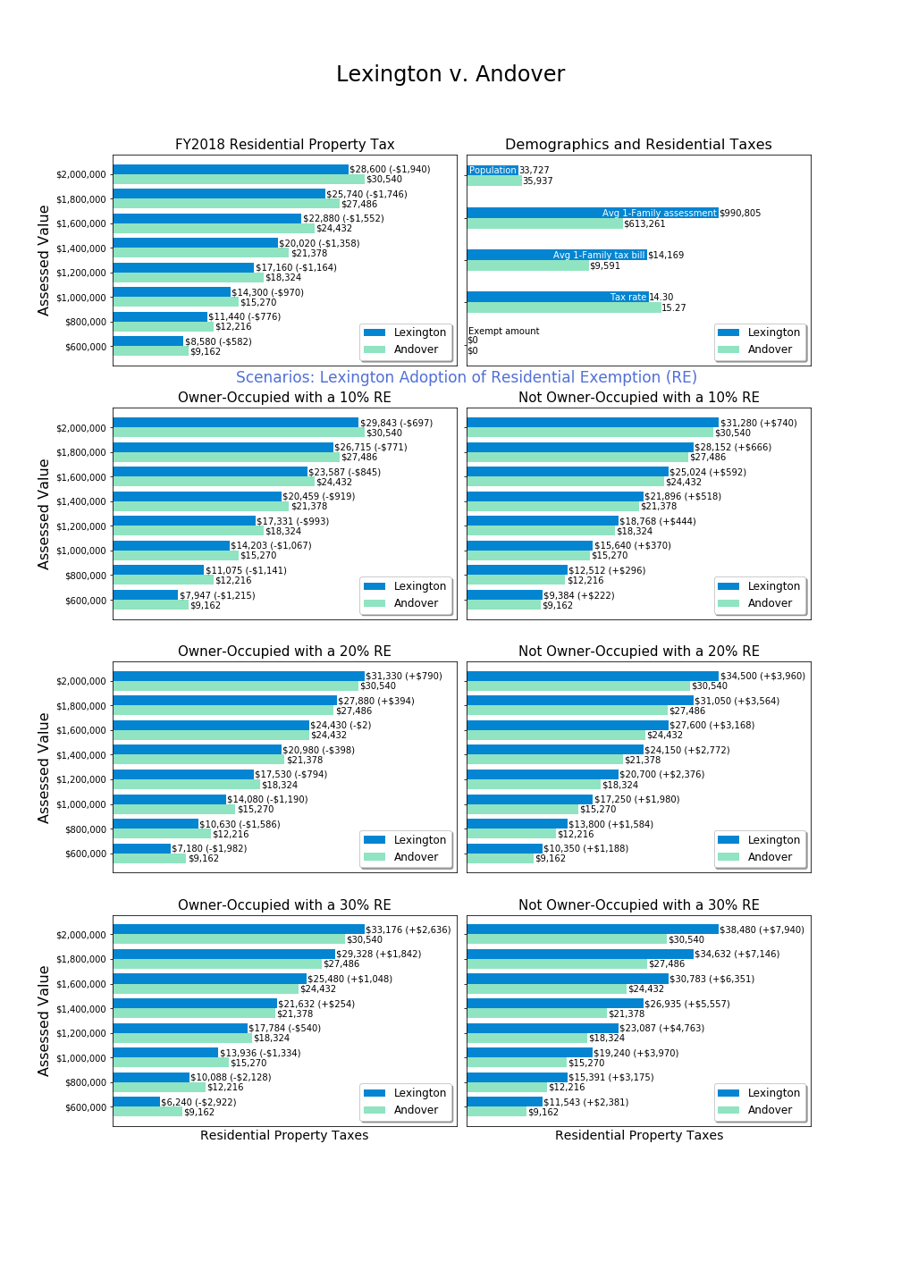

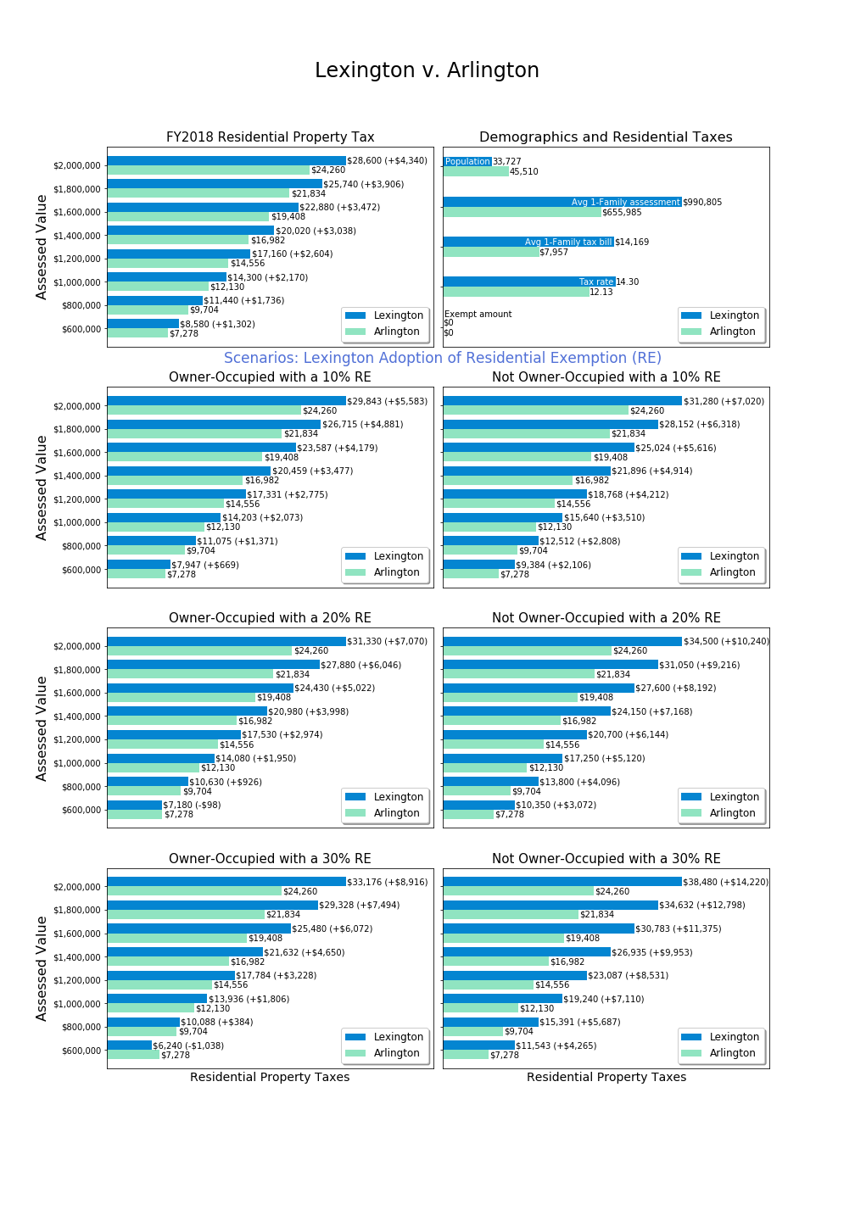

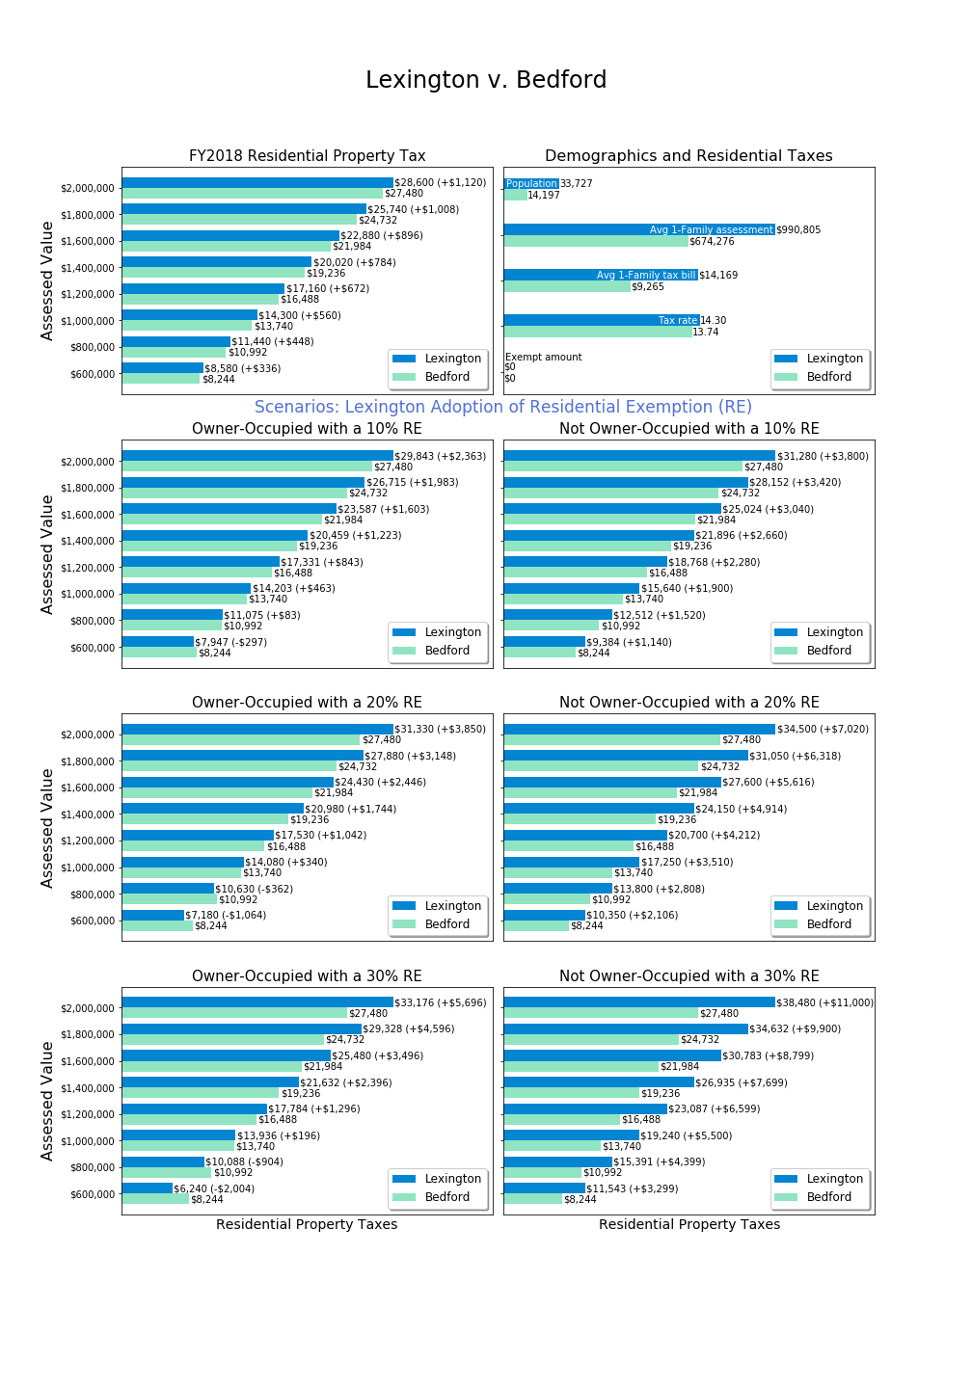

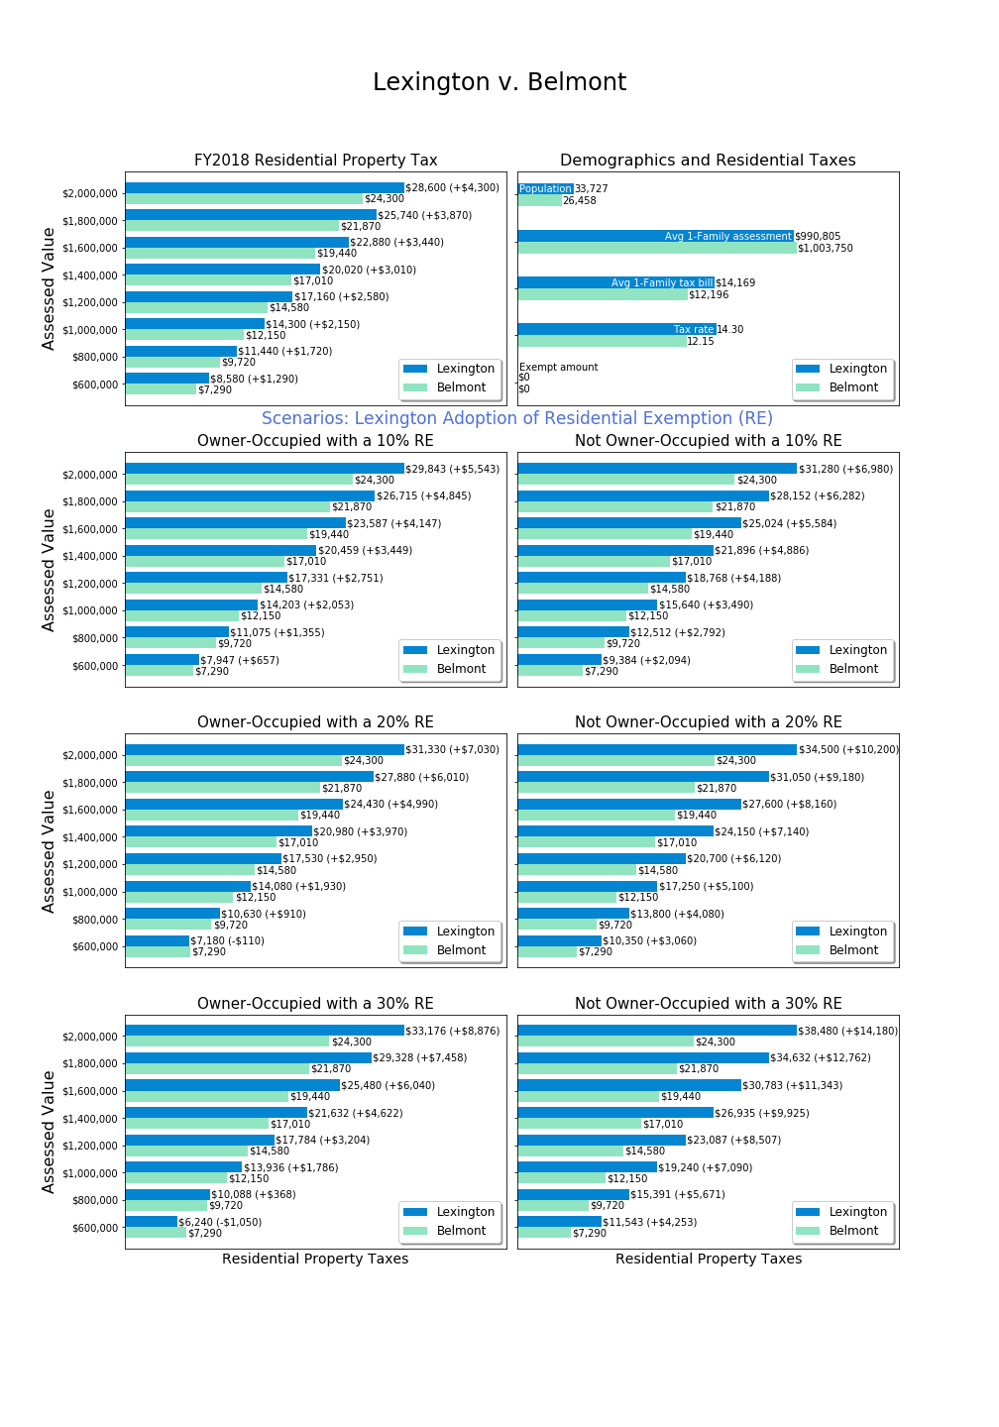



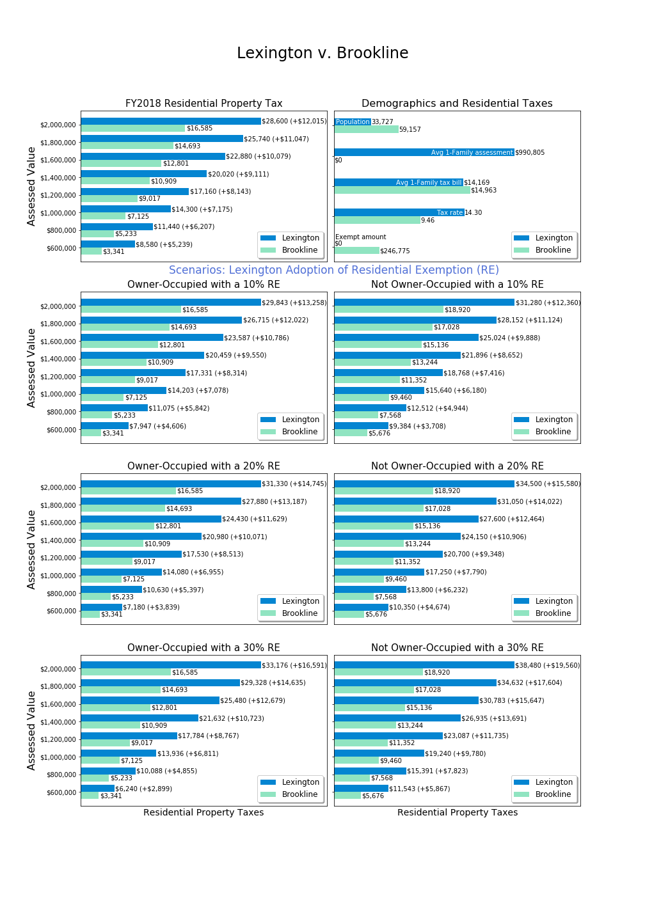

Brookline average single tax bill source: <https://www.boston.gov/sites/default/files/imce-uploads/2018-03/fy2018_facts_figures.pdf>.



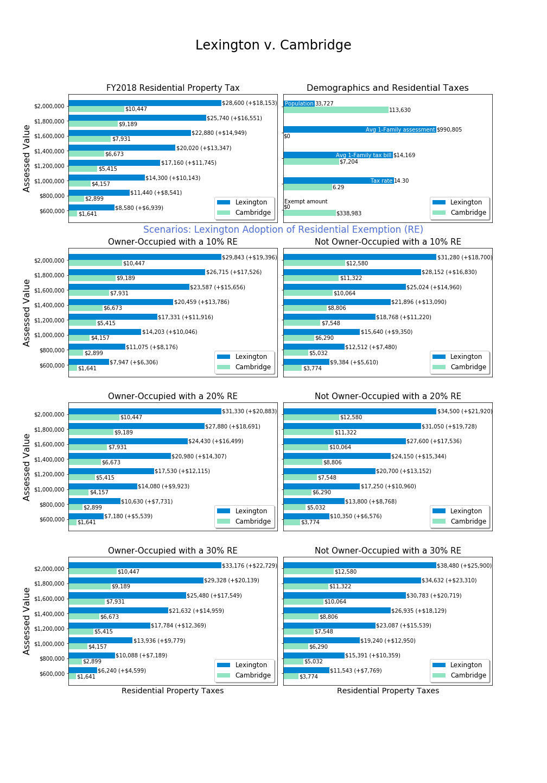Cambridge average single family tax bill for FY2017, source: <https://www.boston.gov/sites/default/files/imce-uploads/2018-03/fy2018_facts_figures.pdf>.

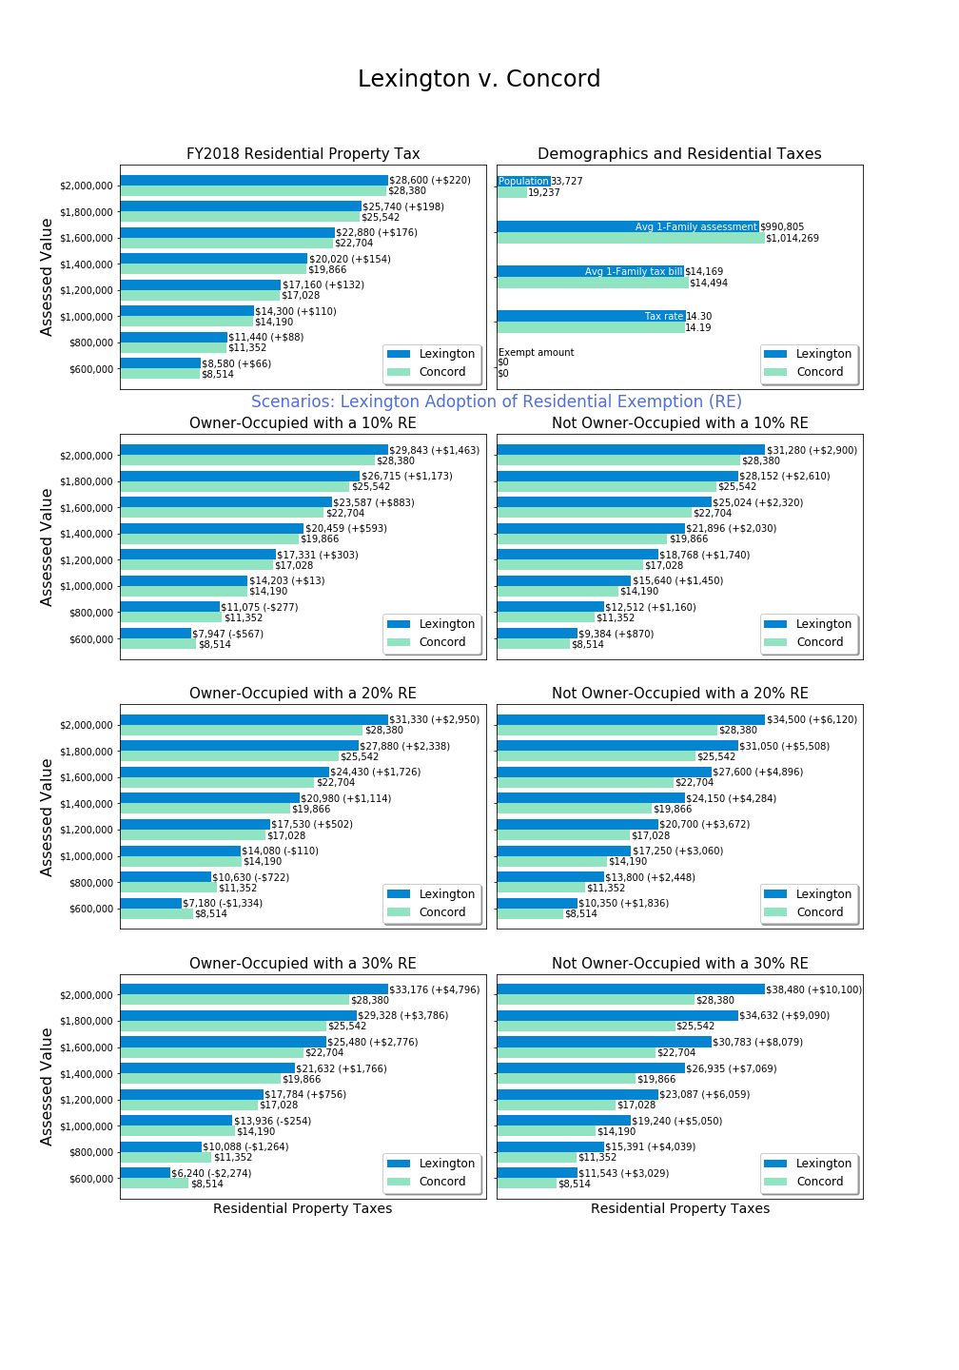

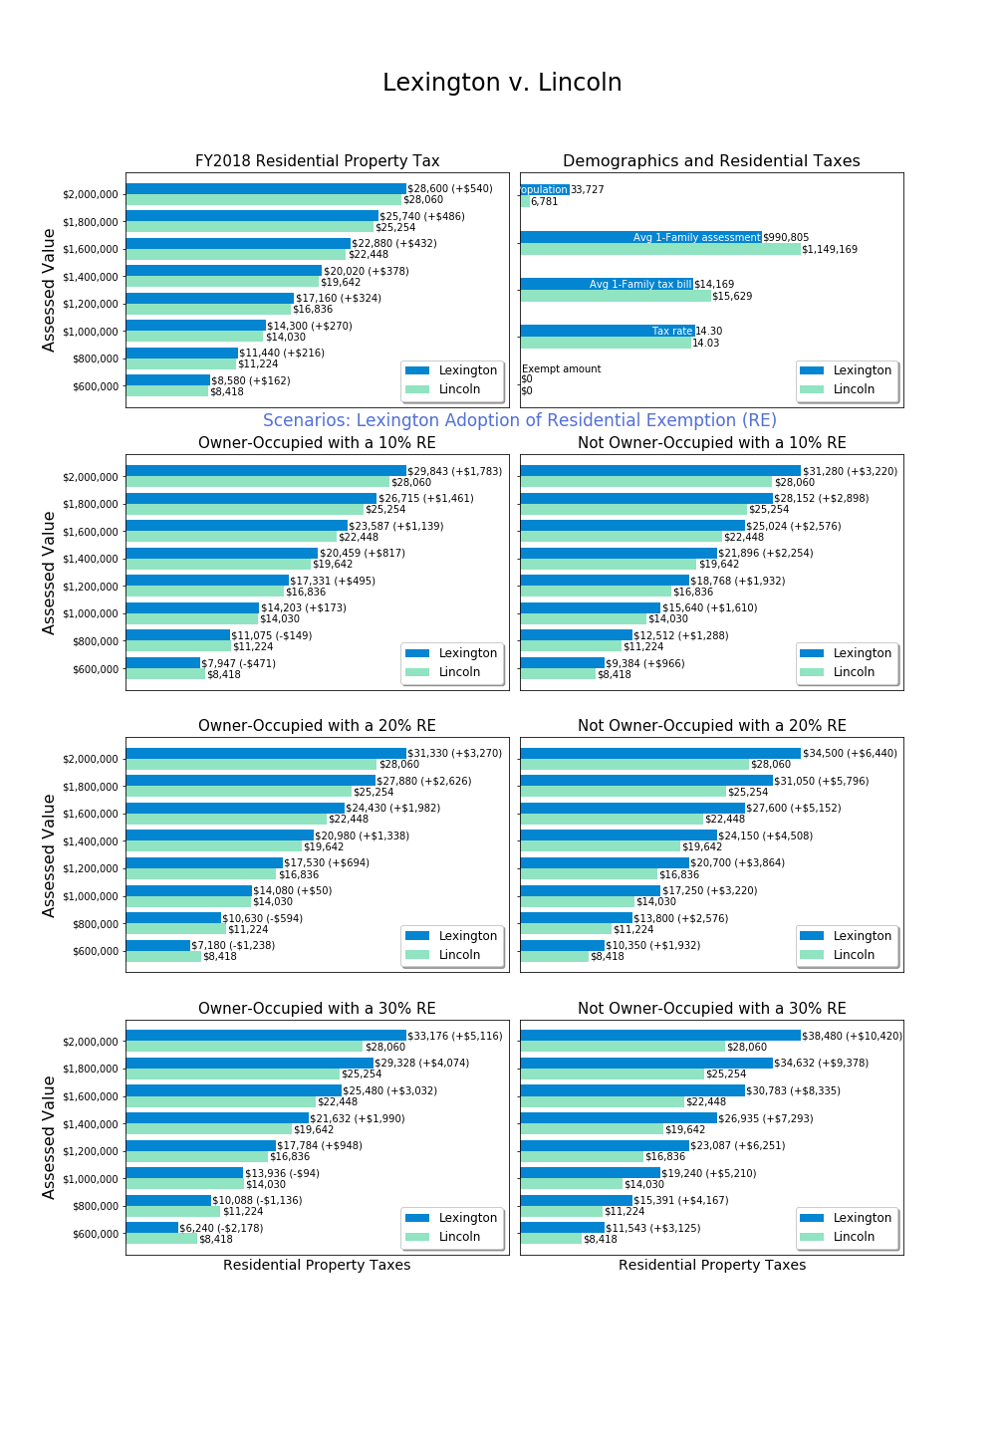

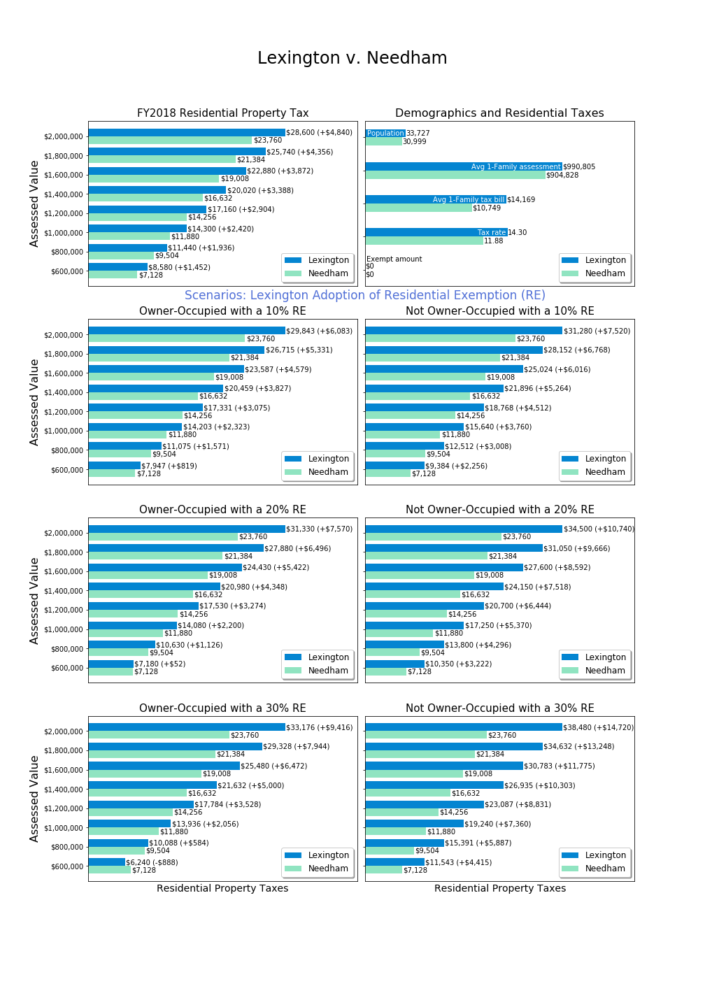



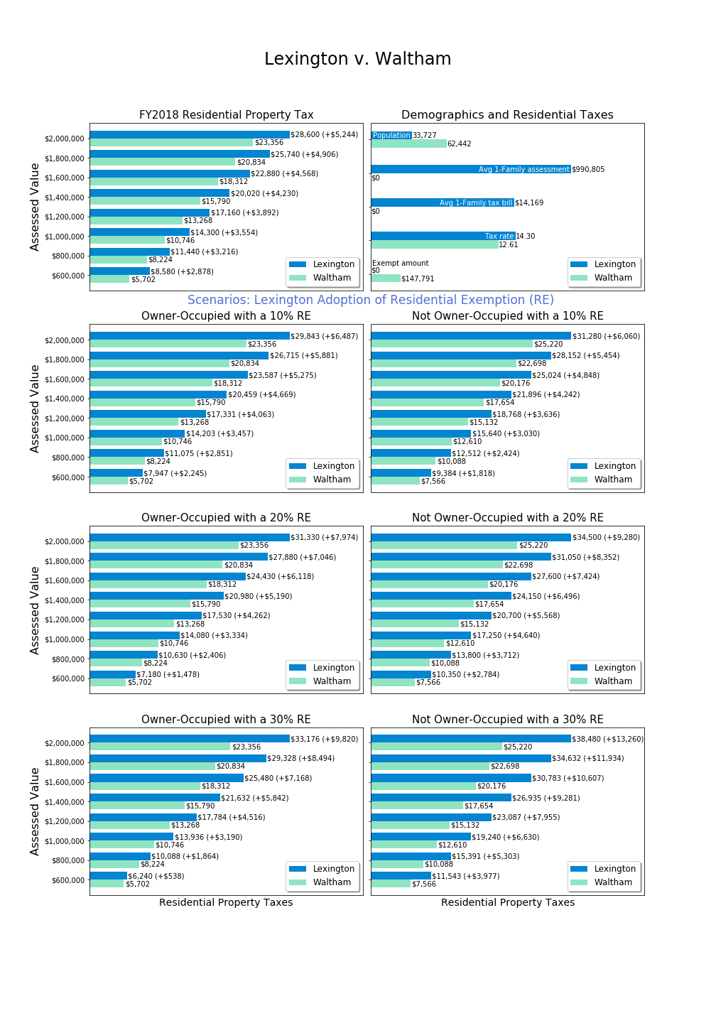

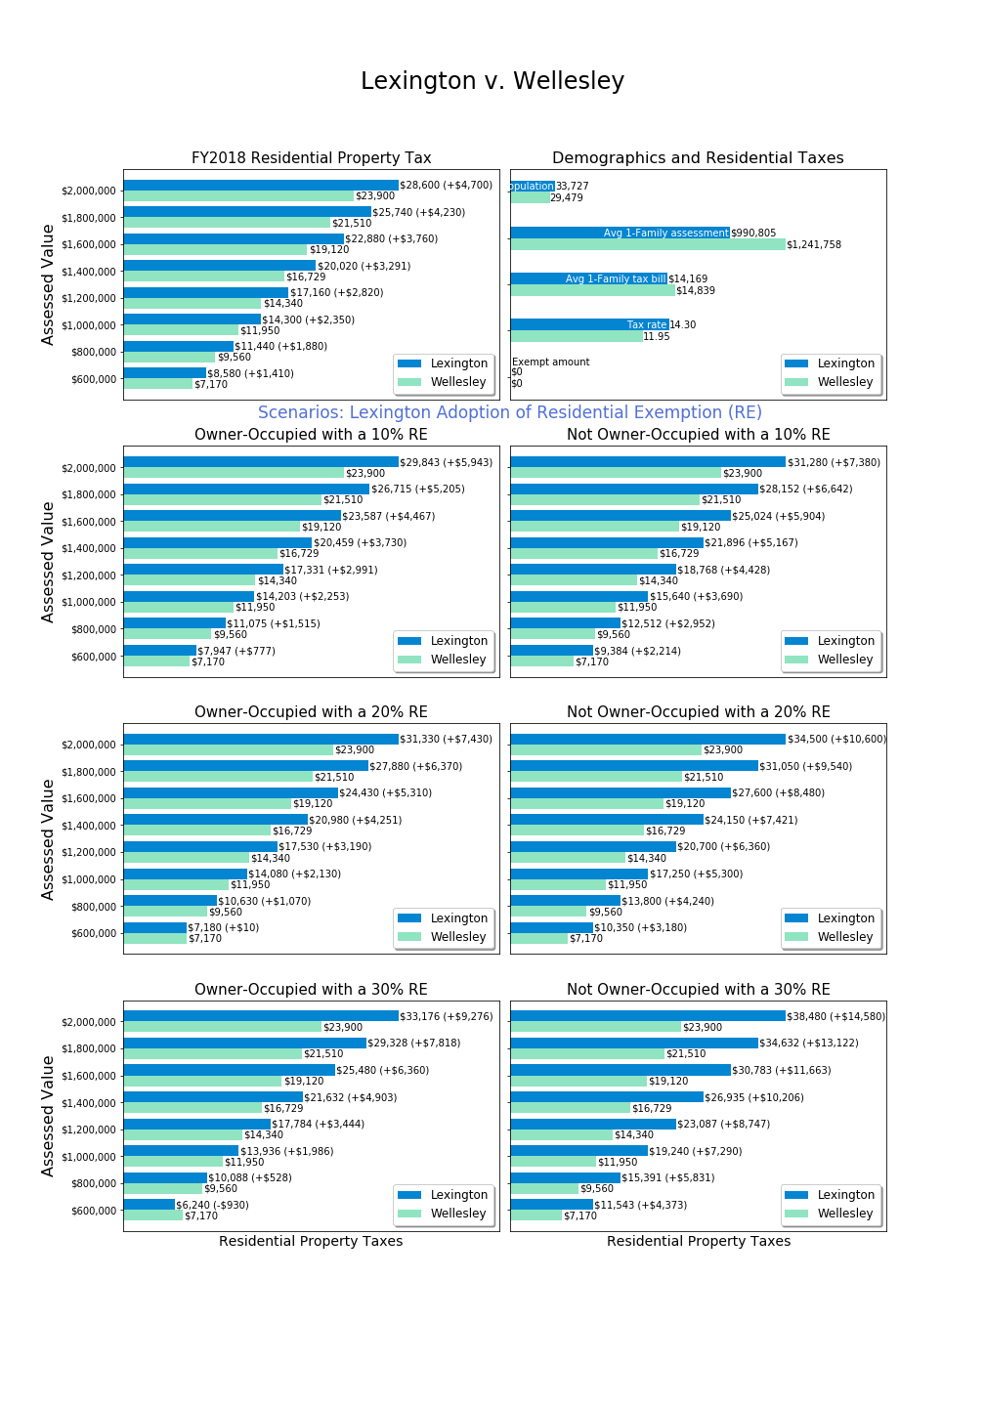

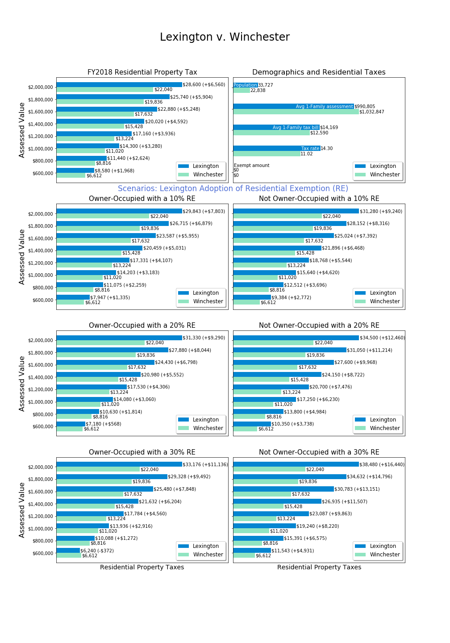

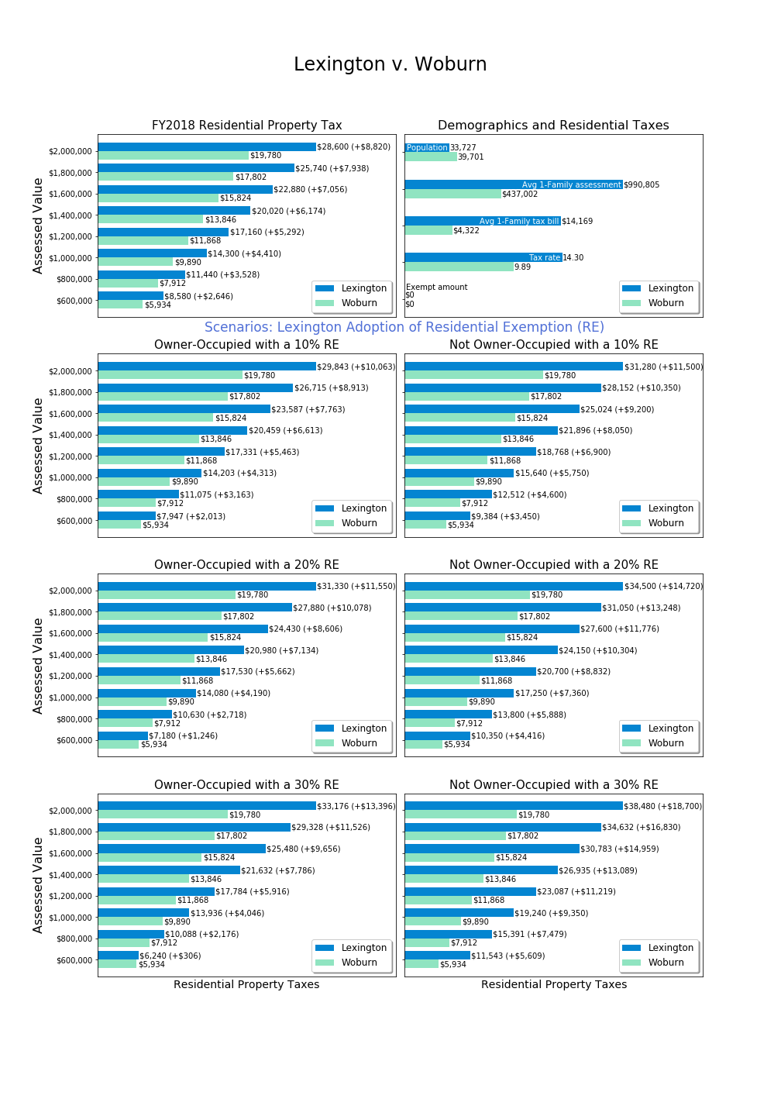

# Services, Housing Stress and Emigration Survey

## Survey Executive Summary

A survey of the Lexington community was undertaken to assess key questions for the Residential Exemption: what portion of the community experiences high stress related to property taxes, how property taxes and high stress relate to migration decisions, and whether proposed tax exemptions would benefit members of the community with greatest need or least use of services. This appendix only considers survey data as a source of evidence, and by itself, does not constitute a comprehensive assessment of residential exemptions.

1,475 individuals (about 7% of the Lexington adult population) responded to the services and housing stress survey. The survey results provide insights into whether relationships exist between demographic and tax data variables and two central variables of interest: housing stress and the forecasted likelihood of leaving Lexington within ten years (migration). While both of these focal variables describe subjective experiences, the committee believes the broad outlines of the results provide insight into residential exemption policy.

Per the committee’s charter, two goals of a residential exemption would be to assist those with high housing stress (especially when property taxes contribute) or to impact decisions to leave Lexington. To discuss measurement of possible policies, we use the conceptual framework of precision and recall.[29] **Precision** is the percentage of those helped by a policy who are in the class of intended beneficiaries. **Recall** is the percentage of all intended beneficiaries assisted by a given policy.

Key Findings:

1. Renters much more often report high housing stress than homeowners.
2. High housing stress is reported at all ages, length of residence, incomes and home values.
3. Income is a better predictor of high housing stress than is home value.
4. Means tested targeting offers higher precision than the State’s Residential Exemption (SRE), but low recall.
5. Renters are more likely to forecast migration than homeowners.
6. Housing stress significantly drives migration for homeowners.
7. Home value and income are not significant predictors of migration for homeowners.
8. Middle aged populations have the highest forecast of migration.

Policy Implications:

1. If rental property owners pass on increased tax burdens from the State’s Residential Exemption (SRE) adoption to renters by increasing rents, it will impact a portion of the community experiencing frequently reporting high housing stress.
2. The SRE is a blunt (low precision) policy and will benefit many individuals with higher income or without high housing stress.
3. The SRE would negatively impact middle-aged members of the community who already have the highest likelihood of migration.
4. A Means-Tested Residential Exemption (MTRE) could offer higher targeting precision, but would provide low recall as few members of the community who experience high housing stress would benefit.
5. Survey respondents across all demographic variables voice concern about high property taxes in Lexington, and residential exemptions should be considered as one potential tool within a broader approach to addressing housing stress. The open responses reported in this section should be read by policy makers seeking to address concerns of residents.

The Committee plans to post survey data and data analysis scripts at a town website in spring 2019.

## 1. Overview

As part of our goal to gather information on what property tax challenges community members face, the Committee undertook to survey Lexington residents. We designed a survey which would collect information on services, housing stress, and migration plans, as well as demographic information allowing us to correlate responses. Furthermore, we gathered open response comments on two topics, although we ultimately decided not to correlate open responses with other questions because we had not disclosed that intent in advance and sought to protect individual privacy.

The central areas of concern for the Committee in addressing with this survey were:

**Economic and psychological stress**: What role does property taxes play in resident housing stress?

**Migration**: Is there evidence that town tax policy impacts migration? For example, are individuals experiencing property tax induced psychological or financial stress more likely to leave Lexington?

**Residential Exemption effectiveness**: Can we estimate the effect of proposed exemption alternatives on either psychological stress or migration?

**Justifiability based on service use**: Can we estimate for proposed exemption alternatives whether recipients of an exemption are heavier or lesser uses or government programs?

**Means-tested estimation**: Can we estimate the number of qualified individuals for a means-tested residential exemption, and better characterize how they are differentiated from the population at large?

As a secondary benefit, we hoped these survey questions would shed insight into resident use of government services, housing stress, and other subjects which residents could raise through open responses.

## 2. Survey Process

The Committee developed and reviewed questions in open sessions. The Committee was interested in ensuring that respondents would be willing and able to answer survey questions, and that the survey questions maintained relevance to purpose.

To measure representativeness of the population as a whole the committee promoted survey distribution verified by statistical testing. The proposed testing was to align demographic questions with census responses so one could measure whether the survey demographics aligned with known quantities about Lexington, such as age or income.

The Committee reviewed the auspices under which the survey should be conducted. We wanted to avoid asking residents directly whether they would prefer lower taxes (in order to prevent biasing responses to “yes”), and also to maintain a reasonable level of obscurity about how responses could be used. Therefore, it was important that the survey not originate solely from the Committee, yet offer sufficient legitimacy to promote responses.

We sought partnership with other town committees and departments interested in surveying Lexington, and found that while other surveys are in process, each one has its own timetable as well as varying levels of outside resources. Aligning with committees on different timetables was not feasible as it would delay our research. For the survey, we partnered with the Lexington Recreation Department which was also interested in how the use of recreation resources correlated with demographics. As one of our questions was about resource utilization for affected populations (possible fairness criteria), this partnership aligned well with our mission, provided additional value to a town department and offered an additional distribution channel, creating an overall “Services and Housing Stress” theme for the survey. Moreover, as the Recreation Department will undertake its own survey in 2019, the results from this survey can be input for further survey construction.[30]

Draft questions were piloted with colleagues and friends, particularly outside Lexington. Piloting provided some feedback and raised some questions for the committee to address, such as:

What does it mean to receive fire or police services? Is getting directions from a police officer a service? How about being written a parking or speeding ticket? The committee left this ambiguous in the survey.

Did we need to ask marital status? What did this mean for non-traditional family organization? We decided to drop a question on marital status and replace with size of household.

What was the survey “getting at” in asking about race? Because the survey was themed around services and stress, race did not strike some pilot respondents as relevant, and while there could be insight into subcommunities, the committee determined it was not central to our line of inquiry and dropped any question on race or ethnicity.

Pilot respondents warned the committee that intrusive questions unrelated to the theme might cause survey abandonment. Therefore, each question was carefully weighed for the value it would provide versus potential survey abandonment. Because sensitive financial questions are critical to correlation goals, we needed to include some difficult questions. We placed these questions last so we would collect information from respondents who might submit partially completed surveys should bias arise.

Because the State’s Residential Exemption is based on assessed value and not economic means, the Committee had interest in how vacation homes and snowbirding factored into Lexington residency. Did some members of the community declare residency in Florida for tax reasons, and what action would they take if their Lexington property were to be charged materially higher taxes? But the theme of the survey and appropriate length prevented us from including any question which would provide insight into how residency and multiple-property ownership operated.

The Committee also discussed the respondent’s ability to answer questions. Would a less-financially aware respondent (perhaps the household member who does not manage finances) be able to answer questions accurately about market value, assessment, mortgage, property taxes, or insurance? The State’s Residential Exemption is related to assessed value, but except for the most financially astute tax payers, we expect residents do not know their current year assessed value. Do residents know their total housing cost? Would some include cable or water and sewer, while others do not?

Our challenge in surveying these concepts in a clear manner for all residents, led to an innovation and some simplifications. One innovation was to introduce the concept of “housing stress” as an intended catch-all for the economic and psychological impact which monthly housing bills may have on a household. In keeping with our charge to support residents remaining in their homes, we reasoned inclusion of both more objective factors such as forecast migration as well as economic and psychological factors such as ease and stress, was important.

Surveying housing costs is a complex area, and the Committee accepted obvious limitations beyond a respondent’s ability to answer questions. The survey did not ask whether someone with a high housing payment would continue to have it into the future (Are they near the end of their mortgage?). Also, the causes of housing costs are unknown (Is debt required to live in the home, add a new addition, pay college costs, or pay a family member’s assisted care?). The survey asks about monthly housing costs, but does not investigate the origin, purpose, future trajectory, or total liability associated with these costs.

As the Committee was interested in property taxes specifically, we asked what proportion of housing costs are related to property taxes. Combined with market value of a home and monthly payments, these questions can give some insight into whether the respondent’s housing costs are materially driven by property taxes.

The Committee considered how to handle respondents who might not have satisfactory knowledge of core questions around housing payments and household housing stress. The committee felt that respondents should state that they are “responsible” for housing costs to be included in final data analysis about property taxation. Most data analysis excludes respondents who are not responsible for housing costs in their household.[31]

### Survey Structure

We structured the survey to begin with questions about use of town resources, attempting to set the tone that this survey was not about property taxes specifically. Section two, on affordability, started with questions of interest to the recreation department, such as access to financial aid. The first question central to our committee’s objective was to inquire about housing stress, and this was followed by an open response question. The open response question thus reveals what respondents are thinking about when asked about housing stress--before the topic of property taxes was introduced (although being a town survey, taxes may come to mind easily).

The survey was constructed using Google Forms. We requested that responses only be submitted by current Lexington residents, but created no residency verification process. We wanted to maximize response rates, so did not request individuals identify themselves, and therefore could not prove that each person answered the survey only one time. The final results were downloaded from Google and processed via Python.

The survey contained the following sections and questions:

**Section 1: Town Services**

All questions start with this phrasing:

In the past 12 months, has any household member done the following?

These are the question numbers for responses:

Q1. Visited the Community Center

Q2. Used town swimming facilities

Q3. Used town recreational fields or courts

Q4. Used Pine Meadows golf course

Q5. Used a school or neighborhood playground

Q6. Used the Minuteman Bikeway

Q7. Used Lexpress bus

Q8. Visited Lexington conservation areas

Q9. Directly received fire or police services

Q10. Attended Lexington public schools

Q11. Participated in any town provided program or service for seniors

Q12. Used Cary library or attended a library event

Q13. Served town government in any capacity (employee, committee member, town meeting member, elected representative)

[Response options:

All questions in section 1 allowed “Yes”, “No” and “N/A” as responses. We provided “N/A” as an option to allow respondents to explicitly skip questions, but we treated those responses the same as blank ones.]

**Section 2: Affordability**

Q1. Are you aware that the Recreation & Community Programs Department offers financial aid for programs and services?

Q2. Has a household member received this type of financial assistance to participate in a program or service?

Q3. If your primary residence is rental, please indicate your monthly rental cost:

Q4. If you own your primary residence, please indicate your total monthly housing payment (mortgage, insurance, property taxes):

Q5. Do you receive a property tax deferral or property tax credit due to limited income?

Q6. What level of stress does your household experience with payment of monthly housing costs?

Q7. Please elaborate or share any additional thoughts. (open response question)

Q8. Thinking about all the costs of living in your owned property or rental (rent/mortgage, home maintenance, condo fees, property taxes, insurance, utilities), what portion of these costs do you estimate is related to property taxes?

Q9. Are you responsible for the housing costs at your residence (i.e. owner or lessee)?

Q10. Are you considering relocating away from Lexington in the next 10 years?

[Response options:

Q3: $0-$1499, $1500-$2999, $3000-$4499, $4500+, N/A

Q4: <$2,000, $2,001-$4,000, $4,001-$6,000, $6,001-$8,000, $8,001-$10,000, $10,000+, N/A

Q6: None, Little, Some, Significant, Substantial, N/A

Q7: Open response

Q8: None, Little (1-25%), Some (26-50%), Significant (51%-75%), Substantial (76%-100%), N/A

Q10: Definitely Not, Unlikely, Undecided - Possible, Likely, Definitely, Have not considered, N/A

Others: Yes, No, N/A]

**Second 3: Demographics**

Q1. Age (respondent)

Q2. Size of household (number of people)

Q3. Disabilities within household (check all that apply)

Q4. Length of time living in town (respondent)

Q5. What type of property is your residence?

Q6. Approximate market property value of your Lexington residence (if owned):

Q7. Please indicate your approximate household income in the past 12 months

Q8. Please indicate how the survey was shared with you (any groups or lists or whether it was forwarded to you.) (open response question)

Q9. Please share any comments to the survey team about this survey. Thank you. (open response question)

[Response options:

To facilitate consistency between our survey with other population measurement tools, we chose demographic brackets used in the United States census via American Community Survey.[32] We made some adaptations to better reflect Lexington’s local population and to target demographics of interest to our focus on head of household decision-making. For example, we combined all age brackets below 30 years old. Similarly, we combined house value brackets below $500,000 because there are few in Lexington’s current housing market. We also split up the highest ACS bracket ($1,000,000+) into 5 novel brackets because of the abundance of houses above that threshold in Lexington. These were exceptions, however; most brackets remained consistent with ACS.

Q1: Under 30 years, 31-39 years, 40-49 years, 50-59 years, 60-69 years, 70-79 years, 80 years and over, N/A

Q2: 1, 2, 3, 4, 5+, N/A

Q3: Checkboxes presented so multiple section possible: with a hearing difficulty, with a vision difficulty, with a cognitive difficulty, with an ambulatory difficulty, with a self-care difficulty, with an independent living difficulty, none of the above, N/A

Q4: Moved in 2015 or later, moved in 2010-2014, moved in 2000-2009, moved in 1990-1999, moved in 1980-1989, moved in 1979 and earlier, N/A

Q5: Single family home, multi-family home, condominium, apartment, other, N/A

Q6: I don't live in a property owned by a family member, Less than $500,000, $500,000-$749,999, $750,000-$999,999, $1,000,000-$1,249,999, $1,250,000-$1,499,999, $1,500,000-$1,749,999, $1,750,000-$1,999,999, $2,000,000 and more, N/A

Q7: Less than $35,000, $35,000-$49,999, $50,000-$74,999, $75,000-$99,000, $100,000-$149,999, $150,000-$199,999, $200,000 and over, N/A

Q8 and Q9 were open response questions.]

## 3. Survey Respondents

Considering the fact that this survey had zero administrative and distribution costs, the committee conservatively hoped for 400 responses. Expecting a relatively small sample, the Committee did not anticipate nuanced results, and emphasized alignment with census categories for representativeness.

The survey ran over the period October 9, 2018 to November 16, 2018 and netted 1,475 responses. Given the frequent open response comments, one can reasonably interpret that respondents were eager to provide their opinions on local taxes and this was an important survey. Numerous respondents thanked the surveyors for providing an opportunity for them to comment about property taxes and services in Lexington.

During the short period the survey was open, the committee planned to track distribution channels to ensure broad reach among Lexington residents. We asked each respondent where they heard about the survey, giving us an idea of the primary distribution channels. However, as this was an open response question, the answers contained numerous variations with respect to each distribution path. Advice to future survey designers might be to provide a selection for consistency. This committee did not select that option because distribution channels were not preplanned in detail, and we anticipated residents would share the survey link among themselves as well.

A few noteworthy adaptations helped ensure widespread distribution:

1. The survey URL was changed to have a town government URL. (Some respondents were put off by unofficial looking URLs, which is not surprising given recent privacy concerns and fake sites.)
2. Posting the survey on the town website provided assurance that it was official.
3. Department distributions (Recreation and Social Services) appeared to respondents as more credible.

One limitation was that the survey never identified which part of the town governance structure had initiated the survey nor the specific purpose for which it would be used. Some residents expressed discomfort or skipped the survey due to vague authority.

The most frequent reported sources for survey receipt were:

|  |  |
| --- | --- |
| Survey source | Count |
| email: email, lex rec, forwarded, email from town, town email, email from lexington human services, email list, email from the town, via email, from lex rec, lexington recreation | 214 |
| facebook: facebook, lexington mavens, mavens | 57 |
| lexington list, lexington listserv, lexington email list, lex list | 38 |
| lexington at home | 9 |
| lexfun | 9 |

*We summed common responses and not the long tail of isolated responses, so these numbers are all undercounted slightly.*

The responses to this question informed us that no single distribution channel dominated.

The question asking whether a respondent has served in town government in any capacity was placed to monitor whether those serving in town government survey would be overrepresented in the responses, in which case it could be argued that political elites are surveying themselves rather than the wider community. The percentage of responses affirming a household member serving in town government was 17%, which reflects the high level of town participation in Lexington but perhaps some over-representation. However, with this modest figure, the Committee feels the survey does represent Lexington in total, rather than principally the views of those in Town Meeting or other committee positions.

We took response representativeness seriously, looking at both the fraction of the Lexington population represented and the distributional similarity to demographic census data. Lexington’s population is about 31,394 residents, and it’s 30+ population is 66% of this figure or 20,720. Of 1,475 responses to our survey, 1,469 were from the 30+ population, or about 7% of the target population. Looking at how representative of the population this 7% sample was, we can look at six demographic questions and compare with known data about the population.

**Age Representation (Q1)**

The following table compares the proportion of survey responses providing age, with age 30+ with the corresponding Census proportion for 30+ year old residents:

|  |  |  |
| --- | --- | --- |
| **Age Range** | **Survey %** | **2017 Census %** |
| Age 30-39* | 9.2% | 12% |
| Age 40-49 | 29.0% | 26% |
| Age 50-59 | 24.3% | 24% |
| Age 60-69 | 16.8% | 17% |
| Age 70-79 | 14.2% | 11% |
| Age 80+ | 6.5% | 11% |
| Total Respondents 30+ | 1,351 |  |

\**Age 31-39 survey*

*Census Source:* <https://censusreporter.org/profiles/16000US2535250-lexington-ma/>

The figures from the housing survey are comparable. The most noteworthy difference is that the 80+ year old population is under-sampled in our survey, relative to the Census proportion.

**Household Size Representation (Q2)**

The table below shows the proportion of survey respondents reporting household size:

|  |  |
| --- | --- |
| **Household Size** | **Proportion of Samples** |
| 1 | 8.3% |
| 2 | 27.4% |
| 3 | 17.4% |
| 4 | 34.4% |
| 5+ | 12.5% |
| Total Respondents Reporting Size | 1,363 |
| Average Survey Household Size | 3.2* |

*\*We assume 5+ has average of 5.2 to construct this average size.*

Census data indicates the average persons per household is 2.8 (<https://censusreporter.org/profiles/16000US2535250-lexington-ma/> (2017 ACS census). Our larger average survey household size may be due to under-sampling of age 80+ years.

**Residency Representation (Q4)**

We have not correlated the length of time in Lexington with Census responses

<https://censusreporter.org/profiles/16000US2535250-lexington-ma/> (2017 ACS census), although it would be possible.

**Home Value Representation (Q6)**

Respondents were asked for their home value. Some may have interpreted this as market value and others as assessed value. We believe market values may be 10-20% higher than assessed values.

We have not gauged representation formally here, although the frequency distribution of responses shows that all segments of home value have representation.

**Income Representation (Q7)**

The following table compares survey responses for income with the 2017 Census:

|  |  |  |
| --- | --- | --- |
| **Income Range** | **Survey Sample** | **2017 Census** |
| < $50,000 | 7.5% | 17% |
| $50,000-$99,999 | 16% | 13% |
| $100,000-$199,999 | 35% | 29% |
| $200,000+ | 41% | 40% |
| Survey Respondents reporting income | 1,154 |  |

*Source:* [*https://censusreporter.org/profiles/16000US2535250-lexington-ma/*](https://censusreporter.org/profiles/16000US2535250-lexington-ma/)

This table suggests the survey under-represents the portion of the community with incomes below $50,000.

**Rent versus Own**

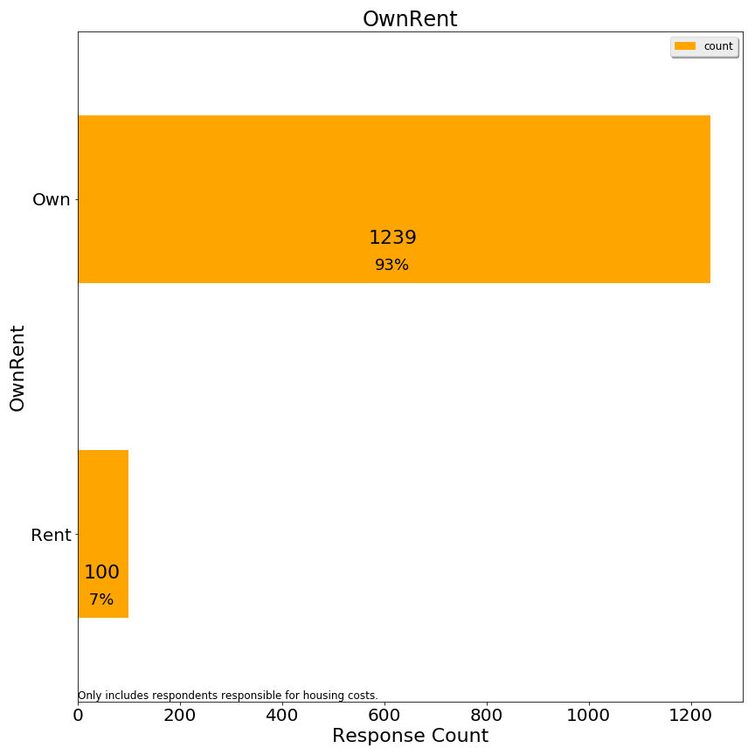

1,339 respondents responsible for housing costs provided data from which to infer whether they rent or own. For survey responses, if monthly rental cost was provided, the observation was recorded as “rent”. If the monthly rental cost was not provided, and the market value of the home was provided, the observation was recorded as “own”. If both fields were blank, then the respondent was not coded with either. The survey suggests 7% of respondents rent and 93% of respondents own.

ACS census data (<https://censusreporter.org/profiles/16000US2535250-lexington-ma/>) reports that 19% of Lexington housing units are renter occupied. However, this is not equivalent to the percentage of population living in rental versus owner units, nor the percentage of the adult population which is being surveyed. It does suggest that the survey under-represents renters to some extent.

**Error Corrections**

Twenty-nine respondents indicated housing costs in excess of $10,001/month and yet had homes valued at under $1.5 million. These cases were re-coded as “ResponseError” since it appeared that the respondent had interpreted the question as annually. For respondents with higher valued homes, this response seemed plausible and so those data were not re-coded.

**Grouping Responses**

For some analyses, grouping responses is helpful to see larger patterns. After preliminary analysis, we grouped some responses to the following questions for some analyses:

Housing Stress: Grouped into Low Stress, Medium Stress, High Stress

Market Value: Lowest two categories combined into one

Income: Lowest categories combined

Age: Youngest two and oldest two categories combined, separately

Monthly Rent: Highest categories combined

Relocation: Grouped into Likely, Unlikely, and Neutral

**Principal Responses**

Because some respondents did not answer every question, we had a choice of imputing missing data or excluding observations which were missing any one key variable.

The committee elected to only include data in correlation analyses where the respondent was responsible for housing costs. With this constraint, correlation analyses include all observations where both relevant variables were provided. These analyses are split into owners and renters, since these two populations had largely divergent responses.

1,390 respondents answered affirmatively they were responsible for housing costs. These 1,390 observations are the maximum set of observations used to formulate the correlation charts. However, for statistical analyses, only 914 respondents provided an answer to all key variables, and therefore those analyses only used the observations with all variables. No imputation was performed.

## 4. Comparative Charts and Correlation Analysis on Housing Stress and Migration

**Renters and Owners**

The State’s Residential Exemption is an owner-occupied exemption, designed to provide benefits to owners. It has been adopted in cities and resort towns, in both cases shifting tax burden from (often voting) resident owners to non-resident owners. For vacation homes, non-resident owners absorb a tax increase, while for rentals an owner may attempt to pass through the rental increase to renters.

In analyzing the full impact of a State Residential Exemption would have for Lexington, the committee included both owners and renters. Stereotypically, renters have lower asset levels than owners, and one should examine how the State Residential Exemption would impact renters.

### 4a. Housing Stress in the Survey

A key finding of the survey is that renters express high housing stress more consistently than owners, at all age and income levels:



*%=percent within categories owning or renting indicating high stress*

|  |
| --- |
| *A note on interpreting single color* *horizontal bar charts on stress and migration:*  For charts which only display “high housing stress” or “high migration likelihood”, we show a subset of all responses categorized by the y-axis label. The values in these charts reference the percent of respondents who meet the criteria displayed in the title (in the case above “high housing stress”) for each group. Thus, 58% on the renter bar means 58% of renters report high housing stress, and the other 42% are not shown in the bar chart. The other 42% is not shown since it obscures the ready perception of the horizontal bars.  Thus, the percentages shown do not add up to 100% vertically, but instead reference each category separately adding up with an unshown opposite response to 100% horizontally.  (Chart percentages are reported differently than frequency distribution bar charts where the percentages add to 100% vertically. A later note on stacked bar charts clarifies the color schema and grouping for stress and migration.) |

Housing stress may vary across subclasses of owners, but is less frequent than among renters in every case. For example, housing stress among owners is higher for those in lower value homes, but well below the frequency of housing stress among renters:

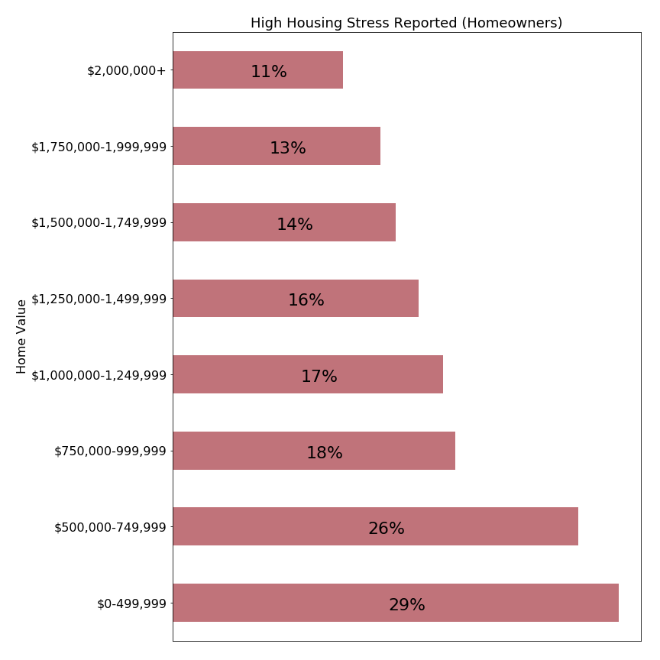

*%=percent within categories owning or renting indicating high stress*

One explanation is that renters may be stressed knowing that many are not in permanent situations. It must be incredibly stressful to be paying $3000/month in rent and trying to save for a down payment on a permanent property while housing prices escalate at high rates.

In the context of these results, policy makers considering adopting the State’s Residential Exemption should consider the social effects of potentially transferring a tax burden from owners to landlords providing housing to renters. Nationally, renters typically have lower total assets than owners, and the United States policy of subsidizing owners over renters (such as the federal home interest deductions) has been heavily criticized in recent years.

**Housing Stress versus Home Value**

Within the class of owner-occupied homes, the State’s Residential Exemption is a progressive tax which shifts tax burden from those with homes below the breakeven point (just above $1,000,000 in Lexington) to those above that point. Our survey can help answer whether the transfer of taxes is shifting from a more burdened to less burdened population.

Again, reviewing the relationship between home value and housing stress, we see that housing stress is more often reported for those in lower valued properties:



|  |
| --- |
| *A note on interpreting stacked horizontal bar charts on stress and migration:*  Colors: colors have been chosen to represent levels of the parameter being measured, in most cases “housing stress” or “forecast of intent to move”. Stress and intent to move were measured on a five or six point scale, but these are grouped into adjacent categories so an easily interpreted using a three color scheme.  Stacked bars: Each row corresponds to the entire number of respondents meeting the criteria labelled on the left (100%). A colored bar is shown with area proportionate to the respondents in that category (percent). Below the primary label showing the percent value is an integer value, representing the actual number of respondents. This actual number can be used to interpret the significance of the finding, as small counts (<20) have less reliability than higher number counts.  Interpreting percentages: these charts indicate the frequency with which respondents report a sentiment of the questioned intensity, which is different from the intensity. The language in the report uses the term “frequency” to reference how often respondents indicated an issue. For example, in the chart above 29% report “high” levels of housing stress. But while high levels of housing stress are reported more frequently for lower market values, we cannot conclude that the housing stress is higher than those occupying more expensive homes, and we can see that in no case do all members of a given category experience high housign stress. |

How can this chart be used to understand proposed residential exemptions?

First, we note that Lexington has a high level of owner-occupancy, and therefore adopting the State’s Residential Exemption would largely transfer tax liability from those who own lower valued properties to those who own higher valued properties.

Survey responses indicate that 17-29% of homeowners with homes valued at under $1,250,000 report high housing stress. A residential exemption benefitting this all homeowners with houses valued at or below that point would have a relatively low precision, as three out of four beneficiaries did not report high housing stress. Such an exemption would be funded by homeowners with properties above $1,250,000, where 11-16% report high housing stress. While this is a smaller percentage than the lower value homes group reports, the number of respondents reporting housing stress remains significant. A transfer of tax burden on to this population might exacerbate the high housing stress which already exists for some households.

Policy makers should also recognize that the impact of a tax shift could increase the extent of housing stress among high value property owners more than it provides relief to those with lower valued properties. A property owner with a $2,000,000 property would experience a property tax increase approximately double the tax reduction experienced by an owner with a $600,000 home. The survey does not directly measure how this shift would be experienced by either group.

**Housing Stress by Income: Owners**

Unlike the State’s Residential Exemption, means-tested residential exemptions include an income criterion to target residents who have demonstrated need. The chart below visualizes the relationship between income and housing stress of our survey respondents:



Homeowners with income below $50,000 report housing stress in 52% of responses, almost as frequently as responses from all renters. The second subset, those with incomes between $50,000-$74,999 report high housing stress in 32% of responses, a rate more frequent than in any market value category (see previous chart). Comparing this chart with the prior chart comparing home value versus housing stress suggests that including an income criterion for a residential exemption could better target residents with high housing stress than relying on home value alone.

The Massachusetts state circuit breaker provides assistance below an income cutoff of $58,000 for individual and $88,000 for married filers. These charts suggest that Lexington residents below those income levels report housing stress more frequently than those above those thresholds. However, at those thresholds only about one in three residents report high housing stress.

High housing stress is reported among Lexington residents at all levels of income, so an income based cutoff cannot ensure property tax relief to all respondents stressed by monthly housing costs.

**Housing Stress by Income: Renters**

The state circuit breaker and some matching programs offer tax relief to renters. How well does income correspond to high housing stress for renters?

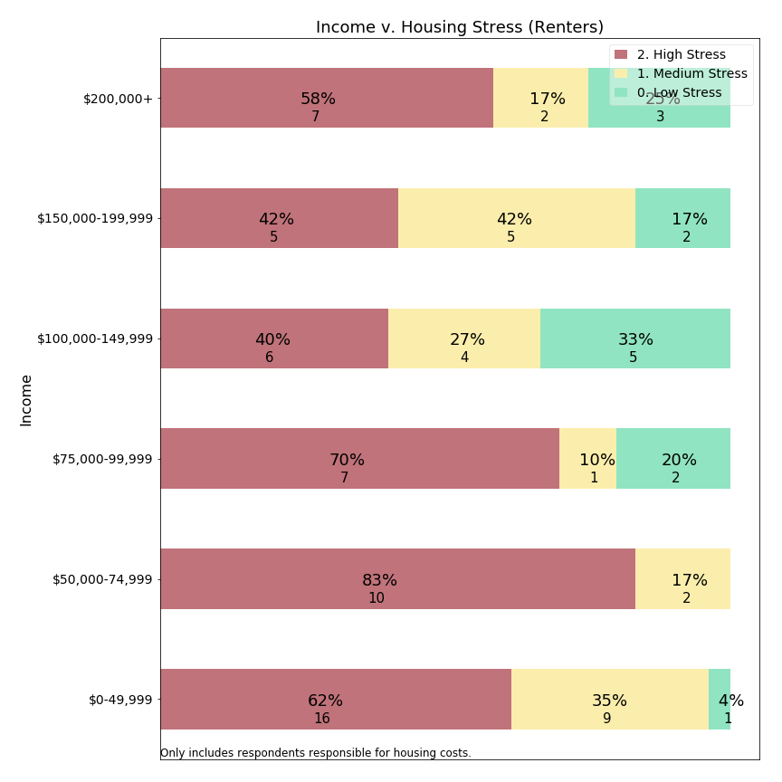

At first glance, it appears that high housing stress is prevalent for renters across all income levels. Moreover, except for a single respondent, all responses for renters earning under $75,000/year indicate high **or** medium stress. The data suggests housing stress is more consistently experienced among lower income residents than other residents.

A second observation is that some low-income individuals live in rent-controlled properties and therefore may have lower housing stress due to controls. This chart does not pull out respondents with rent controls separately. Our survey did not ask for rent-controlled unit residency status among renters.

This chart suggests that creating meaningful means-tested programs for renters may be difficult, and reminds us that policies which shift tax burden from homeowners to renters may adversely affect esidents frequently reporting housing stress.

**Housing Stress and Monthly Rent: Renters**

Renters may have greater clarity about their overall housing costs, as capital costs, property taxes, water and sewer, and home maintenance are wrapped into a single rental tax presented by the property owner from whom they rent. While a renter may not know how property taxes factor into their monthly rent, they can report monthly rent and housing stress.

Moreover, the state income tax and circuit breaker calculations offer financial credits in relation to rent. For example, the Massachusetts state circuit breaker compares 25% of a resident’s rental cost to 10% of their income. A means-tested exemption could use the same basis, which suggests the survey should address the relation between monthly rent and housing stress:

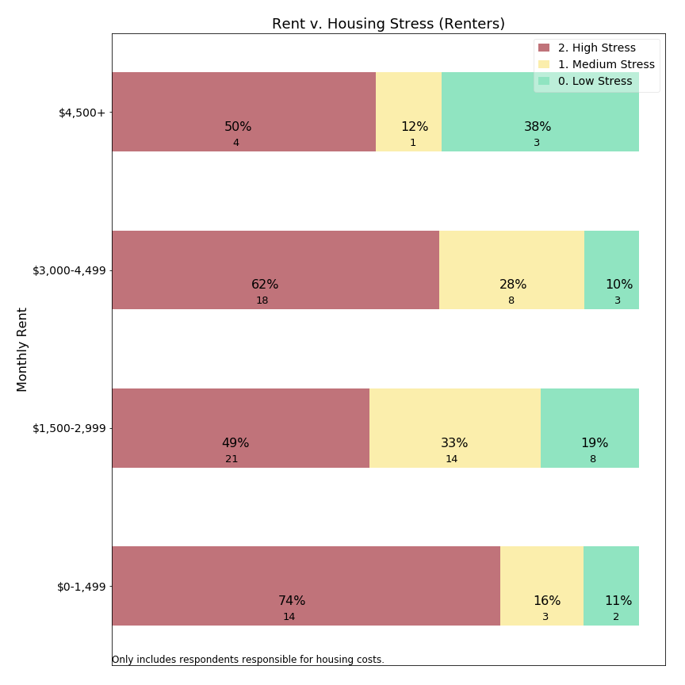

Our data suggest that housing stress levels are high, but fairly consistent across rental levels.

An interesting point of focus is respondents reporting rents below $1,500/month. This group has pervasive high stress levels, but also is renting at below market rates (unless simply renting a bedroom in a home--a rental arrangement not distinguished within our survey). This relationship suggests that households living in affordable housing are frequently reporting high housing stress. It may be that this lowest tier is immune from property tax burden shift, as residents in affordable housing are protected by regional rent controls.

**Housing Stress and Age: Owners**

Concern for Lexington’s senior population contributes to local interest in residential exemptions. Further, survey open response comments (below) explicitly mention retirement and fixed income as factors in relation to property taxes burden. The next chart visualizes the relationship between age and housing stress:



Considering both high and medium stress levels, it appears that the ages with most frequent housing stress are 30-59 year olds. Respondents between ages 60-79 reported less frequent housing stress, presumably because some households have moved past child care costs, mortgages and college bills. A small uptick may be occurring around 80+, but with limited statistical significance and with less frequent high housing stress than 50-59 year olds. The survey data suggests that housing stress may be experienced at all ages of the population, and does not provide statistical support for age-based criteria in means-tested residential exemptions.

**Housing Stress and Age: Renters**

The survey also allowed us to examine the relationship between housing stress and age for renters:

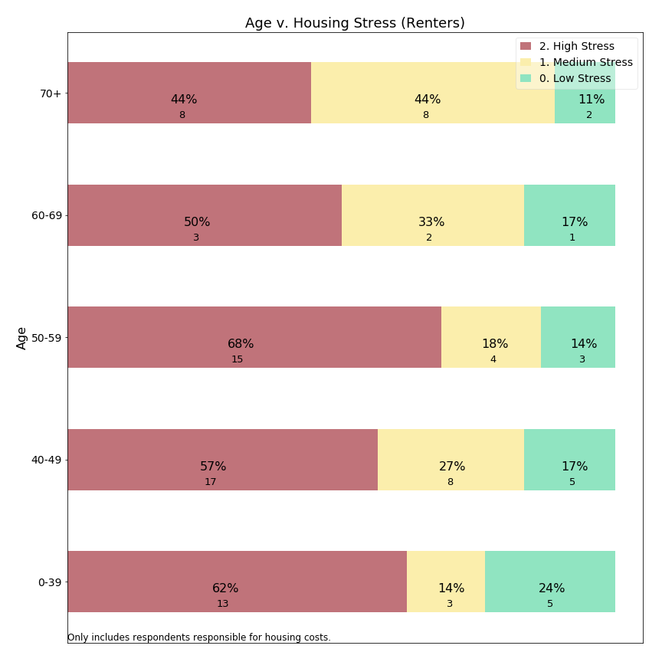

Renters in all age groups report high housing stress in half or more responses. For the oldest group, there could be a small decrease in frequency of high stress offset by responses of medium stress levels.[33] As with owners, our survey data do not support a age criterion for a means-tested exemption.

**Housing Stress and Time in Lexington: Owners**

Another criterion used for eligibility in means-tested residential exemptions is length of time in town. Therefore, we use the survey data to ask about the relationship between time in town and housing stress:



Survey data suggests that residents who have recently purchased homes in Lexington report housing stress most frequently. As these residents may have just assumed significant mortgages along with continuing housing inflation, they may have greater debt burden than more established residents.

While we do not observe that property taxes are causing this housing stress, we can state that housing stress survey data does not support a residency requirement typically included in means-tested residential exemptions.

**Housing Stress and Time in Lexington: Renters**

Similarly, the survey allowed us to examine the relationship between tenure in Lexington and housing stress for renters:

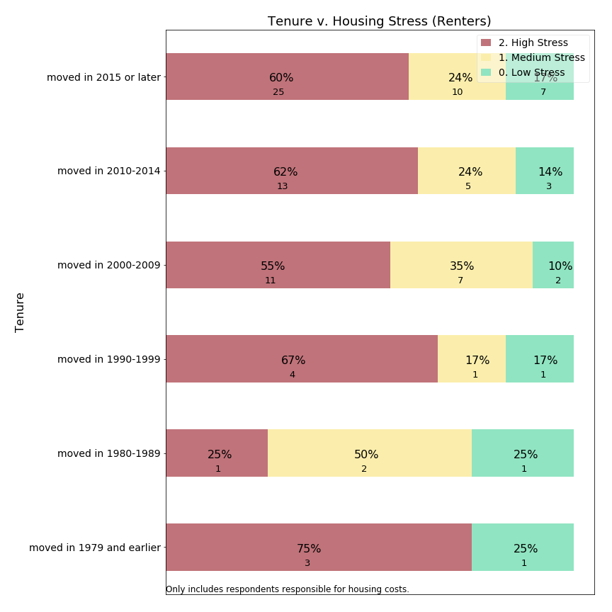

As with the prior metrics, renters express high housing stress at all lengths of tenure. The one exception appears to be renters who have lived in Lexington since the 1980s, but this group is too small to support a statistically significant departure from the larger group of renters.

**Housing Stress and Means Testing**

A typical Massachusetts means-tested exemption targets aid at residents who meet multiple criteria: senior age, low income, ten year residency, lower home value, and without “excessive” assets. Data from the survey can be used to ask whether residents meeting “Sudbury-like” criteria express high housing stress more frequently than do those who would be disqualified by one or more of the eligibility criteria. The survey responses only align with those criteria approximately because the survey thresholds were selected to match common census categories, which differ somewhat from thresholds listed in Sudbury’s “Senior Means Tested Exemption”. Furthermore, the survey request information about financial assets, nor does it ask whether the homeowner’s primary residence is in Lexington. The following table describes how Sudbury’s policy thresholds compare to the approximations we have used with regard to the survey data:

|  |  |
| --- | --- |
| **Sudbury Criteria[34]** | **Survey Approximation** |
| Age >= 65 | Age >= 60 |
| Circuit breaker income, i.e.:  $86,000 joint,  $72,000 head of household,  $57,000 single | Income <= $75,000 |
| 10 year residency | Tenure since 2005 (13 years) |
| Assessed home value < $799,600 | Assessed home value < $750,000 |
| No “excessive assets” | [None] |
| Primary residence Sudbury | [None] |

Concord’s experience with a means-tested exemption is that only about a quarter of those eligible for the state circuit breaker received a local exemption. Therefore the survey approximation includes more residents than would ultimately qualify and may understate housing stress.

By approximating “Sudbury-like” qualifications from our survey responses, we can compare those who meet all four criteria above (code=1) to those who did not (code=0) with respect to housing stress:



Among owners, those who met the survey means-tested approximation reported high housing stress 42% of the time, as compared with 17% of those who did not meet all the criteria.

The absolute response counts, however, lead us to a point we will develop further below: a means-tested residential exemption may have higher precision (42% of those targeted have high housing stress) than the prior series of charts (e.g. owners’ stress with regard to income, age, home value), while it would have a lower recall (30 respondents reporting high housing stress met the means-tested criteria compared to a far larger 191 respondents who did not meet all the criteria). If we had been able to include an asset test as well, one would expect precision to improve further, while recall would decline.

**Precision versus Recall, a Conceptual Framework**

As illustrated in the example above, shaping policy parameters forces us to acknowledge and evaluate trade-offs between reaching all community members who need assistance and not providing assistance beyond those with need. The concepts of precision and recall help us examine that trade-off. **Precision** is the percentage of those helped by a policy who are in the class of intended beneficiaries. **Recall** is the percentage of all intended beneficiaries assisted by a given policy.

The stacked bar charts presented above illustrates this inherent trade-off between precision and recall in the context of high housing stress among survey respondents who either would or would not qualify for a “Sudbury-like” means tested exemption. We make this evaluation by considering how each variable relates to housing stress and which portion of the population would meet the criteria. We imagine which groups would be included or excluded by adjusting inclusion criteria (e.g. adding an asset test, changing the age threshold).

A technical way to visualize these policy choices is to plot precision-recall curves. Before doing this, we need to make explicit an assumption this Committee has made about the target population and our “housing stress” proxy variable.

Assumption: high housing stress is the portion of the population we are trying to target with our residential exemption policy choice. In the charts above, we assume a purpose of adopting a residential exemption would be to alleviate housing stress. We do not distinguish among sources of housing stress (mortgage, maintenance, property taxes) but try to understand whether those experiencing high housing stress could be assisted with tax relief.

In an ideal scenario, each resident would report accurately and honestly whether they experience housing stress, and only those actually experiencing housing stress would receive assistance. But because stress is a subjective concept, typical public policies would use a more objective proxy and offer assistance in relation to this proxy variable. Thus, we represent a survey response about housing stress as “ground truth” and the proxy variable in question as a “classifier” and we evaluate which classifiers provide the best predictors of ground truth.

**Precision** = percent of beneficiaries who have high housing stress

If 18% of home owners report high housing stress, Lexington could achieve a precision of 18% simply by offering financial assistance to any random subset of homeowners. The objective of a residential exemption should be to offer tax relief in a more targeted manner, significantly improving on an 18% random sample.

**Recall** = percent of those with high housing stress who are beneficiaries

If Lexington were able to offer tax relief to all residents, then 100% of those with high housing stress would be addressed. But if a random 10% of residents were selected for tax relief, then only 10% of high stress residents would receive aid, a recall of 10%. The objective of a residential exemption should be to offer sufficient recall that residents believe the program is meaningful and worthwhile in comparison to its implementation cost.

**Precision v. Recall Curves**

Each of the variables evaluated (home value, income, age, tenure) offer a distinctive trade-off between precision and recall in identifying those with high housing stress. Considered separately a policy maker could select a cut-off for each variable and use that cut-off to determine an optimal trade-off between precision and recall. Comparing these curves is useful in helping policy makers determine which criteria provide the most targeted means to address housing stress in the community.

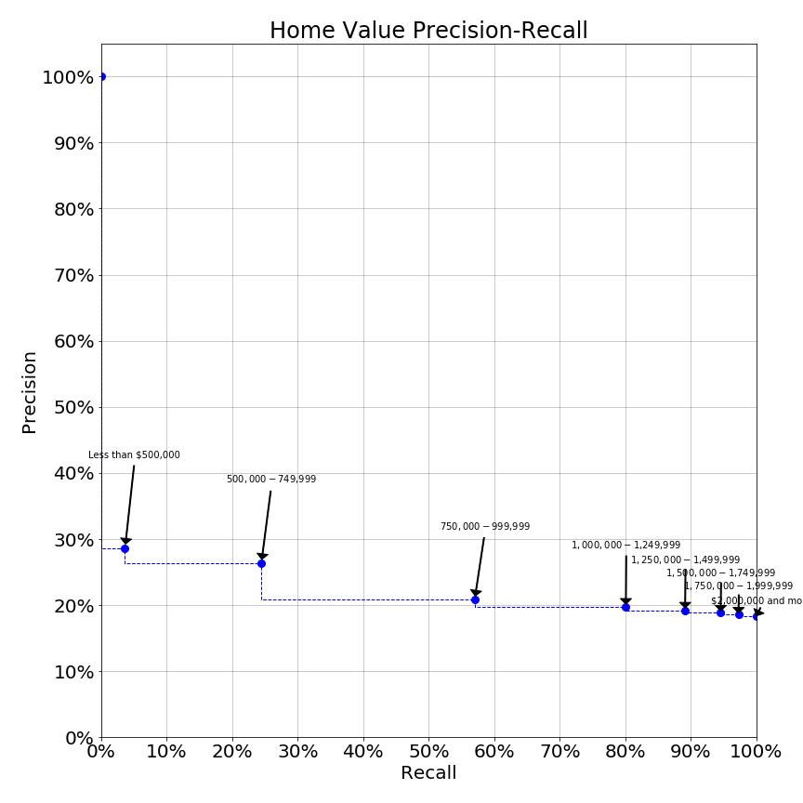

*Note on Precision-Recall Curves*

Each chart shows trade offs between precision and recall for the variable listed in the title of the chart.

Annotated points correspond to survey thresholds which could be used for policy cut-offs. Each potential cut-off has a separate balance of precision and recall, shown as the plotted point. Dotted lines provide rough connectors and are not represented by survey questions.

Ideal public policy would be represented by a curve offering high precision and recall simultaneously.

The home value precision-recall curve shows that an exemption policy targeting those with home values below $500,000 would have a precision of 29% (see corresponding stacked bar chart above) but the recall (% of high housing stress respondents reached) would be under 5%. Increasing the home value inclusion threshold to $750,000 greatly increases the reach (recall) of the program while only slightly diminishing targeting precision. Further increases in the threshold beyond $750,000 degrade precision such that the program would not be much better than random sampling of the population. Thus this curve would suggest that the SRE (which may benefit those up to ~$1,200,000) is correctly labelled a blunt instrument, but in fact appears to be only slightly better than random.

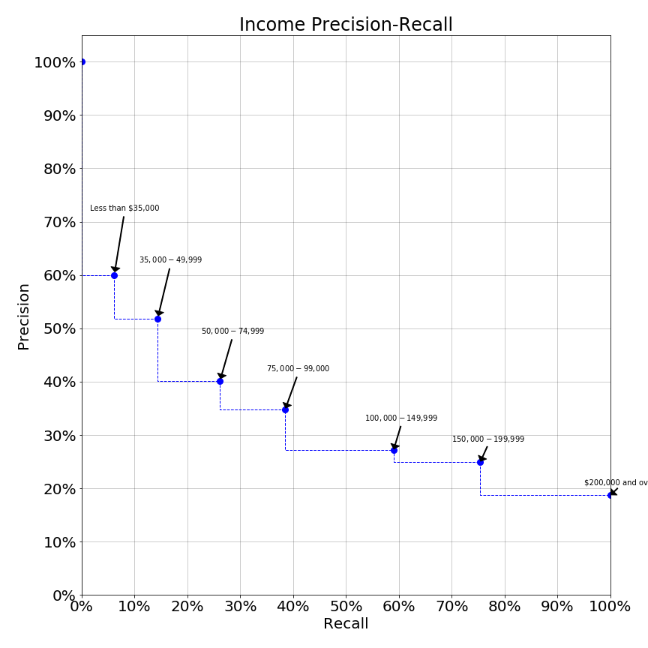

In contrast, the income precision-recall curve is significantly sloped. Here, we see a curve which offers significantly higher levels of precision at a variety of thresholds. At income levels up to $50,000 an income exemption would have precision over 50%, such that over half the beneficiaries have high housing stress. Yet at the $50,000 income threshold only about 15% of the population in need would be reached. Raising the income inclusion threshold to $75,000 reduces precision to 40% while expanding recall to one-quarter of those in need. While both precision and recall at either $50,000 or $75,000 income levels might not be as high as one might desire, use of precision-recall curves quantifiably demonstrates the superiority of income as an eligibility criterion over house value. These charts demonstrate why a state residential exemption may be viewed as inferior to a means-tested residential exemption.

Other variables we examined produce precision-recall curves which indicate they would make poor inclusion criteria:

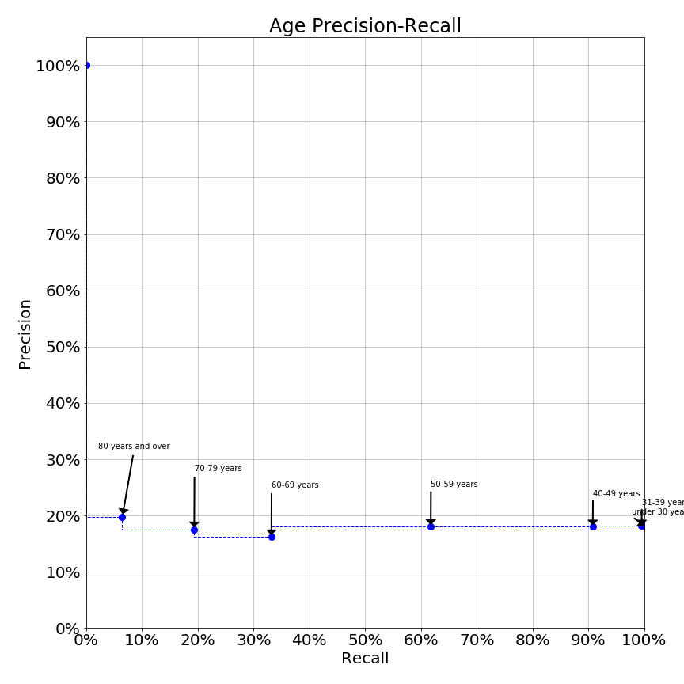

The age precision-recall curve suggests that some age thresholds may in fact perform worse than random selection (18% precision). Yet, means-tested exemptions often include age criteria for eligibility.

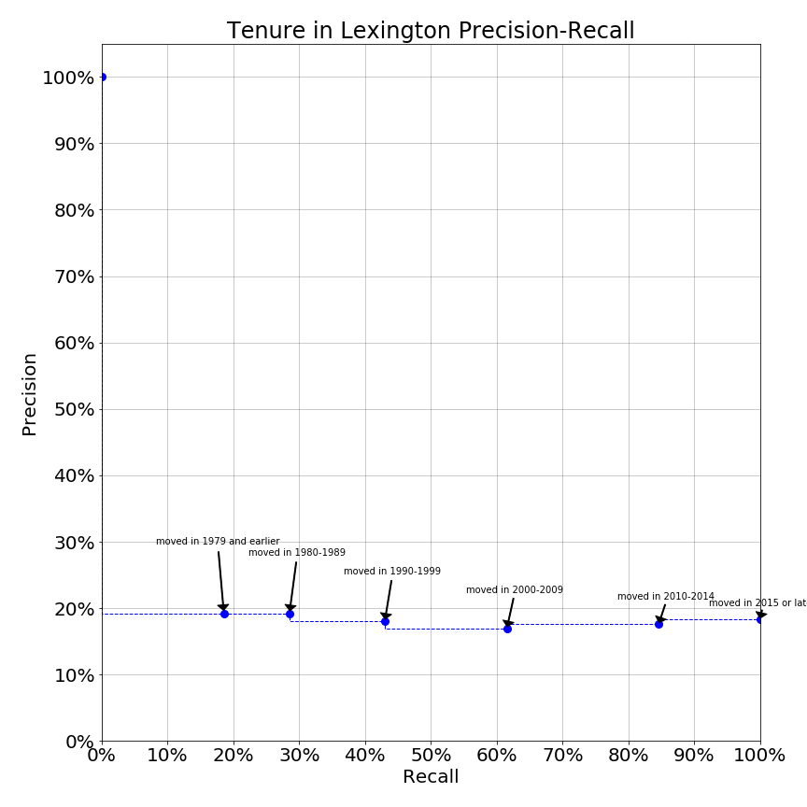

The tenure in Lexington precision-recall curve also suggests that length of time in Lexington provides no value in classifying residents’ high housing stress. Again, means-tested exemptions often include residential tenure as an eligibility criteria.

**Housing Stress and Monthly Housing Costs: Owners**

Lexington homes range in value from condominiums as low as approximately $500,000 to single family homes priced as high as $3,000,000. Individual assets vary, as some owners purchase homes outright while others have substantial mortgages. The survey data can shift from home value to monthly housing cost, and determine whether housing costs drive perceived housing stress:

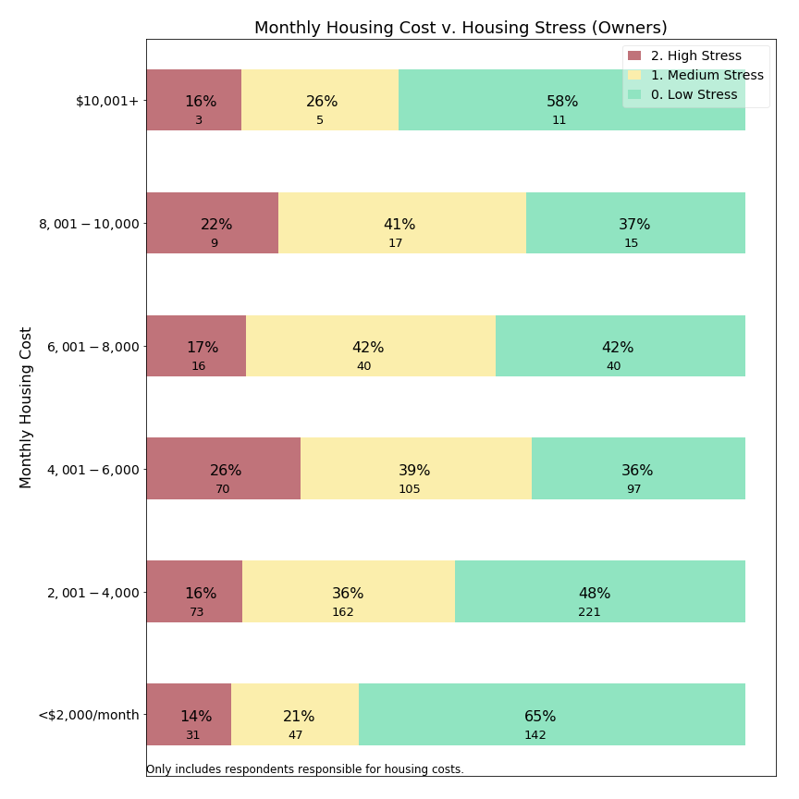

It appears that housing stress is similar across a wide range of monthly costs from $2,000 to $10,000 per month. Among the handful of residents paying more than $10,000 per month, housing stress may occur less frequently. A caveat is that some individuals in the $10,000+/month group were excluded from our this examination due to what appeared to be response errors explained earlier in this appendix, and these individuals registered high stress more frequently. Among those paying less than $2,000/month in total housing costs, suggesting no mortgage and modest property taxes, residents less often reported housing stress.

**Housing Stress and Property Tax Percentage: Owners**

One way to look at whether property taxes relate to housing stress is visualizing the relationship between property tax share of housing costs and housing stress:

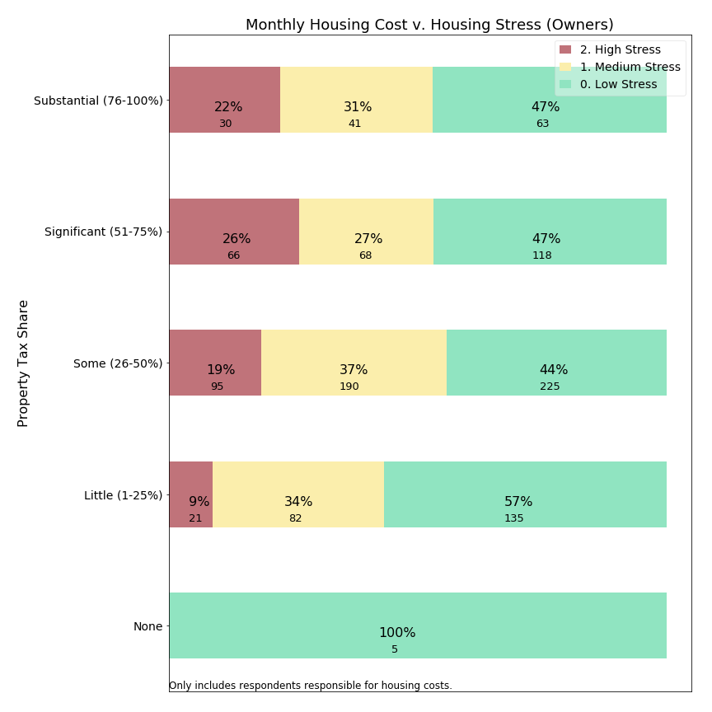

Among respondents reporting property taxes in excess of one-quarter of their housing costs, similar high stress levels exist to the general owning population. However, for those for whom property taxes are less than one-quarter of the monthly housing bill, high housing stress is reported only 9% of the time, or about one-half the rate for owners in general. This suggests that homeowners might be less stressed when property taxes are only a small portion rather than the dominant portion of their housing costs.

### 4b. Migration in the Survey

The Committee’s charge to support residents remaining in their home not only covers stress, but also whether residents appear “forced out” of Lexington. The survey asked whether the respondent is considering relocating from Lexington in the next 10 years. Arguably this is a subjective forecast, and actual migration occurs due to changes in life circumstances (such as employment relocation, marriage, grandchildren, divorce, limited mobility or injury, and death of a partner) at least as much as due to property tax burden. These questions measure whether the respondent gives serious thought to leaving Lexington, rather than whether they actually will move away. Moreover, a decision to migrate by itself might not indicate the respondent feels “forced out”. The sections below examine whether respondents forecast departure in the next ten years, using the term “migration” in charts for this subjective prediction.

**Migration versus Owning and Renting**

As we have seen, the largest divide in housing stress is between owning and renting. Given the transaction costs of home ownership, it should not surprise us to see a divide in migration as well:



Perhaps the most surprising aspect of this chart is that one-third of owners indicate intent to depart Lexington in the next ten years. Given actual migration patterns, which include moves due to unanticipated circumstances, this figure might seem higher than expected. What is driving half of Lexington’s renters and one-third of it’s owners to forecast migration? Is it related to property taxes?

**Migration versus Housing Stress**

If property tax burden can affect migration, then we should expect to detect a relationship between monthly housing stress and migration intent. Some individuals with high monthly housing stress might seek to leave Lexington to reduce housing stress. Alternatively, it is possible that even residents with lower levels of housing stress might forecast departures of Lexington to earn a better return on their housing assets. A $10,000 property tax differential between Lexington and Cambridge, for a similar priced home, could simply tip the scale.

Below is the relationship between housing stress and migration in survey responses:



For owners, the survey data shows a strong relationship between monthly housing stress and whether respondents are considering migration from Lexington. For those experiencing significant or substantial levels of housing stress, over half are likely to depart Lexington. (We assume causal direction from housing stress to migration.)

Is there a similar relationship between housing stress and migration for renters?

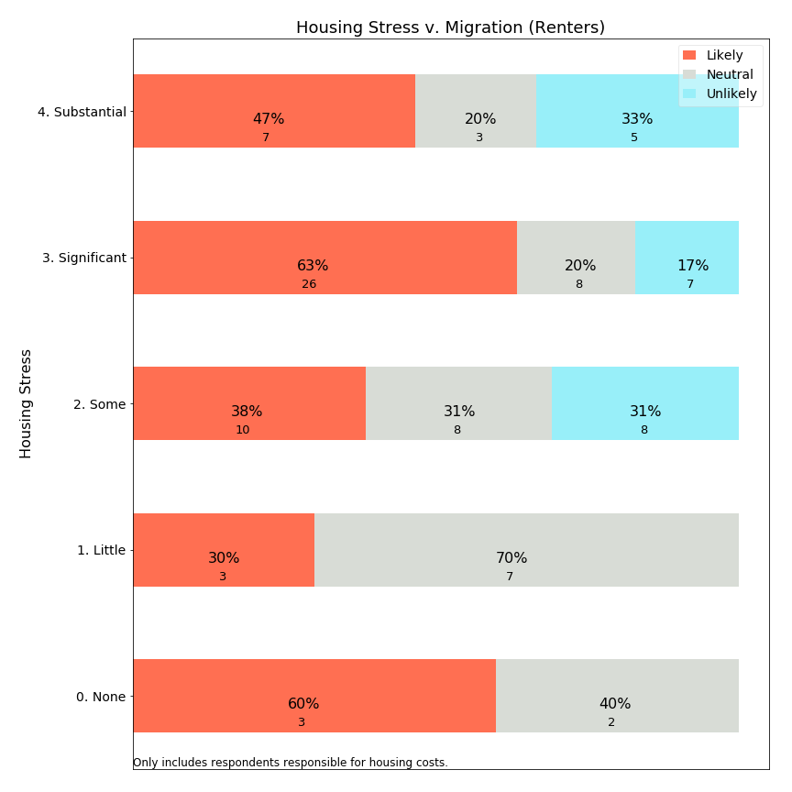

Discerning a pattern for renters is hindered by the small number of respondents for most level housing stress. Renters reporting significant housing stress are a sizeable group, however, and almost two thirds of them are likely to move away. Unlike home owners, renters may have lower transaction costs in changing housing and are able to migrate in response to service and cost considerations. It could be that higher migration is typically expected for renters, and rents respond more quickly to compensate renters for Lexington’s relative value in the rental market.

**Migration versus Home Values: Owners**

The SRE provides relief to owners of lower value homes. Is this group of residents more likely to migrate?



The survey data suggests that those living in lower valued homes forecast migration at slightly *lower* rates than those with medium or high value homes. If forecast migration rates are lower for those in low value homes, then survey data suggests raises doubt about whether a residential exemption protects residents from being forced out of Lexington.

**Migration versus Income (owners)**

On the other hand, a means-tested exemption would use income as a criteria. Are lower income owners more likely to migrate out of Lexington?



The survey data suggests that migration forecast is highest in the $50,000-$74,999 range and slowly declines with increasing income. While not a strong relationship, a means-tested exemption reaching up to $75,000 would benefit those in this subgroup. We cannot predict whether that benefit would change their migration choices.

An interesting exception to the general trend presented in this chart is respondents with income under $50,000. This group forecasts a lower likelihood of departing. Is it possible that some of these residents are in affordable housing and unable to realize similar value elsewhere? Alternatively, do their financial circumstances (including transaction costs associated with moving) make it difficult to leave, so that rather than being “forced out” they are “locked in” involuntarily?

**Migration versus Income (renters)**

Means-tested exemptions can provide tax relief to renters based on income. What does the survey data show about income versus migration forecast for renters?

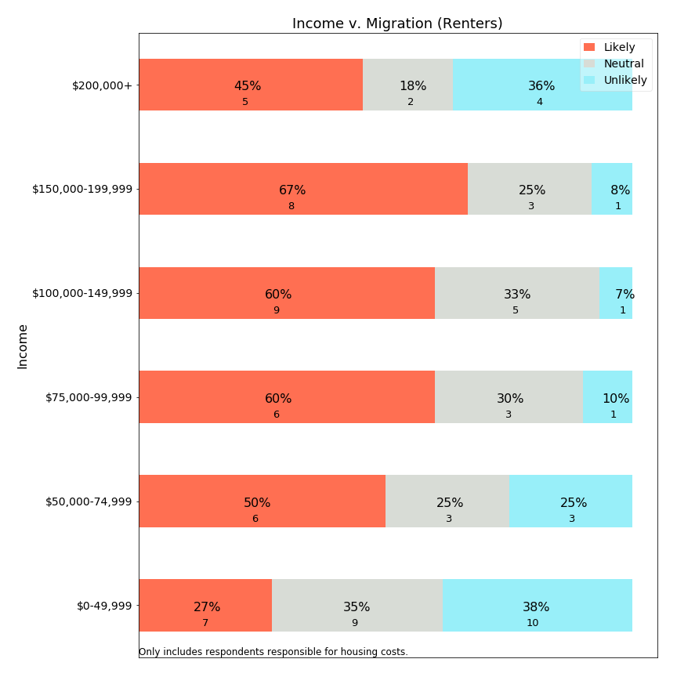

It appears that migration likelihood increases with income until $200,000, while the small sample above $200,000 may elect to continue renting in Lexington--though these sample sizes are quite small. At the lowest income level, renters may be much less likely to migrate, however. A review of affordable housing limits ($51,150-$78,900 for households sized 1-5), suggests that some portion of this group may reside in affordable units with rent control. Beneficial rent control could support a renter staying in place for a longer time.

**Migration and Monthly Rent (Renters)**

If low income renters forecast migration less frequently, is that pattern repeated when examining monthly rent?

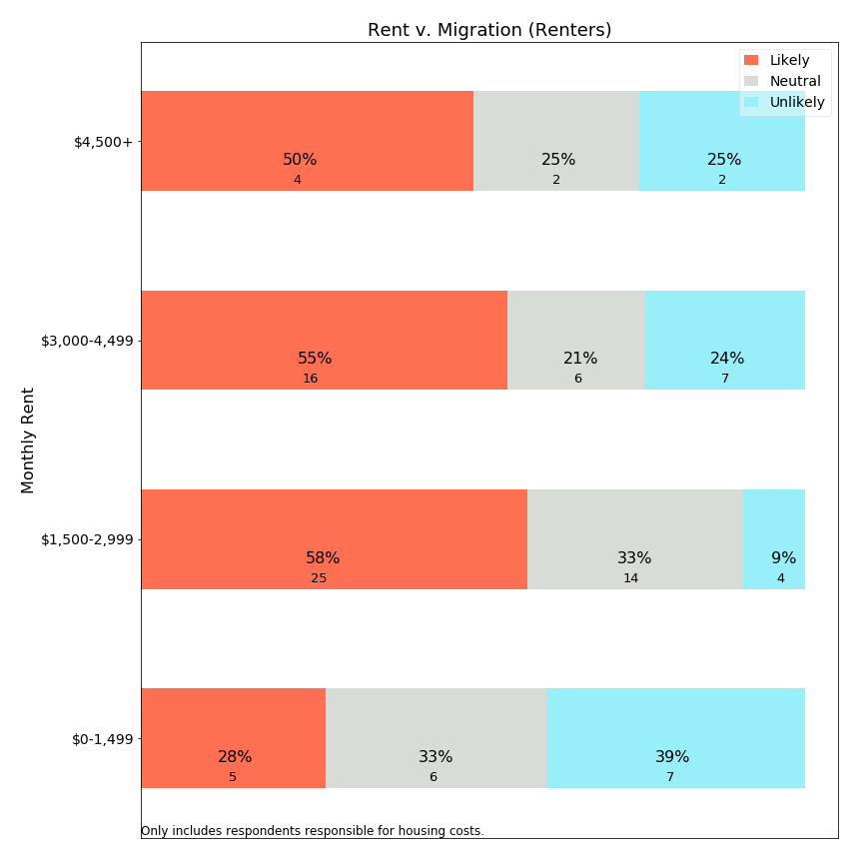

Yes, examining the relationship between rent and migration, we see a dramatic drop in migration expectations for renters with rents below $1,500/month. Because rents at this rate would typically be rent controlled (affordable) or only a room in a house,[35] it appears that renters in affordable housing are more likely to remain in Lexington than those with higher rents. This finding is particularly interesting because we (earlier) found that housing stress is higher for those with lower rents.

**Migration versus Age: Owners**

The Committee examined whether senior citizens are being forced to leave Lexington. Below is a visualization of age versus forecast migration:



The survey identifies that owners in the range age 50-69 forecast the highest likelihood of relocating from Lexington. Especially troubling is the 50-59 age category, where about half of residents indicate high likelihood of leaving Lexington in the next 10 years. For those educating their children in the public schools, this age group represents those typically with older children who can expect to complete public school education in the next 10 years. This age cohort is also planning retirement and determining whether Lexington is a community in which they could remain through retirement.

As expressed in comments to this Committee (see Public Hearing appendix and survey open-ended responses below), many community members are frustrated that so many residents would educate their children in the public schools and then quickly leave. This 50-59 cohort is valuable to keep in town, as they would typically have the financial resources to contribute to town budgets while they continue to earn income. A poorly deisgned residential exemption could have the effect of “pushing” this vital age cohort out of Lexington, or ensuring that the half who are likely to leave will leave. While the SRE is designed to benefit those in smaller homes, it is unclear whether the 50-59 year old population is living in those homes. Moreover, most means-tested implementations, like the state circuit breaker, have a minimum age of 65 and offer no benefit to the 50-59 year old respondent. Data from the survey suggests that, if Lexington has a migration “problem” among homeowners, it is across the 50-69 year age range. It is possible that neither type of residential exemption would benefit this population of mobile professionals, and could increase motivation for them to leave Lexington. Further study beyond this Committee’s work may be needed to understand migration motivations for this specific population.

**Migration versus Age: Renters**

While renters are more transient than owners, what does the survey data tell us about the relationship between age and forecast migration?

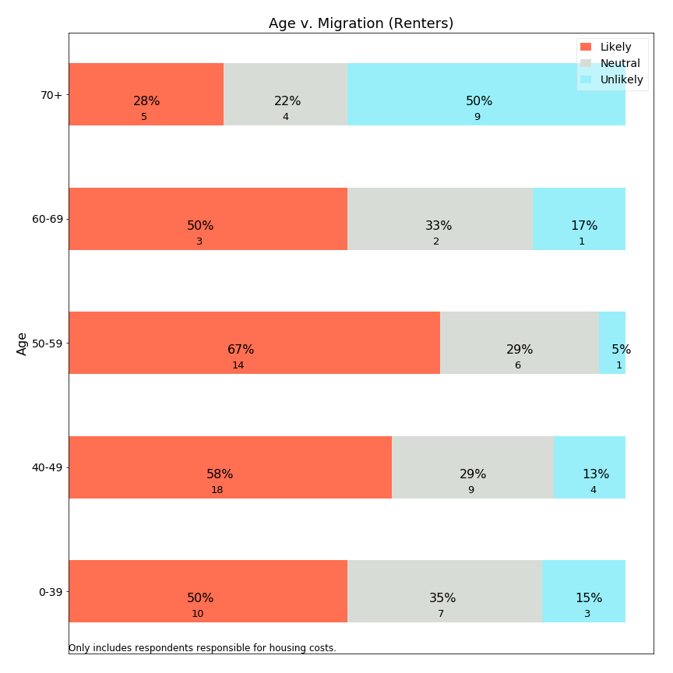

As with owners, higher forecast rates are seen for renters aged 50-59. High rates of mobility exist for all ages, except the 70+ age population which shows a decreased intention to leave. These charts suggest that seniors are not being “forced out” of Lexington, or that those reaching retirement age assess their financial resources before deciding to remain in Lexington through old age.

**Migration versus Time in Lexington: Owners**

Means-tested exemptions often include a residency requirement. What does survey data tell us about the relationship between residency length and forecast migration?

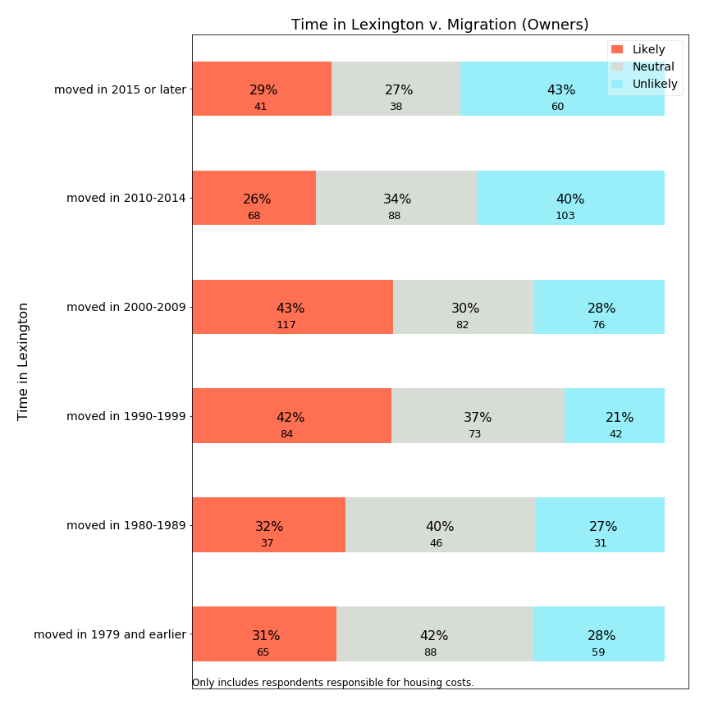

Not surprisingly, the most recent owners in Lexington forecast the lowest rate of planned migration. Those who have just arrived plan to stay. Those who entered Lexington between 1990-2009 forecast the highest rates of departure. This may correspond to the age range charts shown earlier and include many residents who may have entered Lexington for education of their children and are now considering next steps as retirement approaches.

**Migration versus Time in Lexington: Renters**

How does time in Lexington relate to migration for renters?

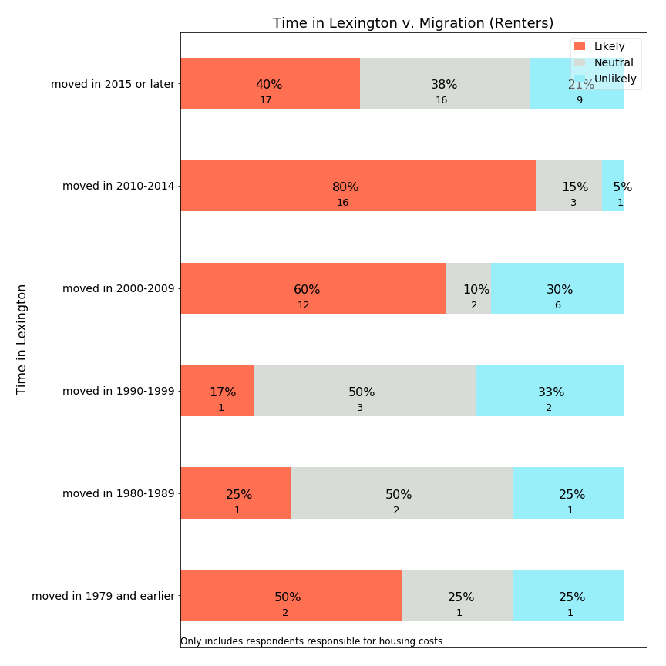

The majority of renters entering Lexington from 2000-2014 expect to leave Lexington in the next ten years. In contrast, those who have been living in Lexington for more than twenty years and are presently renters are more likely to continue living in Lexington--but these long term renters are an extremely small group.

**Migration versus Means-Testing**

Using survey data, we can examine whether respondents approximately qualified for “Sudbury-like” means-testing have lower or higher tendency to forecast migration.



Surprisingly, the small percentage of residents meeting all means-testing eligibility criteria report migration likelihoods at similar frequencies to those who do not. It is possible that those who need the most financial assistance have depressed levels of mobility due to their financial circumstances. This suggests that the impact of a residential exemption may impact psychological stress more than migration.

**Migration v. Monthly Housing Cost: Owners**

How can the survey provide insight into whether overall monthly housing costs are encouraging residents to migrate?

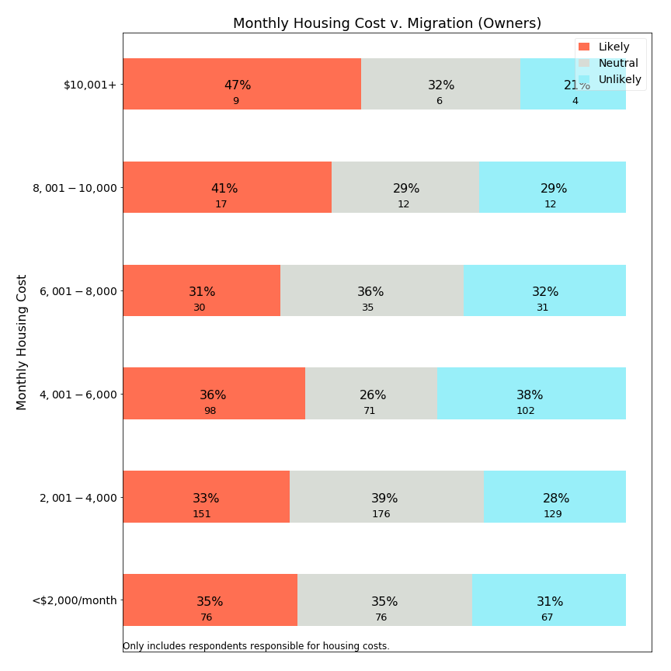

Monthly housing costs around $8,000 appear to be an inflection point, above which residents are more likely to leave Lexington and below which they are less so. It seems likely that these values represent mortgages and other costs more than property taxes, given their high levels.

**Migration versus Property Tax Share**

If property tax share is associated with housing stress, is it also predictive of migration?

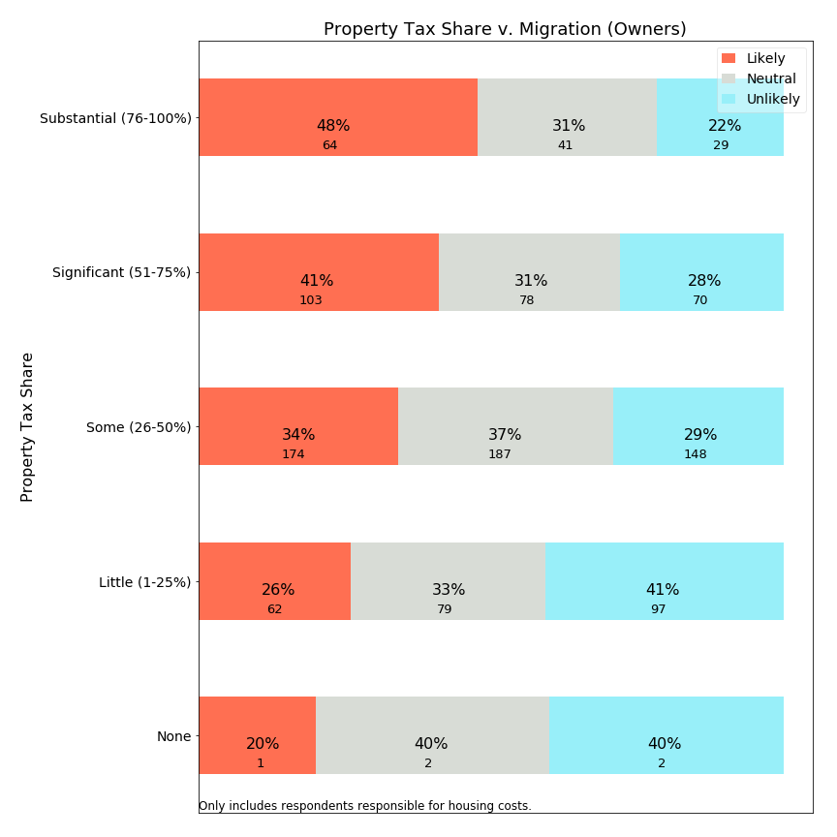

The survey data shows a fairly clear relationship between property tax share and frequency with which respondents indicate they expect to leave Lexington. Among those with under 25% of housing expenses due to property taxes, about one-quarter likely to leave. At the other end, those with more than 75% of housing expenses as property taxes indicate fewer than one-quarter expect to stay in Lexington for ten more years. Since high property tax percentage is driven by mortgage age or perhaps subjective perception, it is unclear whether public policies would specifically target residents who have large property tax share of housing costs.

## 5. Correlation Charts

The following charts identify the frequency relationship between independent variables. These charts provide a picture of Lexington demographics, and those who would be net beneficaries or contributors to a residential exemption.

This chart shows the relationship between home value and income, two variables which are often used as eligibility criteria for a residential exemption:

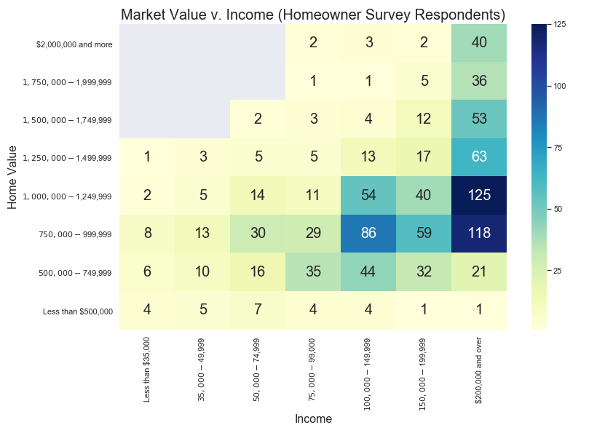

The gray boxes represent intersections which had no respondents in the survey, such as owners of $2,000,000 homes with incomes below $75,000. Because the SRE would help those below a horizontal breakpoint (around $1,200,000), a substantial numbers of respondents with incomes above $100,000 would be helped by this exemption (dark blue boxes on the right). On the other hand, a means-tested Residential Exemption would help a subset of those on the left portion of the chart (a vertical breakpoint), typically around $75,000.

Additional charts examine the subset of these respondents who own single family homes and condominiums:

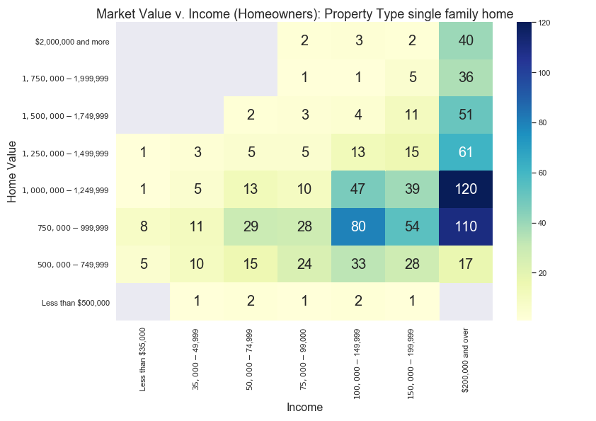

Above is a chart showing market value v. income for single family homes, to be contrasted with a similar chart below for condominium owners.

Survey respondents with reported home values below $500,000 typically owned condominiums (lower chart). Additionally, the condominium chart highlights that the largest group of condominium owners have properties valued between $500,000-$749,999 and are supported by incomes between $75,000-$149,999. This large cluster of owners would benefit from a SRE, as this exemption would benefit nearly 100% of condominium owners--including those earning over $200,000 income. However, this same group would typically not qualify for inclusion for typical means-tested exemtpions.

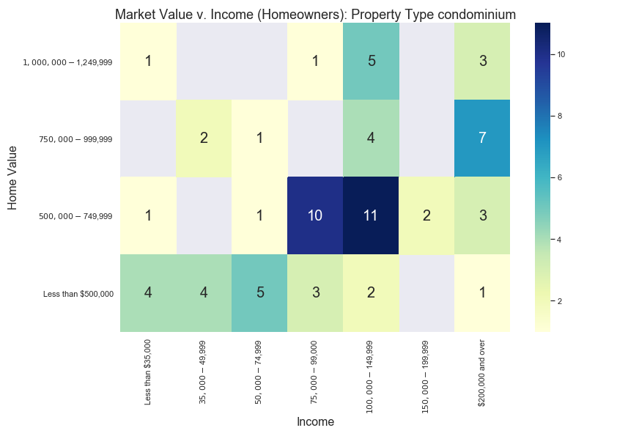

How does housing stress relate to these income and home value intersections? For this calculation, we assigned a value=1 for each respondent with significant or substantial housing stress, and value=0 for lower stress categories. The cells in the charat below show the ***percentage*** *of respondents reporting these “high” stress levels*:

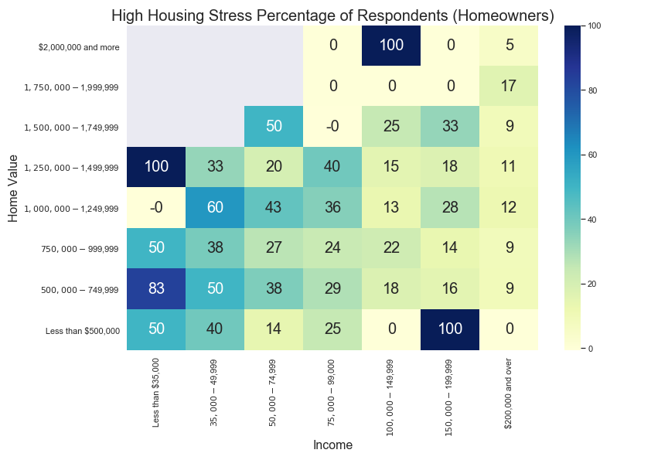

As this chart shows, high housing stress exceeds 25% of respondents for incomes below $100,000 and approach 50% of respondents incomes below $50,000. However, housing stress is not uniform for home values, as those with higher income levels do not consistently report high housing stress at any home value level.

## 6. Open Responses to Survey

Two open response questions were designed to solicit further information. The first open response question asked for additional information or elaboration after asking about monthly housing stress, with no prompting about property taxes. The second question was at the end of the survey, requesting any additional information respondents wanted to offer. The section below enumerates the most frequent phrases elicited in response to these questions and provides samples of comments using these phrases. There are several themes which can be summarized here:

1. High property taxes. Even for those who value the town services, the most common resident complaint was that property taxes have increased too fast and are higher than comparable towns. Concern about high property taxes was a consistent theme across most comments and keywords.
2. Town services. Some residents appreciate the services received, while others do not feel they are of sufficiently high quality for the taxes paid.
3. Capital projects and school spending. Several residents touched on these factors as drivers for high property taxes.
4. Future property taxes. Several residents mentioned future projects such as the police station and the high school, and a few suggested the town prioritize school projects and not attempt to do more than can be accomplished.
5. “Our” money. A few responses express resentment that town government does not treat money as their own and spend money too easily.
6. Long term residents. Several respondents lament changes to the character of the town.
7. Fixed income. Numerous respondents indicate that property taxes are too high for those entering retirement.
8. Rent or utilities. Several respondents are concerned about the cost of rent or utilities.
9. Regret about plans to leave Lexington. Respondents, including some with children in school, retirees, and multi-generational Lexington families express regret about plans to leave Lexington.

Resident comments will be published along with survey responses. The comments are in a separate data file and randomized so they will not correlate with the survey responses and maintain anonymity. Moreover, the comments were reviewed and edited with these guidelines:

Intent to keep comments intact as much as possible and substitute or redact any portion which is problematic, maintaining the spirit of openness and avoiding censorship claims.

Specific concerns to review:

* Comments which might lead to identification of a particular person making the comment. These include: specific age, employer, street name, etc.

* Comments which stereotype others while not contributing to the conversation constructively.

Where redaction or editing occurred, the specific section was substituted with square brackets (“[ ]”). For example, a year “1964” could become “196[x]” or a specific employer could be adjusted to “[employer]”. The comments reported below are post-redaction.

**Open Response Statistics and Quotes**

The first open response question asked about housing stress, which yielded the following most frequent bigrams (2-word phrases):

|  |  |
| --- | --- |
| Bigram | # occurrences |
| property taxes | 31 |
| property tax | 25 |
| affordable housing | 14 |
| stay lexington | 10 |
| town services | 9 |
| taxes high | 8 |
| living lexington | 7 |
| high school | 7 |
| tax burden | 7 |

For each bigram, we share a representative sample of comments:

property tax or property taxes:

“Town really needs to stop spending so much money in order to stop the terrible rise in property taxes…”

“Other than that the house is too big for two people, property taxes would be second biggest reason to move.”

“I do indeed consider property taxes in Lexington to be prohibitive for seniors and retired persons.”

“Certainly property taxes are high, but we see great value from town services.”

“The combination of property taxes and the lack of new, smaller private homes in good condition, we do not anticipate being able to stay in Lexington.”

“Being able to defer property taxes helps me a great deal.”

“Property taxes are higher than my mortgage and will be the reason I move out of Lexington”

“We love Lexington but as the kids leave the nest, the fact that property taxes increase and retirement is getting closer, we are not sure we will choose to stay here due to the high taxes.”

“...please do not make the property taxes progressive, i.e. a higher percentage for larger homes. Just stop spending beyond your means. Just like the rest of us have to do.”

“My mortgage holder (my mortgage originator sold my loan to [company]) denies my participation in the town's state-enabled property tax deferral program for an arbitrary, trivial reason.”

“Not eligible for a property tax deferral (age) tax work-off covers only 10% but this becomes a moral question. These programs are a cruel hoax on senior citizens in town. Why do I have to work till I die, when others come in educate their children then leave and actually financially benefit from the capital gains on the sale of their property.”

“We have lived in town since 196[x] and will hate to leave. Seniors need a break on property tax”

“Lexington government's lack of fiscal discipline is driving property tax rates to extreme levels that will drive senior residents away and block newly established couples from living here.”

“I am concerned with the rising property tax rates and the ability of aging residents to pay. This town is always talking about diversity, but they don’t seem to be concerned at all with socioeconomic diversity.”

“We'd really like to stay in retirement but need to find a lower property tax.”

“High property tax (injustice) makes it so difficult for me to think of saving for retirement.”

“As tax reform and property tax can not be deducted and really Hope town consider lower the tax rate. use our tax money as their own money.”

affordable housing:

“Please consider providing more affordable housing for seniors.”

“Our senior citizens and young families need affordable housing. Our seniors do not need expensive elder care/senior facilities--they need small single story rental options that are TRULY affordable so they can age in the town they love.”

“there needs to be more affordable housing availability for those over 60 &/or retiree's without children to help to maintain the diversity of our community.”

“It is appalling that people are buying houses here and not living in them, using them for tax shelters, or buying houses and letting people live there to attend the schools. There isn't enough affordable housing in town, and it impacts our neighborhoods and the makeup of our town.”

stay lexington:

“I hope that it helps to allow taxes to be lowered so I can stay in Lexington”

“We can't afford to stay in Lexington like our parents did.”

“We won't be able to afford to stay in Lexington when we retire.”

“Lexington Town Taxes are prohibitively high! As we age, it is not economically viable for us to stay in Lexington, a town in which we have rented, and then owned a Town House and now a Single Family home! Town finances need to be managed better before passing the burden to the Town residents.”

“I wish they will be a way … to stay in Lexington in my home forever once my kids outgrow the school system .. as an [foreign country] immigrant and US Citizen this is my home and the only one I can go back when I retire ...due to the political situation of my original country ... I wish I could financially be able to afford it but even with savings, Lex taxes are crazy high …”

town services:

“Besides the school system, we don’t see strong value for our taxes reflected in other town services. It is motivating us to move when our kids complete school in this area.”

“We are fortunate to have many excellent town services”

“Do not implement a residential exemption that simply shifts the tax burden to other residents. Cut town services particularly schools to make up for any shortfall created by any residential exemption.”

“We are concerned with the constant capital projects in the town related to town services, fire station, Cary Hall, DPW garage, community center, in a time where we have and have had multiple school projects at the same time.”

taxes high:

“Property taxes are high, but we do receive a lot of benefits.”

“Certainly property taxes are high, but we see great value from town services.”

town taxes:

“I do hope the survey will be used to find ways to stop increasing town taxes. People move out of Lexington because of the taxes, there must be a way to decrease the spending so we don't have to increase taxes.”

“We love living in Lexington and all the town services, community organization and especially the public schools. We understand that takes money and have no issue with the level of town taxes. However, for the money we are paying, we are disappointed in what we're hearing so far of the math program at Harrington Elementary.”

living lexington:

“Cost of living in Lexington is incredibly high, and it's very depressing to watch all the smaller and more affordable homes in our neighborhood torn down”

“Many people in the town are upset about the rising cost of living in Lexington, particularly the rising property taxes. Most people are not aware of the 32% increase that is locked in over the next 10 years based on official Town projections, nor are they aware that this increase does not include any new taxes to fund the $300 million+ (Town estimate) replacement high school that is in early planning stages.”

“We hope to age in place because we love living in Lexington. However, the taxes may make that prohibitive.”

“Taxes make it impossible to retire and stay in lexington. I was born in 195[x] in Lexington and I am 3rd generation living in lexington.”

“i love living in lexington-think it is a great well run town”

high school:

“General concerns about rising taxes and large-scale projects (high school, fire station, new children's place, etc) and whether all options are being considered”

“Tax burden to Lexington residents is to high. Tax dollars should be spent on the need for an new high school and cut everywhere else.”

“The schools have become so large and overcrowded, there are no opportunities for kids to participate in any extra-academic/extracurricular activities: 150-200 kids show up to compete for a spot in a school team with 10 kids. The town needs to do something to discourage this crazy expansion of the school system.”

“Please look for ways to have Lexington a lifetime town, not a move-in with preschool kids, move out when the kids graduate from high school.”

“Lexington needs to control spending and be more diligent regarding capital expenses as most families move here for schools and re-building the two middle schools and high school should be the ONLY priority of major projects for the town next ten years.”

tax burden:

“The tax burden is significant and becoming more so. Why do we usually seem to choose the deluxe version when a lesser version is ample, e g. the community center, design for new police station.”

“Some towns such as Cambridge give tax breaks to owner-occupied dwellings, and others have enough tax base (commercial and industrial firms) to make the tax burden fall more lightly on homeowners. We live in a neighborhood where as homeowners of a 2 bedroom bungalow we pay considerably more taxes than the million dollar restaurant across the street.”

“Large families move in for the school system, but their local taxes don't pay the extra cost of putting their children through the schools here. The tax burden gets placed on empty-nesters and retirees.”

**Second Open Response Question**

At the end of the survey, respondents were asked to share additional comments. These were the most frequent bigrams:

|  |  |
| --- | --- |
| Bigram | # occurrences |
| property taxes | 58 |
| property tax | 39 |
| taxes high | 27 |
| real estate | 23 |
| estate taxes | 18 |
| years ago | 13 |
| fixed income | 11 |
| tax high | 9 |

property taxes or property tax

“We pay almost $3700 four times a year for property taxes. Compared to other towns we talk to friends about they get almost twice the services we do here.”

“My husband is dead, and my house is paid off. I’d love to stay in Lex, but I am paying ‘full freight’ and utilizing few services. I looked to see if there were any deals for my in the area of property taxes ($18,000). I didn’t qualify. I’m not Section 8 level. I sold my house”

“It bothers us that property taxes are less in other similarly situated towns with equivalent services.”

“Do have concerns about rising property taxes, especially with new federal tax laws”

“Thinking about retirement. The cost of property taxes will be prohibitive.”

“Taxes keep increasing and even when the mortgage payments will be done we will still pay nearly $1200 per month for property taxes. This becomes an issue as we age and retire”

“My property taxes consume 33% of net income”

“Our property taxes are sky high and keep going up. Our youngest is going to be done with public school soon and we are talking about moving to a town with lower property tax rates”

“In 2004 my husband and I bought our house in Lexington and our property taxes were $3000 a year. Now they have almost tripled and we are retired [living on retirement savings] and Social Security. We really love Lexington and believe in spending for good schools, etc., but it may not have been smart for us to move here in retirement.”

“Too many rental units with children attending public school which makes the school overcrowded and put stress on higher property taxes”

“After kids are done with Lex public schools, we would consider moving out of town because of high property taxes. Town is wonderful and provides many great resources but wished there were a bigger business tax base so that the burden of taxes doesn't come upon residential property owners.”

“My husband is still working at age 7[x] but when he retires I am quite concerned about our property taxes. We have an adult child with special needs living with us and cannot downsize or move very easily.”

“property taxes have >TRIPLED in 15 years. NOT sustainable!”

“Half of my military retirement pay goes to property taxes. I'm retired.”

“Our property tax has nearly doubled in the past 5 years and will likely double again once the new levies, plus the upcoming levy for the new high school, are added. We are seriously considering moving to another town where the property taxes are more fair and reasonable.”

“With our current income and spending, our budget is borderline break even if not in the red, and ANY increase in housing costs (mainly property taxes, as these are generally the only cost that goes up every year) digs us further in the hole.”

“My property taxes are 1/10th my income. My estimated income tax is also 1/10 my income. By the time I'm done paying my bills (401K, retirement, electric, etc.), I end up with $300 to $500 a month to live on. For everything. The ironic part is that I'm too young for senior discounts (only 6[x]) and I make too much to qualify for low income. I haven't bought any new clothes in approximately 5 years.”

“We have conservation land as a part of our back-yard which we never use. It really hurts to pay property tax on that area. The property taxes are increasing way too fast than the salary increase at our workplace!”

“property taxes are too high! runaway spending in the town!”

“Our house is paid, so we don't stress about total costs, but we do stress about rate of increase in our property taxes.”

“The property taxes of $8,000/year for retired couple, former [public employee], is very HIGH! Our house is 1300 sq ft. One bathroom. Why are these taxes so high?”

“Last spring I ran out of heating oil, the property tax bill pushed out the refill until early summer. This coming year I will drop my homeowners policy because there is no room left in my budget with the increases.”

“Property tax too high when we are not using school system. We may decide to move to town with lower property tax”

“The property tax is too high due to substantial special education cost.”

“Although I'm entirely eligible for Lexington property tax deferral program, my mortgage holder refuses to allow my participation owing to legal technicalities in the structure of the program that the bank says inconveniences them.”

“When we moved to Lexington 21 years ago, our property tax was around $4600. Now it's over $12,000, and still going up faster than inflation. We won't be able to fully retire here.”

taxes high or tax high

“Town taxes are too high and spending is questionable, e.g., first fixing the old high school a few years back for $60M, and now deciding to build a new one for $200M.”

“The taxes are too high. The town spends money at too high a rate”

“Have adequate financial resources to pay bills. Would rather taxes weren't so high--and don't like to think about how high they are. But also understand that taxes are necessary for services.”

“lexington has high costs with very little services or amenities that are useful to all. it is not the same town I grew up in!”

“taxes are so high that I can't keep up with them.”

“high taxes--house assessment increase was astronomical”

“My feeling is that the assessment on our house is too high and I feel it was manipulated to increase the tax bill. Our house is old, small and in poor condition. If the taxes were lower, I would be able to fix the areas of the house that need to be repaired.”

“the taxes are crazy high”

“There have been 9 out of 10 overrides in the past 10 years. Taxes are too high even with the evaluation on all the McMansions. Negotiations on union contracts is a big problem. Where are the cost controls?”

“It is costly living in lexington, mainly due to high taxes.”

“Taxes are very high, largely because of school spending.”

real estate or (real) estate taxes

“Must move out of town due to high real estate taxes (on limited income).”

“Smaller real estate options to "age in Lexington" are few. I grew up in Lexington, graduated from the school system. My family has been here for 75 years. My view is that Lexington has focused on replacing small homes with McMansions purchased by people who want the school system for their children with no intention of making Lexington "home."”

“the real estate taxes keep going up and we are not sure we will be able to continue to live in this town--the town is spending vast sums of money to replace schools and other public buildings-- money that the town does not have and wealthier people in town keep voting for overrides”

“My attitude is that if the people of the town care about education and their kids, they care about the town in general. I feel this way, even though I have no children. I have taught in the town for [x] years. The real estate taxes are getting to us, though, as we enter our 70s.”

“expensive real estate taxes as Widow choosing to stay in familiar environment!”

years ago

“We pay $5700 a month for rent and there are only 2 adults and one high school student. It's obscene. We moved into this house 6 years ago and the rent was $4200 but it's gone up every year.”

“Our taxes have more than doubled since we've moved here 18 years ago. We're both in our 70's and plan on staying in Lexington, but worry about affording our taxes as the years go by.”

“Taxes have been on a steep increase since we moved here 4 years ago, and I believe they will continue to rise at a steep rate due to town construction on public buildings. It may become unaffordable in the near future if the town continues to grow/build at this rate.”

“Our taxes on an unrenovated, 3 bed, 1 bath, 1200 sq ft cape represent more than 1/3 of our total housing cost--and this on a house we bought 5 years ago for $500k with a conventional mortgage and downpayment. The taxes will cause us to move even before we have our child in school.”

“Our high taxes are an issue for many retirees. With new schools, fire and police buildings and other additional large expenditures happening, we and others are worried that we will be forced to move to a town with lower taxes. We do not want that to happen to us.”

“When we moved to Lexington 21 years ago, our property tax was around $4600. Now it's over $12,000, and still going up faster than inflation. We won't be able to fully retire here.”

fixed income

“I worry that Lexington spends money without any concern for those on fixed incomes e.g. Purchase and demolition of Armenian School on Pelham.”

“Real estate taxes are too high and are making it hard for fixed income retirees to remain in this community.”

“I also have elderly parents living in this town on a fixed income and the taxes we pay here are outrageous. I only stay in this town because my parents do not want to move and my youngest has 3 more years of high school.”

“Retired, on fixed income. Property taxes are very high. Mortgage is paid off.”

”Property taxes are high for those on fixed incomes. Cambridge, for example, provides both a residential tax credit and an elderly tax credit.”

“As seniors raising elementary aged children, we will be forced to move out of town as soon as they complete their education here. We will not be able to afford staying here on a fixed income. Even if we could, the housing now available would not be appropriate for aging in place.”

“I don't think that all fixed income qualifying residents know that they can defer their RE taxes at an extremely low interest rate, until their property sells. How can we get this knowledge of this very generous town benefit to every financially struggling resident who qualifies?”

“Once we retire, we are very concerned with our qtrly tax bill of $4,000. Candidly, after 33 years, we may decide to sell and find a community with Real Estate Taxes in the $6 to $8 K range, annually. We've loved Lexington but may be to expensive on a fixed income basis.”

## 7. Statistical Analysis of Housing Stress and Predicted Migration Decisions

Prior analysis sections describe correlations between pairs of key variables with visual illustrations. While such an approach is easily comprehensible, it is an incomplete characterization of variables which are driven by multiple variables. Policy makers should be interested in comparing the strength of contributing factors when multiple are present, as well as quantifying the change in dependent variables which might be expected with a change in policy. Statistical analysis offers an approach to estimate these factors.

Two questions merit statistical analysis:

* What contribution does property taxation make to reported housing stress?
* What contribution does property taxation make to self-reported, predicted migration decisions?

Household stress was surveyed using a categorical response question with five answers of increasing stress, reflecting an implied ordinal scale. Statistical estimation would best use of one two approaches:

* Treat household stress as a continuous variable with five point estimates, and use **ordinary least squares** (OLS) to predict changes on a continuous scale. This approach is limited because survey responses are truncated at a minimum and maximum value but a statistical model fits to a line.
* Use an **ordinal logistic** model to reflect latent levels of stress with estimated thresholds which are associated with respondents selecting from five levels. This method allows the thresholds to exist independently of one another, but has the disadvantage that confidence interval estimation is more complicated.

We used OLS estimation first, because it easily estimates statistical significance, thereby allowing less significant variables to be omitted in model iterations. We initially limited response inclusion to cases where the respondent reported both owning a home and being responsible for housing costs (1239 of 1475). Of these, 1208 provided answers to the housing stress question, and 914 answered all statistically relevant questions.[36] After selecting appropriate parameters, we tested our model tested against an ordinal logistic model. The ordinal logistic model test did not provide insights and is not included here.

To run analyses using the migration likelihood responses, we recorded the response categories as follows:

* Definitely Not: 0
* Unlikely: 1
* Have not considered (or) Undecided - Possible: 2
* Likely: 3
* Definitely: 4

We elected to combine two codes which are seemingly neutral into code 2 as neither response lends itself to being more or less likely than the other, and both belong somewhere in the middle of this scale. The end result is that the relocation dependent variable is an ordinal variable with five levels (0-4), with higher levels indicating higher forecast propensity to migrate out of Lexington.

An OLS model predicting housing stress has a R2=0.2, and seven significant explanatory variables. With this model, we can estimate the impact of a residential property tax exemption on housing stress levels as follows: Assume a household has property taxes of $10,000 per year (roughly a $700,000 assessed value). For a range of monthly housing expenditures ($1000, $1500, … $4000) imagine that the property tax were reduced by $5000 (50% would be a very generous tax exemption) and calculate the change in monthly housing costs and property tax % of monthly housing. Using these changes and the coefficient, estimate what happens to the level of housing stress. Not surprisingly, the findings indicate that the greatest impact of a $5000/year property tax reduction will be felt in households having the smallest (prior) monthly housing expenditures and therefore the greatest (prior) percentage of housing expenditures related to property taxes. A bit more surprising may be that the model indicates only a modest adjustment to stress with significant changes in property taxes. However, this modest relationship may be due to the fact that numerous other factors contribute to housing stress beyond the effect of property taxes.

|  |  |
| --- | --- |
| Prior Monthly Housing | Effect of 50% reduction of property taxes |
| $1,000 | -0.40 |
| $2,000 | -0.23 |
| $3,000 | -0.18 |
| $4,000 | -0.15 |

The model predicting migration forecast has an R2=0.12. While it seems that housing stress is among main drivers, and there may therefore be a direct and indirect property tax link, the statistical relationship is weak. We can estimate that a stress change of 1.0 may be related to a 0.28 change in the scale for likelihood of moving, but as the 1.0 stress change is not estimated to occur through tax exemptions, it appears that this study does not find evidence that tax policy would directly affect migration. (This finding does *not* mean that tax policy changes have no effect; it merely means that no significant effect is *identified* with the data from this survey.)

Because property taxation impacts household stress, and the latter impacts migration decisions, we have an “endogenous variable” problem which makes estimation of the impact of property taxation on migration more difficult. We tried using a third model to predict migration likelihood in which housing stress was excluded from the independent variables, since it may mask direct relationships between property taxes, household costs, and propensity to move. As the model overview below describes, the relationship appears largely consistent with the prior models. A weak model exists for migration likelihood, and a large change in property taxes and housing costs for an individual could result in a change in propensity to move, but not enough to change the distribution of responses among this survey’s categories.

Only the OLS results are reported here.

**Statistical Models**

OLS Model for Stress:

====================================================================  
Model: OLS Adj. R-squared: 0.200   
Dependent Variable: StressCode AIC: 2591.0511  
Date: 2018-11-25 21:39 BIC: 2629.5937  
No. Observations: 914 Log-Likelihood: -1287.5   
Df Model: 7 F-statistic: 33.59   
Df Residuals: 906 Prob (F-statistic): 1.05e-41   
R-squared: 0.206 Scale: 0.98833   
--------------------------------------------------------------------  
 Coef. Std.Err. t P>|t| [0.025 0.975]  
--------------------------------------------------------------------  
Income914 -0.0048 0.0004 -10.8862 0.0000 -0.0057 -0.0039  
MarketValue914 -0.0460 0.0094 -4.9003 0.0000 -0.0644 -0.0276  
Age914 -0.0136 0.0036 -3.7911 0.0002 -0.0207 -0.0066  
MonthlyHousing914 0.1538 0.0197 7.7935 0.0000 0.1151 0.1926  
HouseholdSize914 0.1602 0.0404 3.9631 0.0001 0.0809 0.2396  
PropertyTaxShare914 0.0080 0.0016 5.0903 0.0000 0.0049 0.0111  
AgeIncome914 -0.0001 0.0000 -2.1343 0.0331 -0.0001 -0.0000  
One 1.4879 0.0377 39.4321 0.0000 1.4138 1.5619  
--------------------------------------------------------------------  
Omnibus: 15.853 Durbin-Watson: 2.031   
Prob(Omnibus): 0.000 Jarque-Bera (JB): 10.355  
Skew: 0.115 Prob(JB): 0.006   
Kurtosis: 2.532 Condition No.: 1729   
====================================================================  
* The condition number is large (2e+03). This might indicate  
strong multicollinearity or other numerical problems.

Monthly housing costs, household size, and property tax share all increase reported housing stress.

Age, income, market value, and age*income all decrease reported housing stress.

Note: Variables with suffix 914 are mean-adjusted version of the 914 original survey code responses. The new variable is obtained by subtracting the mean from the original 914 observations to create a new variable with mean=0.

OLS Model for Relocation:

==================================================================  
Model: OLS Adj. R-squared: 0.120   
Dependent Variable: RelocationStat1 AIC: 2671.5200  
Date: 2018-11-25 21:49 BIC: 2695.6091  
No. Observations: 914 Log-Likelihood: -1330.8   
Df Model: 4 F-statistic: 32.15   
Df Residuals: 909 Prob (F-statistic): 4.34e-25   
R-squared: 0.124 Scale: 1.0828   
------------------------------------------------------------------  
 Coef. Std.Err. t P>|t| [0.025 0.975]  
------------------------------------------------------------------  
Age914 0.0112 0.0029 3.9053 0.0001 0.0056 0.0169  
StressCode 0.2861 0.0315 9.0718 0.0000 0.2242 0.3479  
PropertyTaxShare914 0.0052 0.0016 3.2042 0.0014 0.0020 0.0083  
AgeIncome914 0.0001 0.0000 4.8003 0.0000 0.0001 0.0002  
One 1.7572 0.0607 28.9288 0.0000 1.6380 1.8764  
------------------------------------------------------------------  
Omnibus: 19.328 Durbin-Watson: 2.027   
Prob(Omnibus): 0.000 Jarque-Bera (JB): 10.633  
Skew: -0.017 Prob(JB): 0.005   
Kurtosis: 2.473 Condition No.: 2672   
==================================================================  
* The condition number is large (3e+03). This might indicate  
strong multicollinearity or other numerical problems.

Age, stress, property tax share, and age*incoe are all positively correlated with forecast of relocation. The overall r^2=0.12, so the relationship is fairly weak.

The strongest relationship is between stress and forecast relocation. A one level increase in stress corresponds roughly to a 0.3 level increase in propensity to move.

Property tax share not only directly impacts propensity to move, but also indirectly affects through its impact on stress.

Therefore we find that property tax burden is related to forecast relocation, however the effects appear in total to be small and most impactful on those for whom property taxes constitute the preponderance of monthly housing costs.

OLS Model for Relocation (without using Stress as a predictor):

===================================================================  
Model: OLS Adj. R-squared: 0.063   
Dependent Variable: RelocationStat1 AIC: 2729.8131  
Date: 2018-11-25 22:24 BIC: 2758.7201  
No. Observations: 914 Log-Likelihood: -1358.9   
Df Model: 5 F-statistic: 13.31   
Df Residuals: 908 Prob (F-statistic): 1.53e-12   
R-squared: 0.068 Scale: 1.1529   
-------------------------------------------------------------------  
 Coef. Std.Err. t P>|t| [0.025 0.975]  
-------------------------------------------------------------------  
Income914 -0.0020 0.0004 -4.4257 0.0000 -0.0028 -0.0011  
Age914 0.0047 0.0034 1.4057 0.1601 -0.0019 0.0114  
MonthlyHousing914 0.0537 0.0184 2.9163 0.0036 0.0175 0.0898  
PropertyTaxShare914 0.0070 0.0017 4.1991 0.0000 0.0037 0.0103  
AgeIncome914 0.0001 0.0000 4.3321 0.0000 0.0001 0.0002  
One 2.1881 0.0407 53.7323 0.0000 2.1081 2.2680  
-------------------------------------------------------------------  
Omnibus: 39.032 Durbin-Watson: 2.005   
Prob(Omnibus): 0.000 Jarque-Bera (JB): 17.049  
Skew: 0.041 Prob(JB): 0.000   
Kurtosis: 2.336 Condition No.: 1604   
===================================================================  
* The condition number is large (2e+03). This might indicate  
strong multicollinearity or other numerical problems.

One may be interested in PropertyTaxShare, since it is a variable which a residential exemption might impact. PropertyTaxShare914 is a normalized version of PropertyTaxShare with this frequency distribution for the five answers::

-4.811816: 418  
-29.811816: 203  
 20.188184: 189  
 44.188184: 100  
-42.811816: 4

A category jump on this PropertyTaxShare914 scale is therefore about 20 points. So a full category jump (20) multiplied by the coefficient 20*0.007 = 0.14; so it translates to about 1/6th step in the predicted propensity to move scale. This finding is consistent with the impact of property taxes on stress found in the first relationship. It is a weak relationship with limited substantive impact.

## 8. Survey Response Summary

This section shows the response frequency for the questions asked in the survey. Each chart shows the absolute number and percent of respondents selecting each response. The open response questions are summarized in an earlier portion of this appendix.

**Section 1: Town Services**

In the past 12 months, has any household member done the following?

Q1. Visited the Community Center

Lexington recently developed a community center at the intersection of Route 2A and Massachusetts Avenue, with function rooms and multi-generation activities.

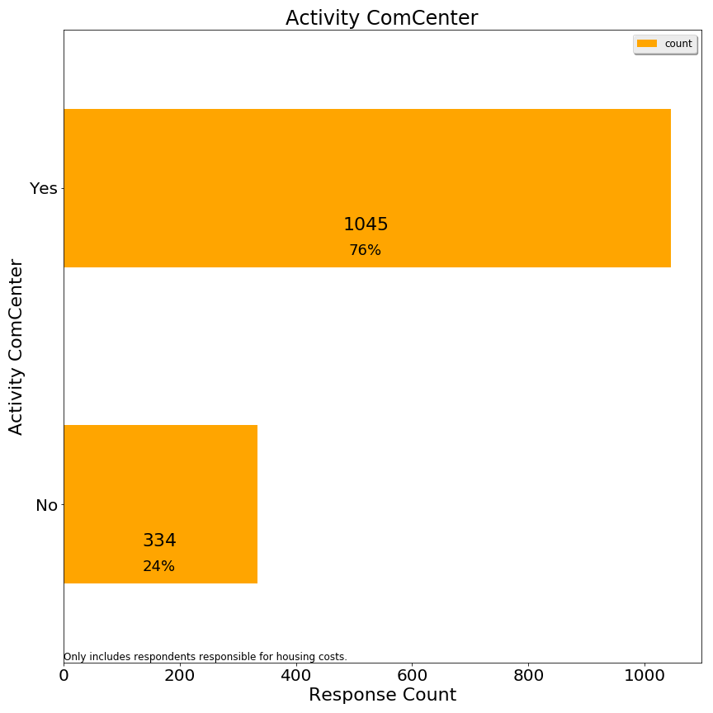

Q2. Used town swimming facilities

Lexington has an outdoor complex for swimming and splashing, as well as a beachfront style pond at the Old Reservoir.

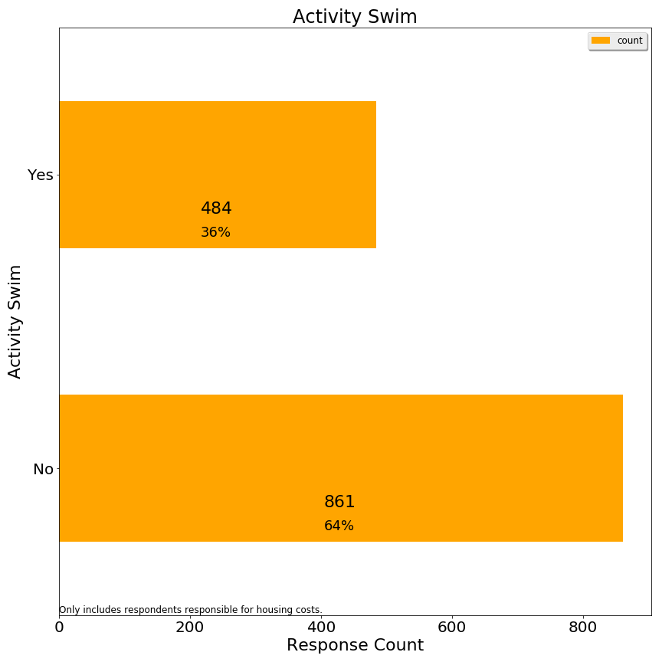

Q3. Used town recreational fields or courts

Lexington has numerous outdoor fields and tennis courts, some of which are lit for night play.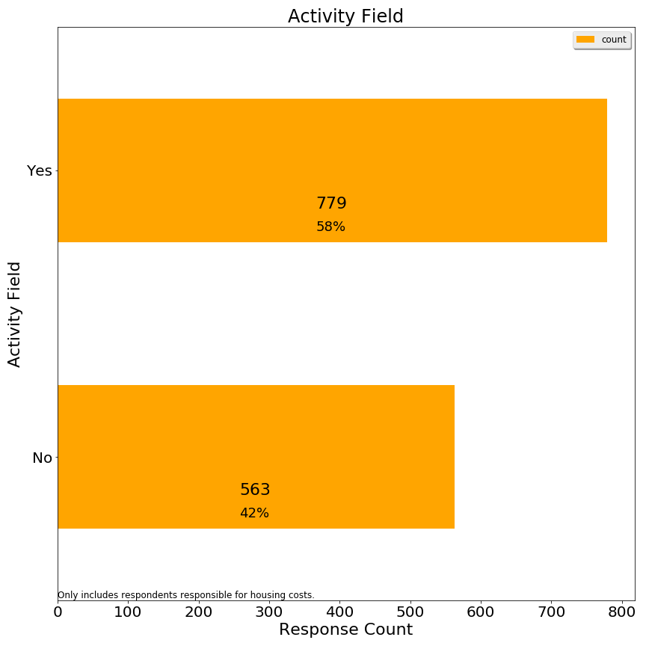)

Q4. Used Pine Meadows golf course

Lexington owns a public 9-hole golf course near route 128.

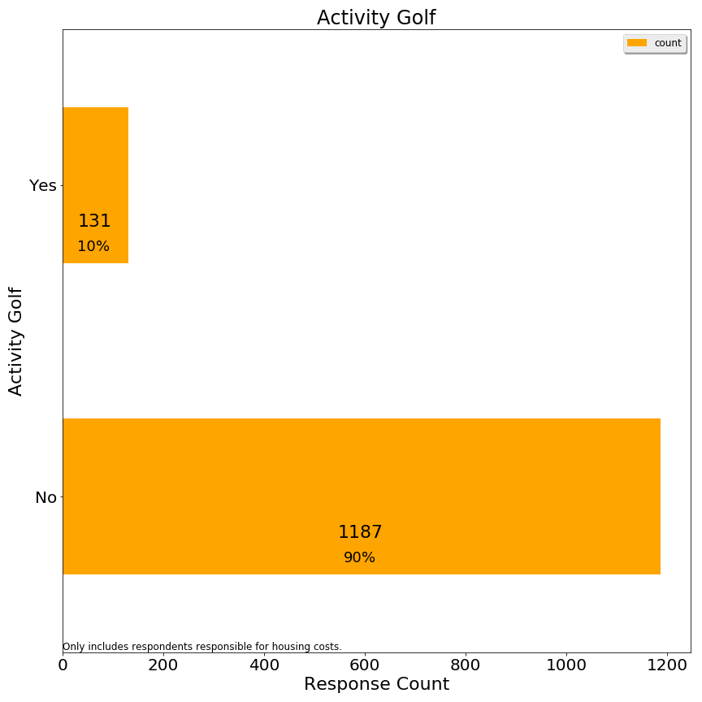

Q5. Used a school or neighborhood playground

Lexington has neighborhood playgrounds and school playgrounds, both of which are open to families without children in public schools.

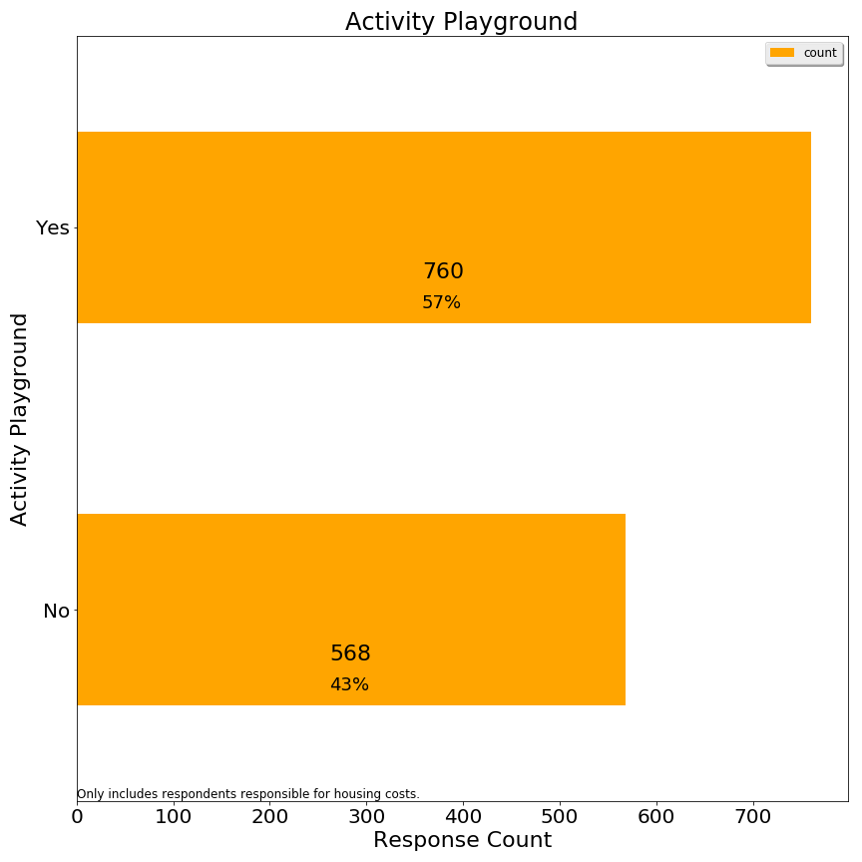

Q6. Used the Minuteman Bikeway

The Minuteman bikeway runs through Lexington from Arlington to Bedford.

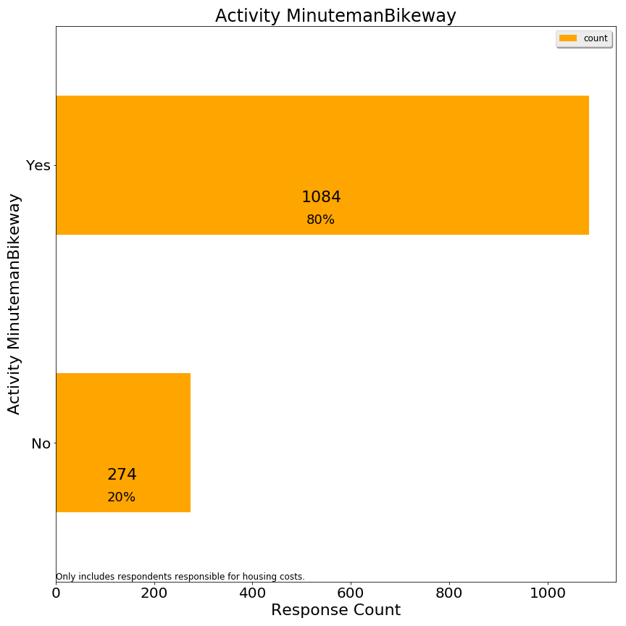

Q7. Used Lexpress bus

Lexpress is Lexington’s local bus service.

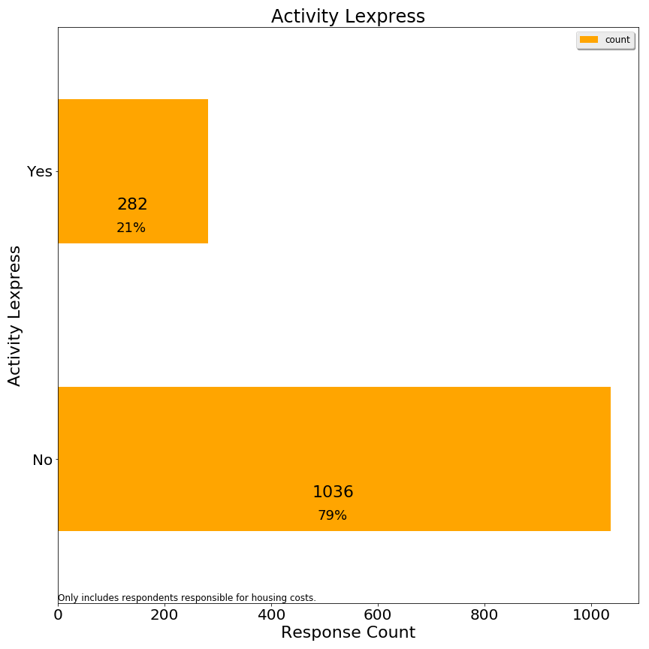

Q8. Visited Lexington conservation areas

Lexington prides itself on the large % of land dedicated to conservation.

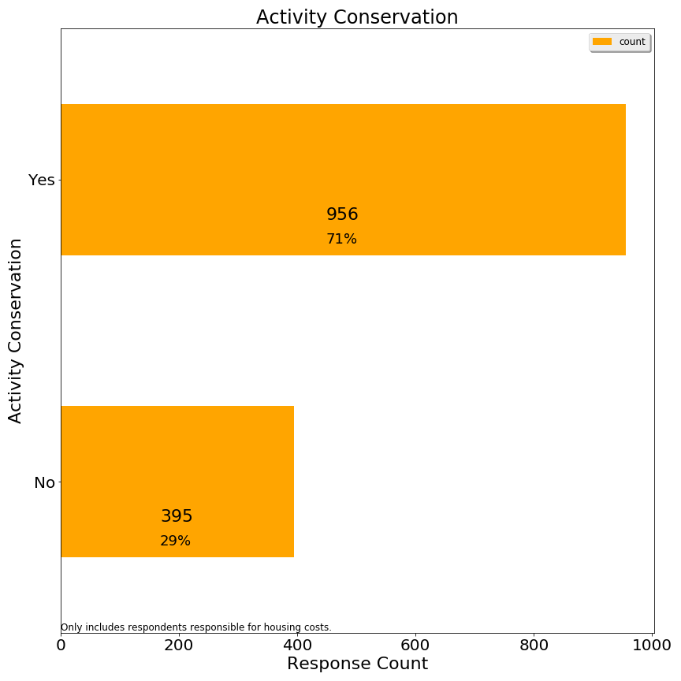

Q9. Directly received fire or police services

Lexington has 1 police station and 2 fire stations, facilities targeted for capital improvements.

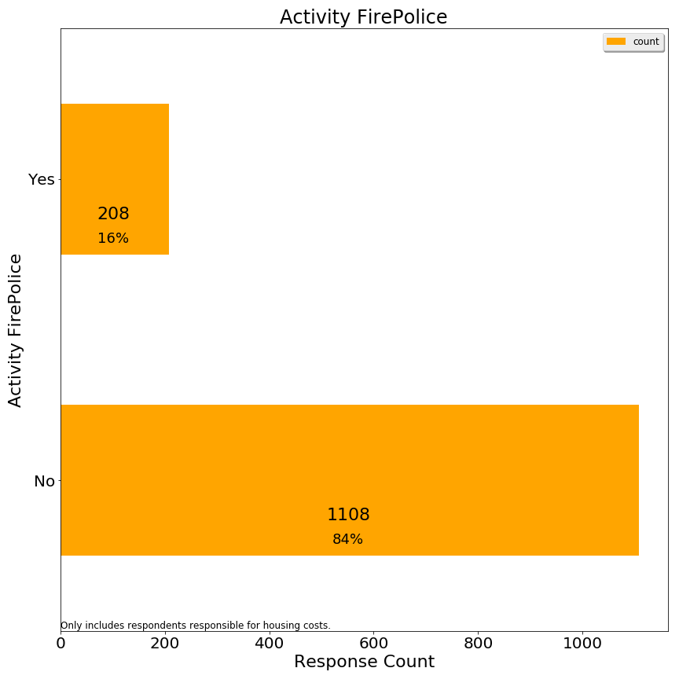

Q10. Attended Lexington public schools

Lexington public schools are a prime reason for residents to move to Lexington--to such an extent that enrollment has outpaced classroom facilities. 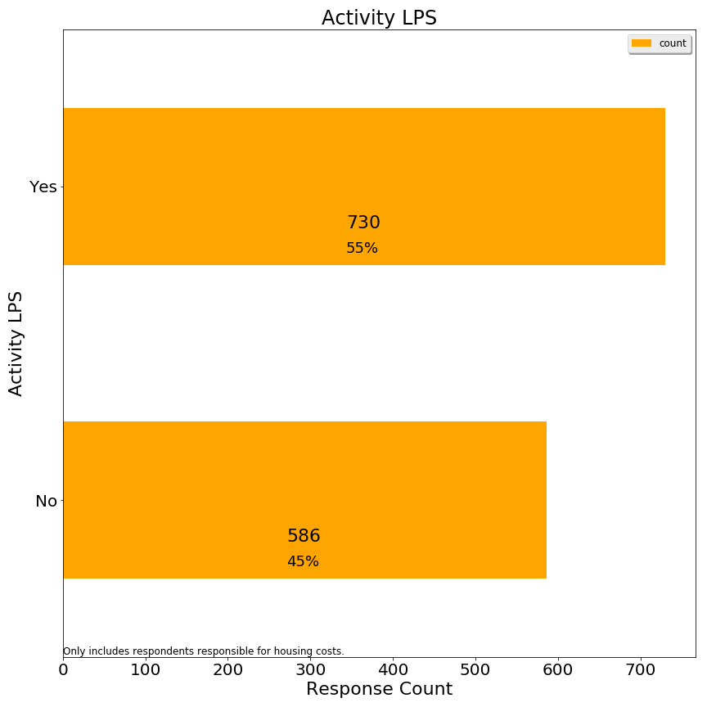

Q11. Participated in any town provided program or service for seniors

Lexington offers a variety of programs and transportation services for seniors.

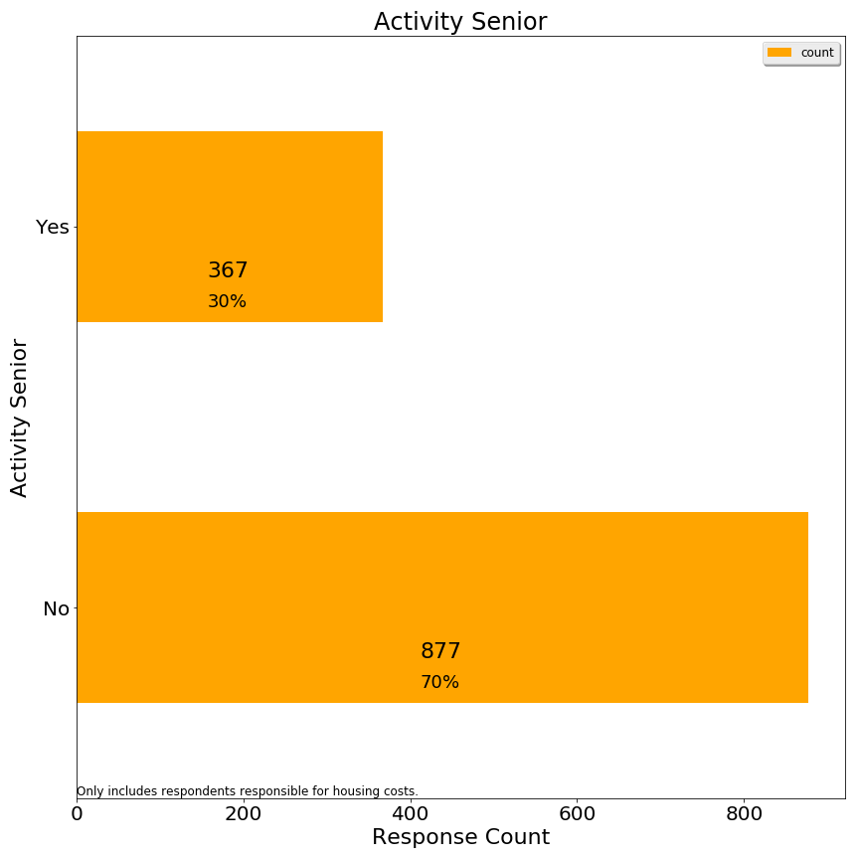

Q12.Used Cary library or attended a library event

Cary Memorial library hosts events and is Lexington’s only library at present.

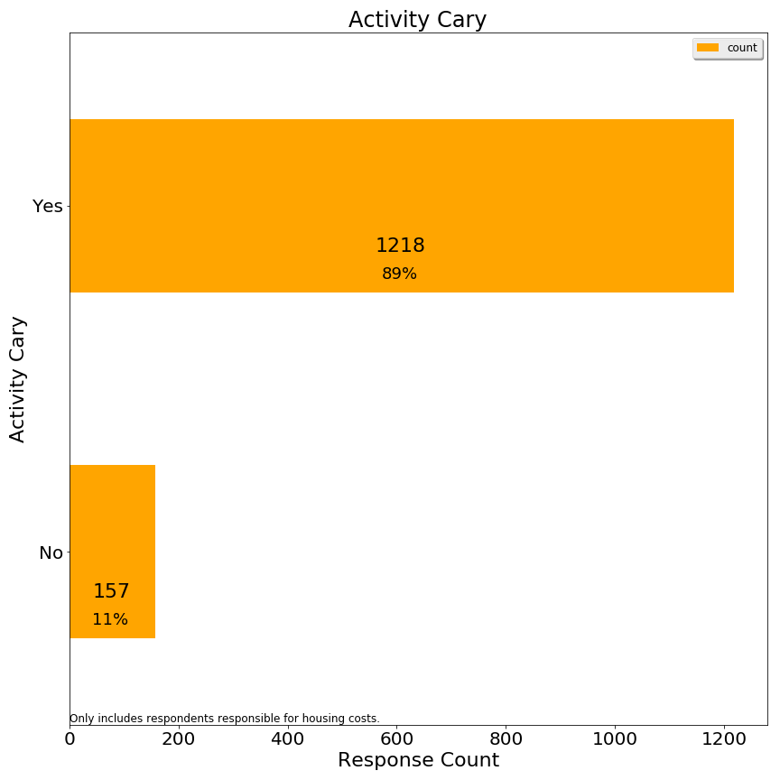

Q13.Served town government in any capacity (employee, committee member, town meeting member, elected representative)

Lexington is governed by representative town meeting and has 21 citizens from each of 9 precincts, along with various town committees which include citizens not in town meeting.

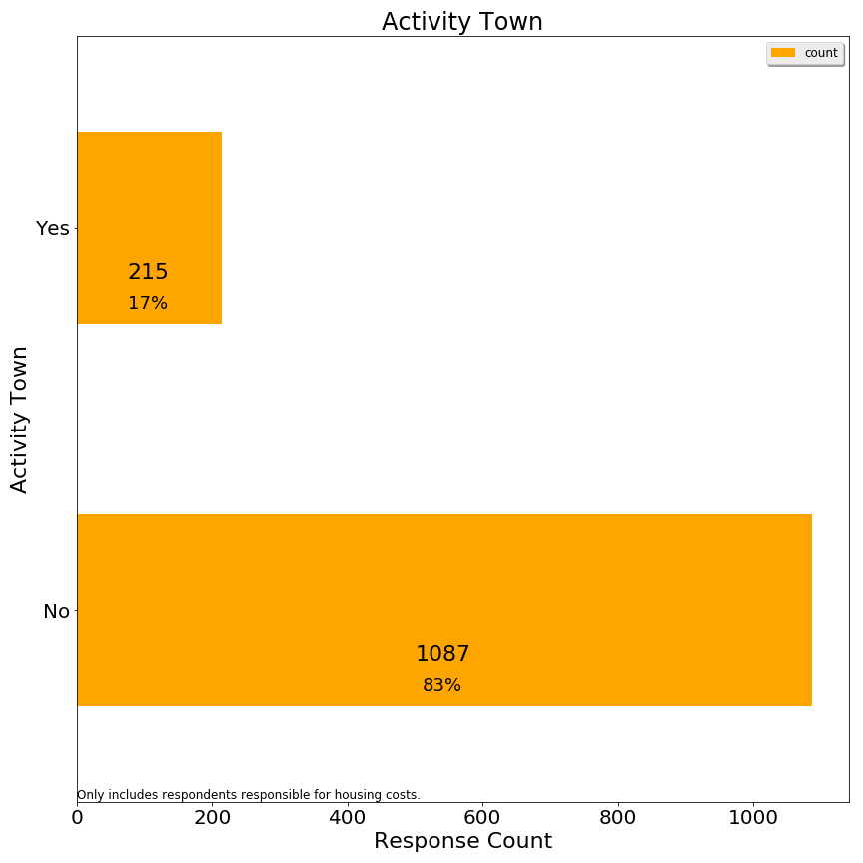

**Section 2: Affordability**

Q1. Are you aware that the Recreation & Community Programs Department offers financial aid for programs and services?

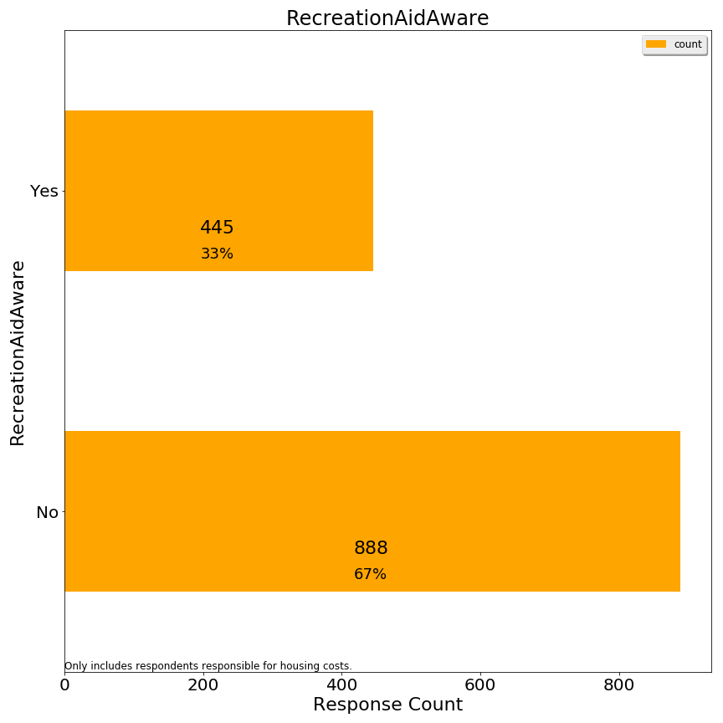

Q2. Has a household member received this type of financial assistance to participate in a program or service?

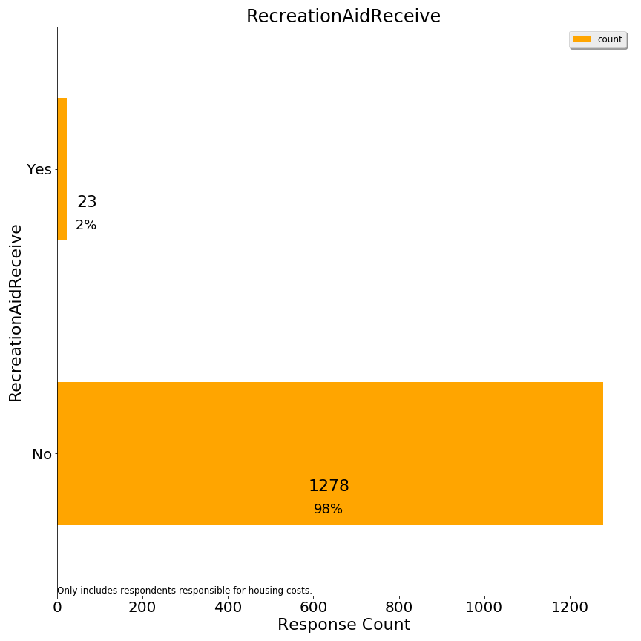

Q3. If your primary residence is rental, please indicate your monthly rental cost:

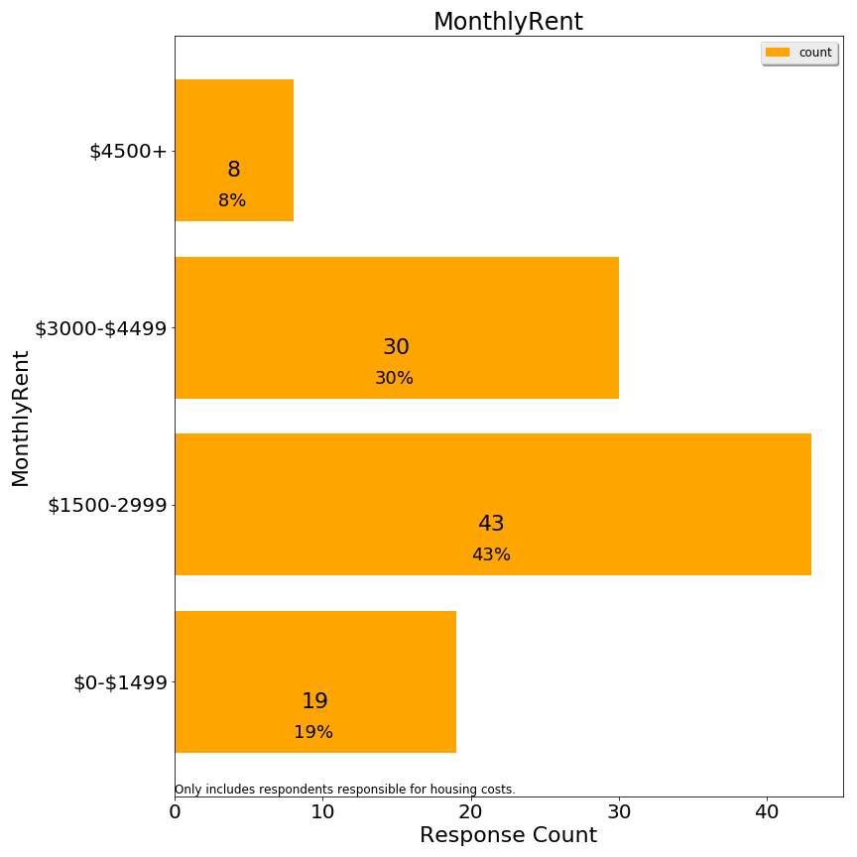

Q4. If you own your primary residence, please indicate your total monthly housing payment (mortgage, insurance, property taxes):

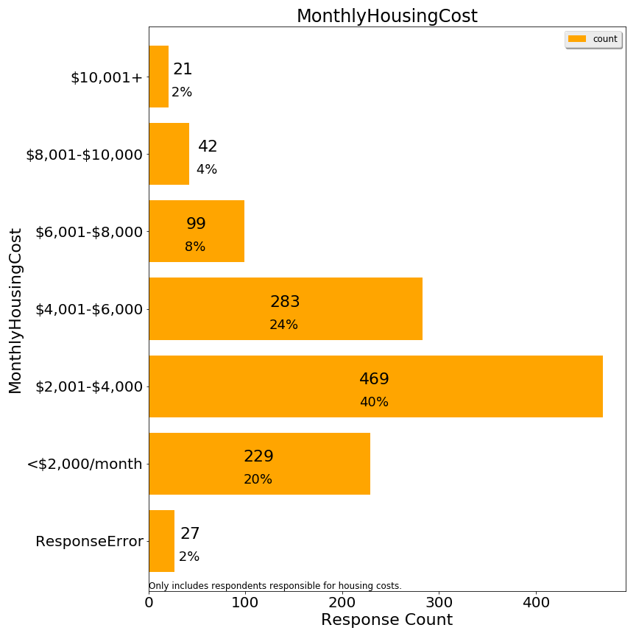

As indicated, some $10,001+ responses were re-coded as ResponseError because it was not conceivable to the committee how it corresponded to a lower home value. We presume the respondents interpreted the figure as an annual cost when they saw a figure such as $10,001+.

Q5. Do you receive a property tax deferral or property tax credit due to limited income?

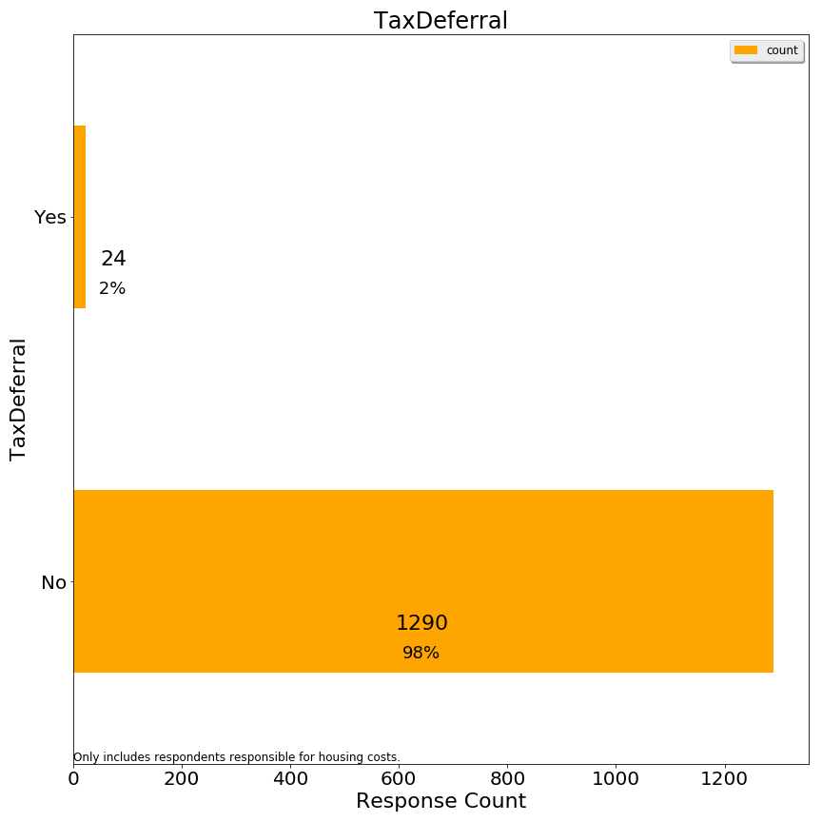

Q6. What level of stress does your household experience with payment of monthly housing costs?

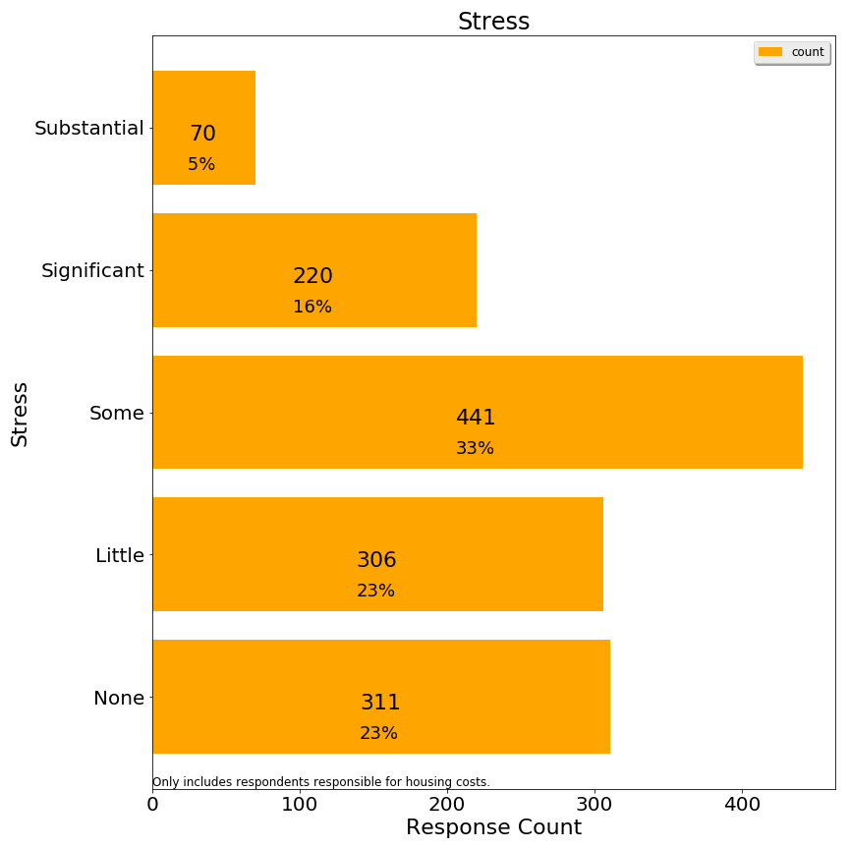

These stress codes were then grouped into high, medium and low for analysis purposes.

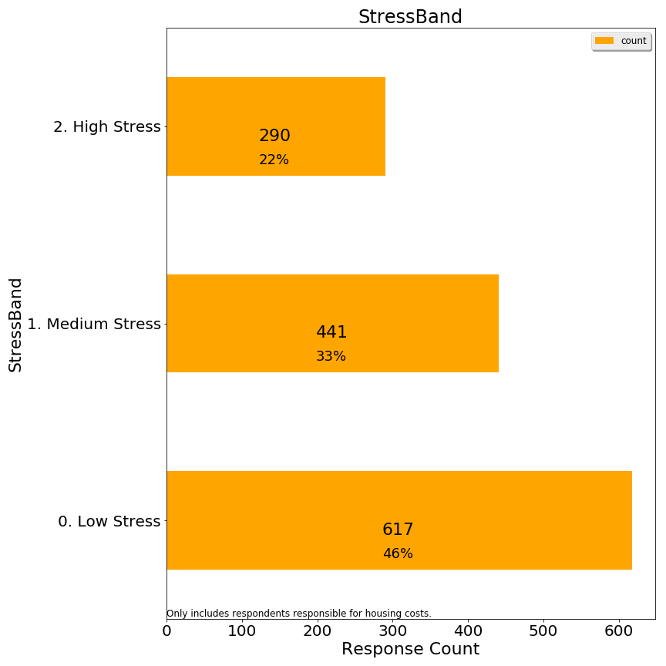

Q8. Thinking about all the costs of living in your owned property or rental (rent/mortgage, home maintenance, condo fees, property taxes, insurance, utilities), what portion of these costs do you estimate is related to property taxes?

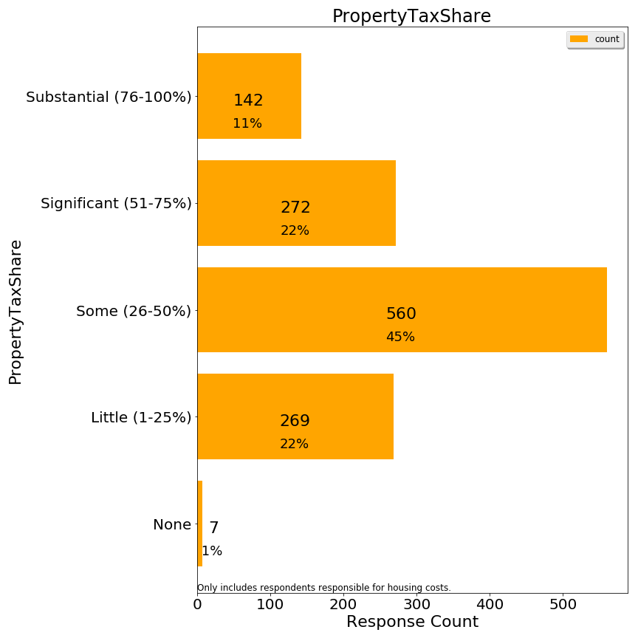

Some respondents criticized the labels which were attached to the %s, even suggesting that these labels implied taxes should be high. In hindsight, labels should not have been attached to the percentages.

Q9. Are you responsible for the housing costs at your residence (i.e. owner or lessee)?

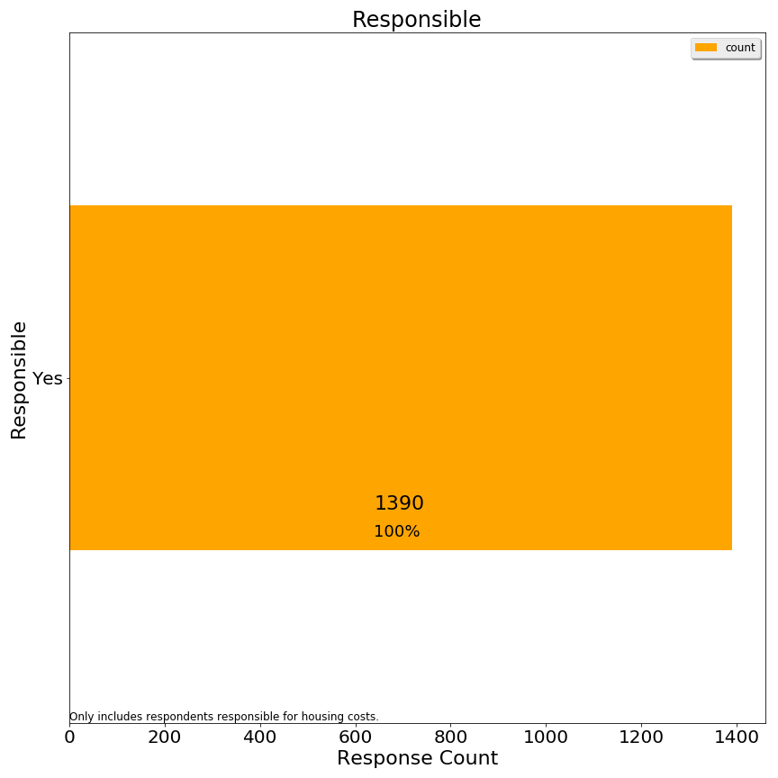

Q10. Are you considering relocating away from Lexington in the next 10 years?

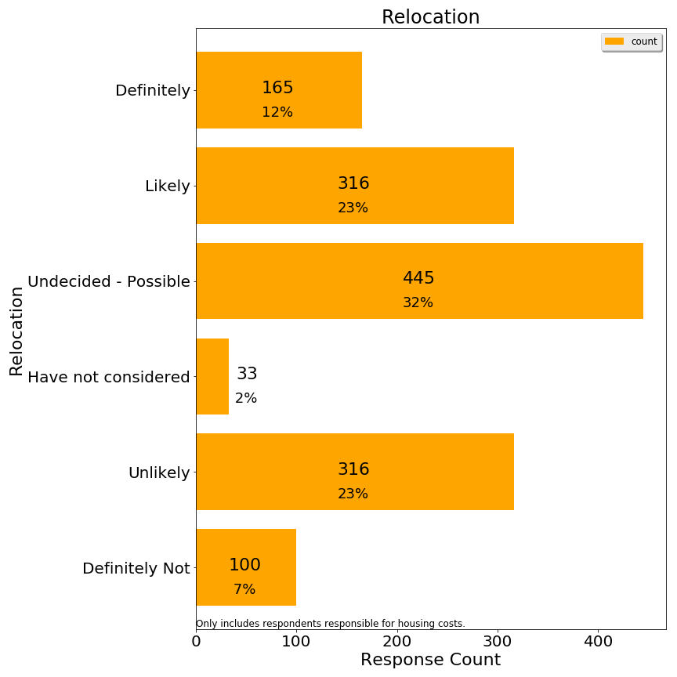

We regrouped responses for correlation analysis using a simpler relocation band variable:

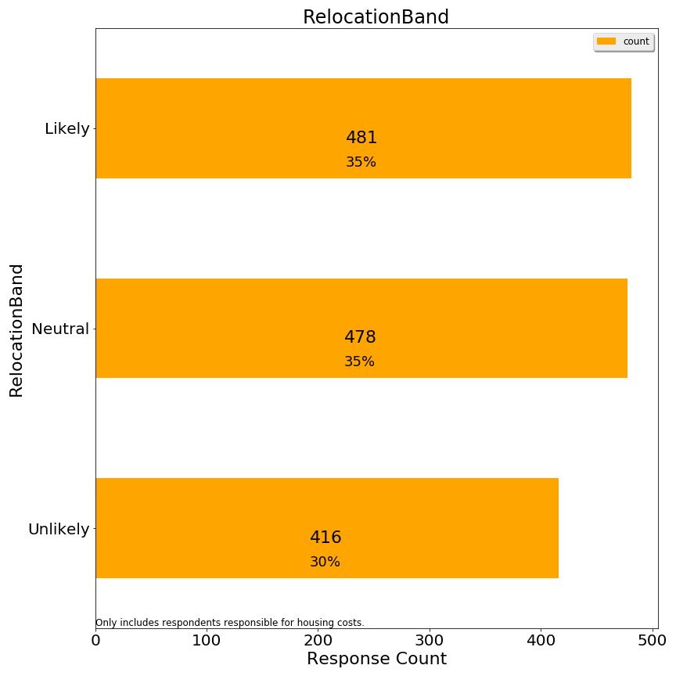

**Second 3: Demographics**

Q1. Age (respondent)

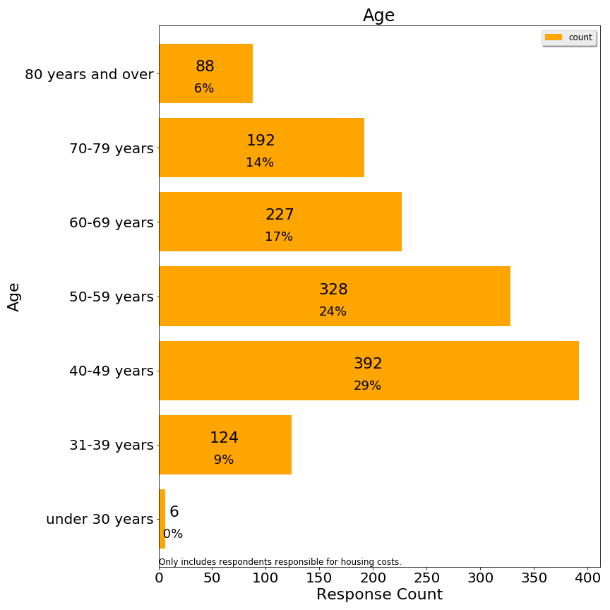

Q2. Size of household (number of people)

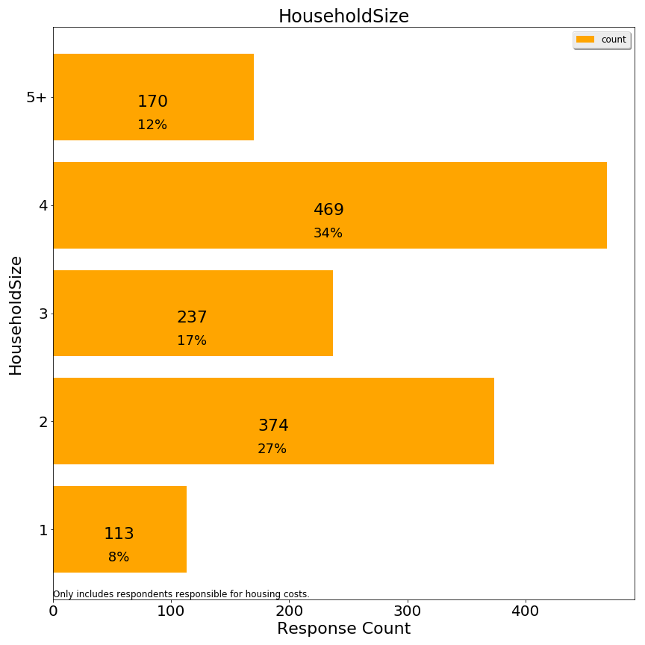

Q3. Disabilities within household (check all that apply)

*Not included*

Q4. Length of time living in town (respondent)

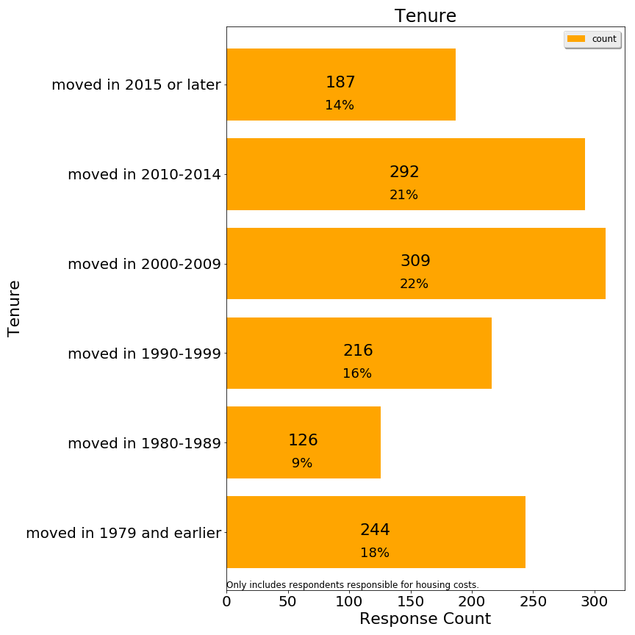

This question was ambiguous for respondents who moved in and out of Lexington multiple times.

Q5. What type of property is your residence?

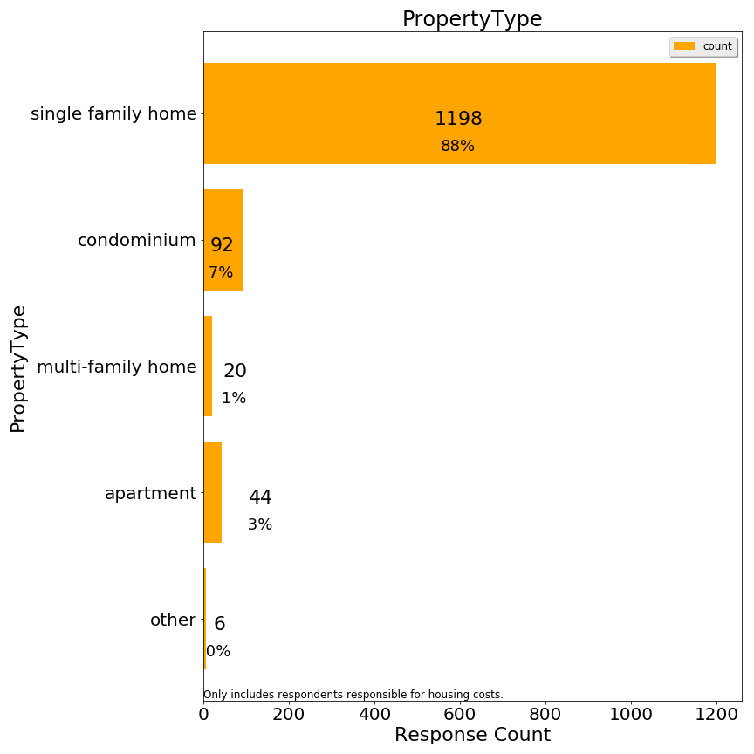

Q6. Approximate market property value of your Lexington residence (if owned):

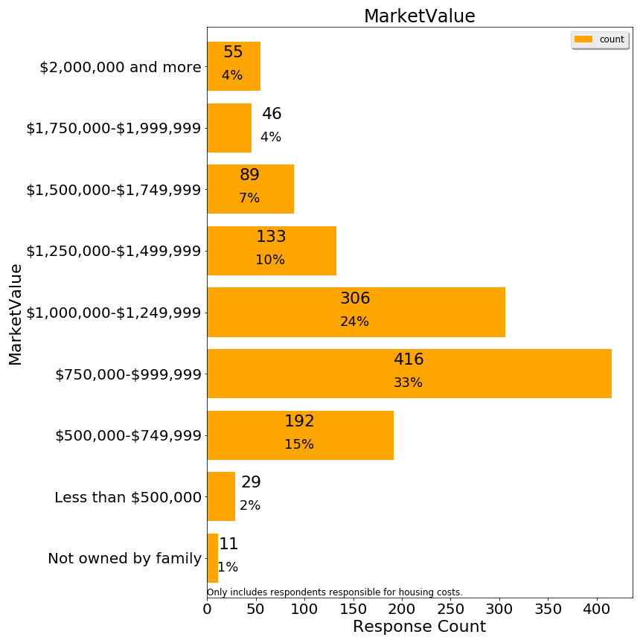

Q7. Please indicate your approximate household income in the past 12 months

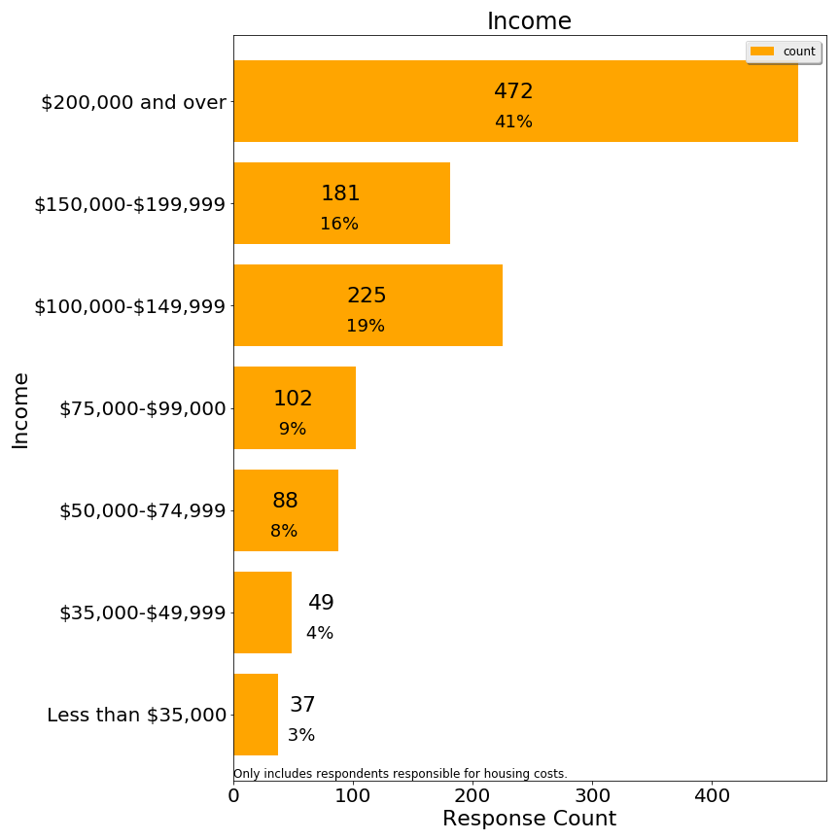

Additional charts on frequency distribution of derived variables are significant:

Number of Activities Reported

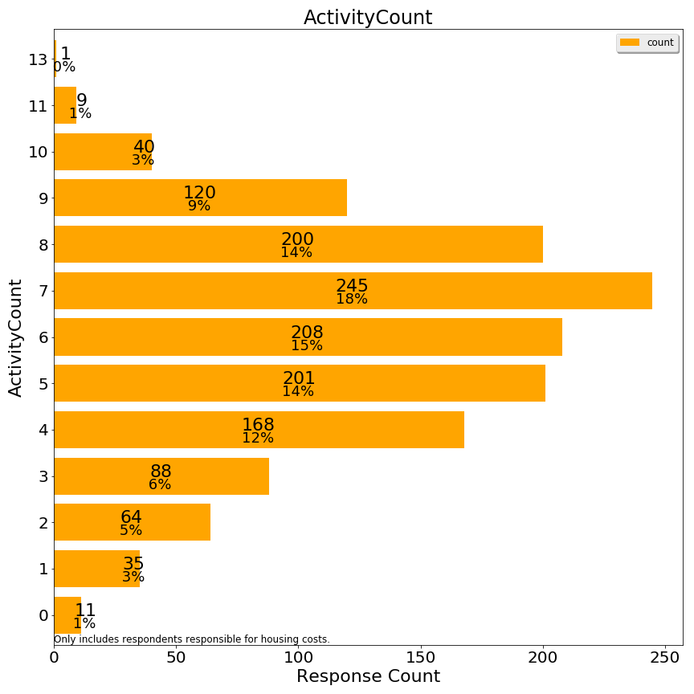

Whether respondent owns or rents



Number approximately qualified for a means-tested exemption (without asset test)

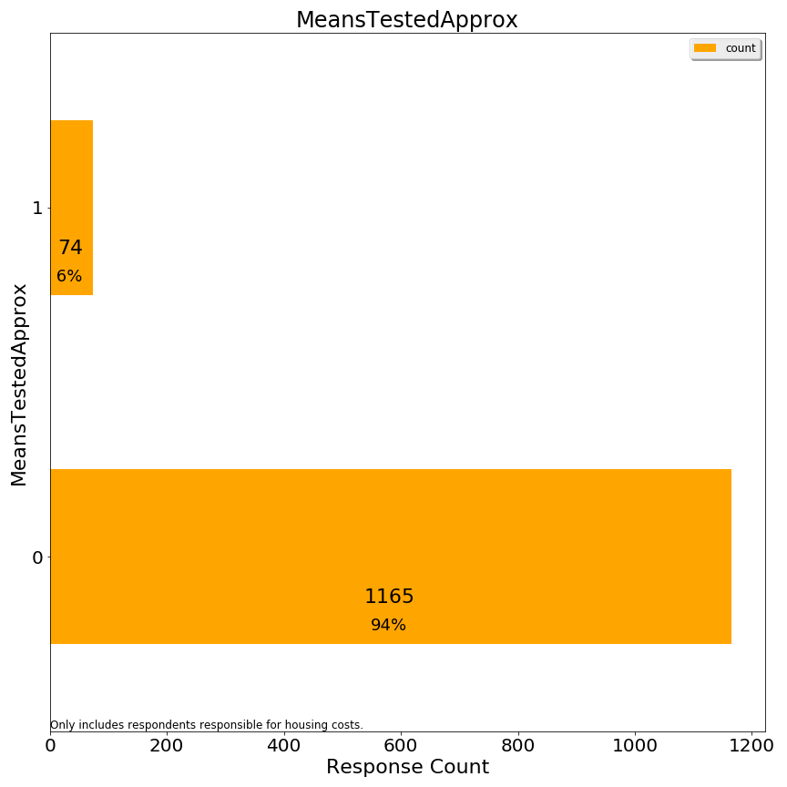

1. <https://www.lexingtonma.gov/sites/lexingtonma/files/uploads/ad_hoc_res_exempt_policy_committee_charge-101518.pdf>
2. <https://www.lexingtonma.gov/sites/lexingtonma/files/uploads/ad_hoc_res_exempt_policy_committee_charge-101518.pdf>
3. <https://en.wikipedia.org/wiki/Precision_and_recall>
4. Note: the committee has not compared migration rates with other communities or over time, so the charge around migration is not sufficient evidence that a “migration problem” exists.
5. The simple interest rates on Lexington deferrals have ranged from a high of 4.77% in FY 2007, to a low of 0.12% in 2015. The FY 2019 interest rate is 1.96%. The income cut-off has increased incrementally from $40,000 in FY 2007 to $70,000 in FY 2019.

   Each year’s deferral is treated as an individual loan at the fixed interest rate in effect in its year of origin.
6. <https://lps.lexingtonma.org/cms/lib/MA01001631/Centricity/Domain/365/FY19%20Budget%20Presentation_FINAL.pdf>, slide 10.
7. <https://www.rhsohousing.org/node/81/housing-inventory>. Note: although five apartment buildings count all their units as SHI inventory, in fact only a quarter of those units are occupied under rent controlled guidelines at any point in time. Lexington has 11.12% affordable housing per state standards.
8. The committee does not have any evidence that Lexington would renegotiate with Brookhaven, so this section serves to make policy makers aware of this possibility or implied tax levels.
9. <https://malegislature.gov/Laws/GeneralLaws/PartI/TitleIX/Chapter59/Section5C>. From 1979-2016 a maximum 20% exemption was permitted without special legislation, but starting in 2016 this maximum was increased to 35%.
10. <https://www.lexingtonma.gov/sites/lexingtonma/files/uploads/fy19_classification_packet_for_boa_11.30.18_final.pdf>
11. The Committee believes homes held in trust and occupied as the primary residence by a named trustee with a sufficient beneficial interest in the property or who has been granted a life estate in the property would be eligible for occupancy exemption. The Committee has no expertise in trust law and did not seek legal opinion on this matter, nor does any statement in this report constitute a legal opinion about eligibility.
12. A corollary is that combining and subdividing parcels changes the average residential parcel amount, but this is not a material consideration for Lexington.
13. The 9,265 figure from the tax classification packet is a rough estimate. Policy makers should treat this figure as an illustration, and evaluate from a longer perspective than how many parcels are owned in FY2019. <https://www.lexingtonma.gov/sites/lexingtonma/files/uploads/fy19_classification_packet_for_boa_11.30.18_final.pdf>
14. Verification failure could occur due to trust complexity, recent recent real estate transactions, and marital separation processes.
15. <https://www.investopedia.com/terms/p/progressivetax.asp>
16. The average single family tax bill is available in Boston’s own report, and it provides figures for Cambridge (FY17) and Brookline (FY18) used in those diagrams. The Boston report contains useful history and also demonstrates that the majority of Boston’s residential property is classified as condominium: <https://www.boston.gov/sites/default/files/imce-uploads/2018-03/fy2018_facts_figures.pdf>.
17. This capitalization effect undermines the ability of the average citizen to compare home prices across markets. Boston home prices are often cited as indicators of the high cost of housing in the Boston area when tax rates are lower than many comparable cities. A corollary is that there are no “free lunches”, so a Lexington home buyer cannot save money by shifting assets to another city, but instead is shifting property tax costs to mortgage or investment opportunity costs. These capitalization effects seem true in principle but are difficult to accept at face value given varied circumstances of home buyers and deserves further theoretical and empirical research.
18. Hypothetical example above uses 28% to give the reader a sense of the magnitude in practice.
19. Approximately 2.5% plus new growth.
20. Operating overrides increase the levy limit, and debt exclusions are medium-term exemptions to the levy limit.
21. This one-third ratio is based on the current value of Katahdin Woods. One might expect the value of apartment buildings to decline a small amount with a residential exemption, making the condominium conversion look more attractive relative to depreciated value. The committee did not examine the relationship between apartment assessed values and market values more generally.
22. Certain Lexington apartments have restrictions associated with affordable housing. At Avalon Lexington Ridge and Avalon Lexington Hills, by law or by binding agreement presently affordable units must remain affordable in perpetuity. Under the Special Permit by which Katahdin Woods was built, if the complex were to convert to condominiums, the Town would have to purchase Katahdin’s affordable units to retain their affordable status.
23. Several communities which adopted a means tested exemption instead of the SRE published studies.
24. Qualified subsidized housing inventory (SHI) could be reduced by conversions as well.
25. Waylad’s exemption is funded from the levy and is therefore not directly offset by increased levy.
26. Asset level excluding primary residence, personal effects, motor vehicles and cemetery plots (as in 41C).
27. One issue to resolve is whether household assets should be prorated for beneficial interest or another adjustment to remove incentive to divorce to bring household assets under this threshold.
28. Perhaps test the waters on the octogenerian exemption with the state legislature for broader adoption.
29. https://en.wikipedia.org/wiki/Precision_and_recall
30. Communication of results to the Recreation Department is occurring separately and is outside the scope of this report.
31. No further clarification was provided to respondents about interpreting the term “responsible”.
32. <https://www.census.gov/acs/www/data/data-tables-and-tools/>
33. For this chart, we combined the 70-79 and 80+ age classes into an age 70+ class due to the infrequent renter responses in this range.
34. [*https://sudbury.ma.us/assessors/2018/05/31/fy-2019-senior-means-tested-exemption-applications/*](https://sudbury.ma.us/assessors/2018/05/31/fy-2019-senior-means-tested-exemption-applications/)
35. One data source identifies the median rent in Lexington at $1,689. However, this seems far below market rates in general, so it is not clear if that figure is a rent controlled rent. <https://affordablehousingonline.com/housing-search/Massachusetts/Lexington>
36. Imputation of income could add about 100 respondents, but we have not elected to do any imputation.